Preferences for Logo
Colours: blue and grey
Type: Combined Icon with Wordmark
I would like “WORKWISE” to be the focus and I think it works best all in capitals with “Onsite Injury Specialists” smaller
This is one I produced quickly, hope yours looks a lot better
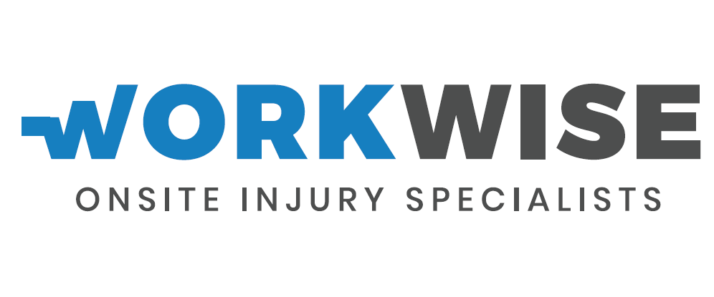



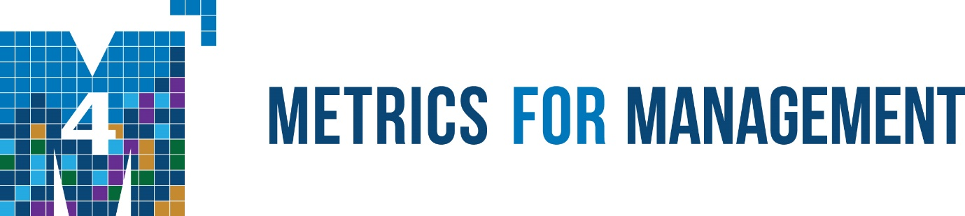

I really like the patterning idea of the bird design of “Independent Reserve”. I was thinking that maybe the icon could be a combination of this and the below icon for “metrics for management” but instead of the M it would be a W.

However, if you feel you could create something similar but unique, please go ahead.

Branding Questions – Workwise Onsite Injury Specialists

- How do you describe your organisation and what you do?

We are a small organisation that provides physiotherapy and musculoskeletal injury prevention services to companies. This service reduces the companies worker health insurance premiums and hence saves them money.

- Why do we do what we do?

We believe that we can change the landscape of the worker health-company relationship. Rather than the worker vs the company when it comes to physical health, we strive to create a safe and happy working environment for the worker that will enable enhanced productivity and reduced company costs, effectively creating a win win for the company and its staff. Through hands on physical therapy, ergonomic and risk analysis, we aim to prevent musculoskeletal injuries and improve work performance. We believe that there is always room for improvement and that happiness is derived from the continuous strive for advancing oneself.

- What are the adjectives and emotions around your brand? 5-7 words, comments or phrases

Reliable, accurate, data driven, ethical, innovative, enhance performance

- Who is the target market?
Any company that has a large number of staff (>50) per site that perform a lot of physical labour and whom are therefore prone to sprains and strains of the muscles and joints. Current contracted companies are SEALY (make mattresses) and BE CAMPBELL (Pork processing plant).


Examples of Logos I like







