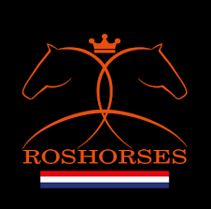
No crown, Australian Institute of Dressage as text

Australian Institute of dressage

Or 2 horses jumping/ rearing (mirror image) over emblem.

