https://housebuyingnerds.com – Current website with characters.

We have our branding and characters set around our logo:
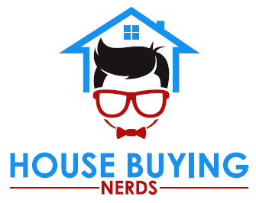

We need 3 character versions:
White Male (Black Hair to match logo)
Black Male
Female (blonde hair)
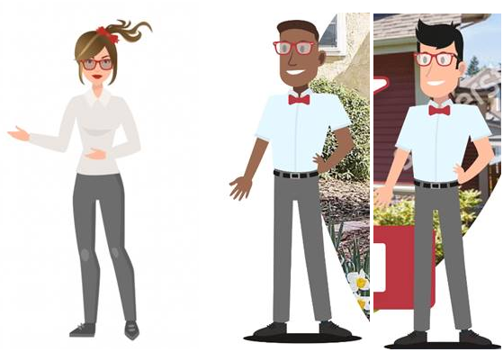
Just to be very clear. We do not like these character designs, so please don’t try to match them.

Design Requirements the characters must have:
- Must be wearing Nerd Glasses
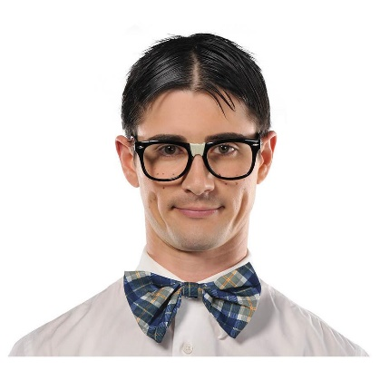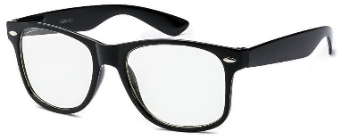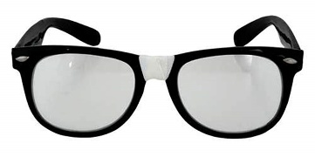
- Shirt
White, Short Sleeved, Button up shirt.
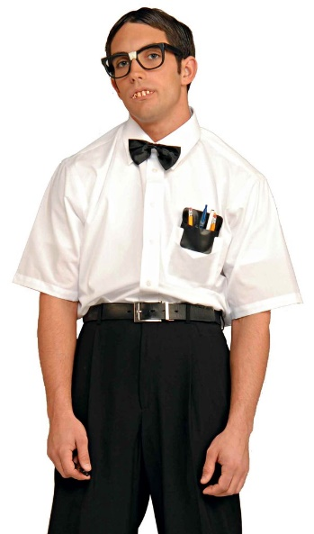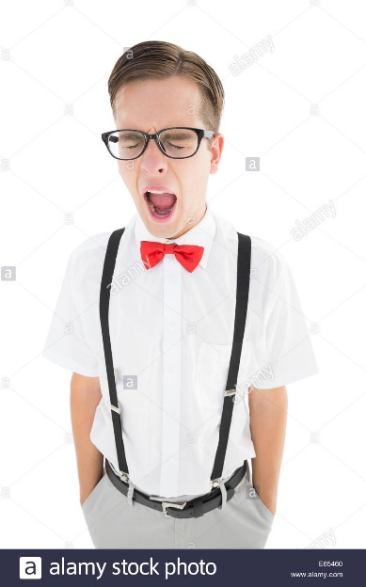

- Bowtie – Must be wearing a Red Bowtie.

- Pants – We either want khaki pants or black/grey slacks.

Other things that are acceptable –
Facial Hair
Overly exaggerated features

We don’t mind if the characters are any style of cartoon, but we are more inclined to like something like this:

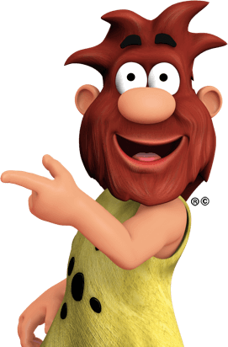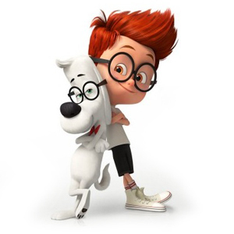

We are not as inclined to accept something like this:
