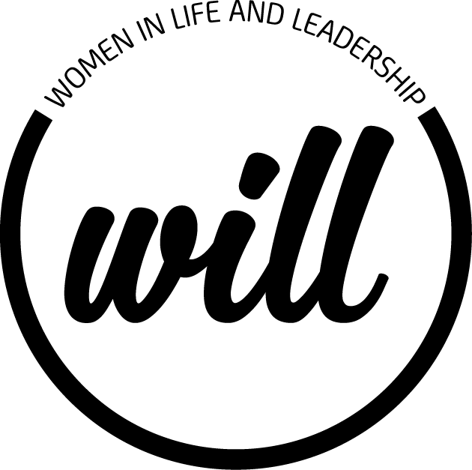
Really like the layout and the spacing and the fonts of the postcard below are just changes to the text
Changes to text for “THE WILL PROGRAM”
- Change “Happy International Woman’s Day 2019”
To..
A Residential Program
Enhancing your leadership skills, life balance and wellbeing.
- Change in World View
A view held (note not Held with a capital) inside of us as to how things work.
- Change in Biases
Our own behaviours and the behaviours of others that reinforce (change this to these ) worldviews
- Error Scripts
Change the word ( “Rewiting to Rewriting”)
- Change text under the heading Kerry Irwin to.…
Kerry is passionate about intuitive guidance to women in life and their careers.
Kerry develops and implements strategies that transform people, teams and organisations, with a particular focus on the raising of confidence and fulfilment of women by coaching them towards their life purpose.
- Correct (Mathew) Byrnes name it is spelt Matthew Byrne
- Change the text under the heading Matthew Byrne to….
Developing leadership styles and strategies that enable women in leadership roles to leverage their value by tapping into all their inner strengths
Equipping women with behaviour change tools to embrace growth in their life and career.

- Change the text in – Why –to
The Program helps you, in a reflective comfortable environment, to uncover the blockers of your success - moving you to the possibilities.

- Change the text in – Support & Program Inclusions –to
Leadership skills workshops, Life style sessions and Assessments supported by Coaching.
Body Wellness Therapies including - Meditation, Yoga, Reiki, Reflexology and Massage.
(Bold the following sentence) Accommodation and all meals are included.

