Website Update
Looking for a new design/layout for our website. Hoping to use another platform other than wordpress, not to fond of it. Wanting something that I can get on and change/update as needed after all said and done. We want a clean, sharp, and professional look while also being easy to navigate and find what you’re looking for. Also hoping to include a something fun to get customers to enjoy looking and going to our web page such as: crossword puzzle, or daily joke, etc.

Dar-tech Inc. (current website- http://www.dar-techinc.com/) is a distributor of raw materials and lab equipment to both suppliers and customers. Home office is located in Maple Heights, Ohio, but we cover all of Ohio and its bordering states: Michigan, Upstate Western New York, Western Pennsylvania, West Virginia, Kentucky, Indiana, North and South Carolina, Southeast Tennessee, Midwest Illinois and Wisconsin.
Pages We Want to be included in our Website
- Home Page
  - Product / application showcase
- Products Page
  - Products by Industry
    - Adhesives & Sealants
    - Civil Engineering
    - Elastomers/ Rubber
    - Inks/ Graphic Arts
    - Metalworking/ Lubricants
    - Paint & Coatings
    - Plastics
  - Products by Function
    - Additives
    - Pigments
    - Mineral Fillers
    - Resins
    - Equipment & Supplies
- Principals Page (Reference Chem-Materials Inc)
  - Logos & URL
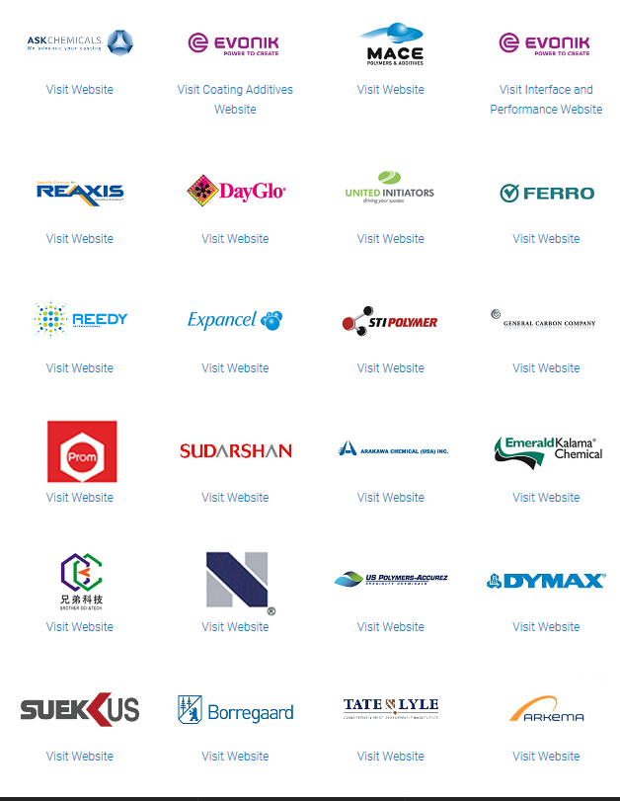
- Sales Regions & Reps
  - Reps (Reference Chem-Materials Inc)

  - Sales Regions (Reference IMCD’s)
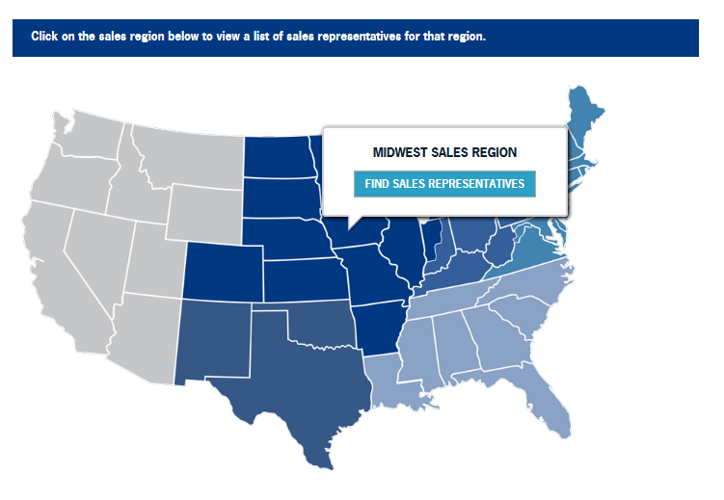
- About Page
  - History
    - Founded in 1951, Dar-Tech, Inc. has grown into one of the area’s major manufacturer’s representatives and distributors of specialty raw materials and laboratory equipment.
    - The company, first known as the Steven F. Dimlich Co., then as the Dimlich Radcliffe Co., was focused primarily on the chemical coatings industry.
    - In 1962, diversification was pursued in plastic, ink, rubber, adhesive and ceramic markets. Walt Walburn joined the company in 1967 and James Benduhn joined in 1972. In 1972 the company name changed to Dar-Tech, Inc.
    - In 1998, Thomas Kramer joined Dar-Tech, Inc. as CFO.
    - In 2012, Walt Walburn succeeded to Chairman of the Board and Brett Walburn to President. In 2011, James Benduhn assumed the role of Senior Vice President and in 2011 Pete Marek assumed the role of Vice President.
    - In 2017, Thomas Dressel joined Dar-Tech, Inc. ownership team and in 2018 assumed role of Sales Manager.
    - The past years have seen the expansion of sales offices and warehouses established in Buffalo, NY, Cincinnati, OH and Louisville, KY.
    - The Dar-Tech market area includes all of Ohio and its bordering states of Michigan, Upstate Western New York, Western Pennsylvania, West Virginia, Kentucky, Indiana, along with North and South Carolina & Tennessee in the Southeast and Illinois & Wisconsin in the Midwest.
    - Dar-Tech is an active member of The National Association of Chemical Distributors (NACD). NACD’s Responsible Distribution Process is ingrained in all facets of our daily operations, providing a unique advantage amidst industry’s ISO Certification requirements.

  - Competitive Advantages
    - To our Suppliers: Dar-Tech professionally represents our Principals’ product lines to customers with an effective sales, logistics, and supply chain management system, as well as provides Principals with valuable market knowledge, responsive support, and the benefit of extending their sales arm through our established relationships with our Customers.
    - To Our Customers: Dar-Tech provides access to industry respected manufacturers and formulators with high quality, well-known, specialty chemical products, an effective logistics network, and a responsive sales and customer service staff all of whom deliver technical support, with a customer-focused, personal approach.
  - Mission Statement
    - Dar-Tech‘s focus is being recognized as the premier source for quality products and service. Total Customer and Principal satisfaction is achieved by our superior technical and marketing support along with outstanding customer service, distinguishing Dar-Tech as a recognized sales organization leader.

  - Company Accreditations/Affiliations
    - NACD (National Association of Chemical Distribution)
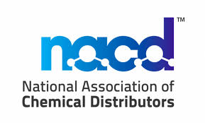
    - The American Ceramic Society

    - American Coatings Association

    - Society of Plastics Engineers
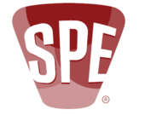
    - Cleveland Chemical Association

    - Chemical Association of Pittsburgh
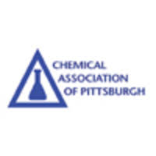

- Contact Us
  - Request a sample (Reference The Cary Company’s)
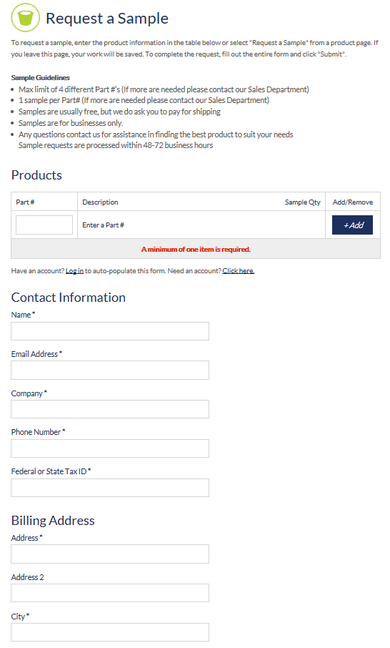
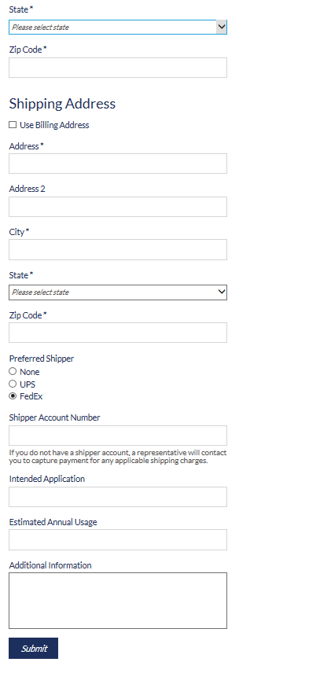
  - Location/Address
    - 16485 Rockside Road
Maple Heights, OH 44137
    - Google Map Pic & Driving Directions
  - Phone Number
    - Toll free: 800-228-7347
    - Local: 216-663-7600
    - Fax: 216-663-8007
  - Email
    - sales@dar-techinc.com

- News & Media Page

