Some sites that we like because of their originality and style.

http://graphiccell.com

https://isadoradigitalagency.com

http://demo.7uptheme.com

The black and white with some colors that stand out. The colors should be vivid and use some gradients between red and blue

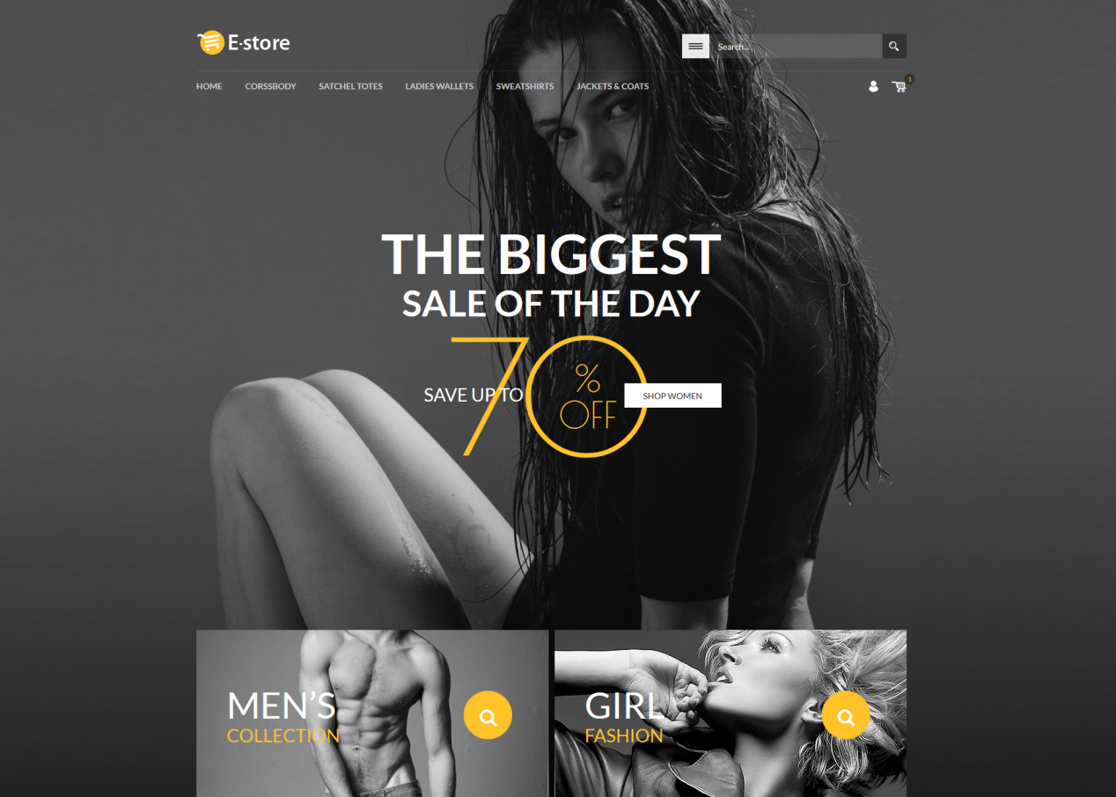

https://erilisdesign.com

THIS ONE WE LIKE A LOT!
The Oli theme with video background!
Colors like in this template are nice too
Also the website we present is not fully finished, it is under construction just like the message of this one. But it already looks appealing and makes you wait for the big lounge!

http://www.ivang-design.com/talos/?storefront=envato-elements

Driven by innovation and human behavior, our web design agency is changing the way brands connect with audiences in a digital world. Discover why market leaders choose our enterprise solutions.

We would also like to work with some Video backgrounds

https://www.youtube.com/watch?v=t77fAvLPqVc

nice colors that would match but a bit to heavy especially with the sound. Should give a realxing feeling

THIS ONE IS GREAT TOO!!!

https://youtu.be/bgkya_v-5Nc

This is also a video background that would be very suiteable:

https://www.videvo.net/video/typing-in-the-dark-03/4478/

I will post suggested page text / content for the different pages during the weekend

