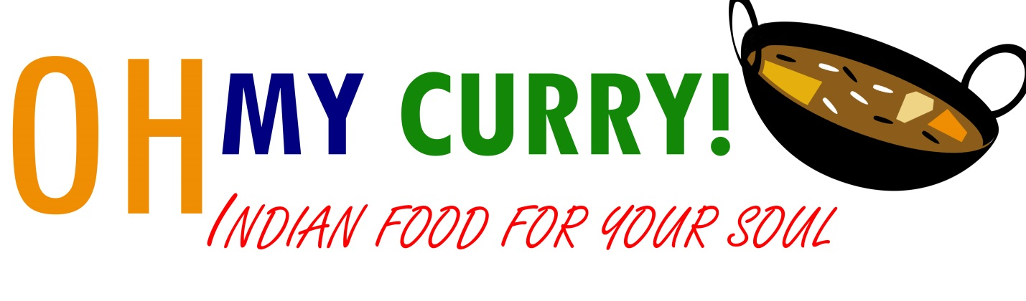Menu

1 Entrée Combo $11 (needs entrée options 1,2,3,4,5)
beef fry P
chana masala
Chicken tikka masala
chicken 65
chilli chicken
goat curry P

2 curry Combo $13 (needs entrée options 1,2,3,4,5)
beef fry P
chana masala
Chicken tikka masala
chicken 65
chilli chicken
goat curry P

Biriyani (needs entrée options 1,3,5)
Fragrant basmati rice cooked with cloves, cinnamon, cardamom, ginger and cashew nut then layered with curry, meat and baked to perfection, (Biryanis come with salad, poppadum, and pickle)
Chicken biriyani
Goat biriyani
Kerala Favorites (needs entrée options 1,3,5)
Porotta and Beef Fry $11
(Porotta a flaky buttery bread from Southern India is normally consumed with a Beef curry locally called ‘Beef Fry’)

Beef Fry P
Kerala’s Most Wanted! Beef is banned in most of India EXCEPT Kerala. This is our House Specialty. Beef cooked with onions, coconut and spices. Literally, the best dish #1.

Chana Masala
All Rounder! This chickpea curry fulfills everyone’s desires, simple and delicious.

Chicken Tikka Masala
World Wide Champion! This is the dish every other dish compares to. We claim this to be our 2nd BEST dish. You decide.

Chicken 65
An All India Classic! Boneless chicken sautéed with onions, whole coriander and spices very mild but amazingly flavorful.

Chili Chicken
This Indo Chinese Fusion is a smashing hit! Boneless chicken, onions, and bell peppers sautéed in soy sauce and chili sauce.

Goat Curry
The dish that reigns supreme. Bone-in Goat cooked in an onion gravy with garlic, ginger and spiced with cinnamon, cloves, bay leaves and more. North or South, goat rules over all!

entrée options
- extra protein- $2.50
- Poppadum and Pickle -$1
- drink - $2
  - Mango Juice
  - Thums Up
  - Ginger Beer
  - Lychee Drink
- Appetizer
  - Beef Puff 1.5
  - Chicken Puff 1.5
  - Egg Puff -2.25
  - Beef Cutlet -1.5
  - Chicken Cutlet- 1.5
- rice or bread (Choose 1)
  - Basmati Rice
  - Chapatti
  - Naan- $1
  - Kerala Porotta- $1
  - Chicken Curry Rice -$2

