Clark County Food Bank
Tacos & Taps 2019

Design Specs for Event Poster:

Size: 11” (w) X 17” (h)

Color: Full color, full bleed

Theme: This year’s poster design theme should capture spot lights, flashy lights, disco balls, bright neon lights. See page 2 of this document for inspiration.

Information needed on poster:

Clark County Food Bank logo
Tacos & Taps logo

Friday, May 3, 2019
Saturday, May 4, 2019

General Admission: $35
VIP Fiesta Ticket: $45
6-Pack Tickets Available

www.tacosandtaps.org

Featuring:
12 breweries
12 restaurants
Desserts & beverages
Raffle drawing
Live Music
Beer Bottle Ring Toss

Must be 21+

Design Theme Inspiration:

https://www.vecteezy.com/vector-art/237125-disco-background


https://www.vecteezy.com/vector-art/249487-abstract-modern-light-background
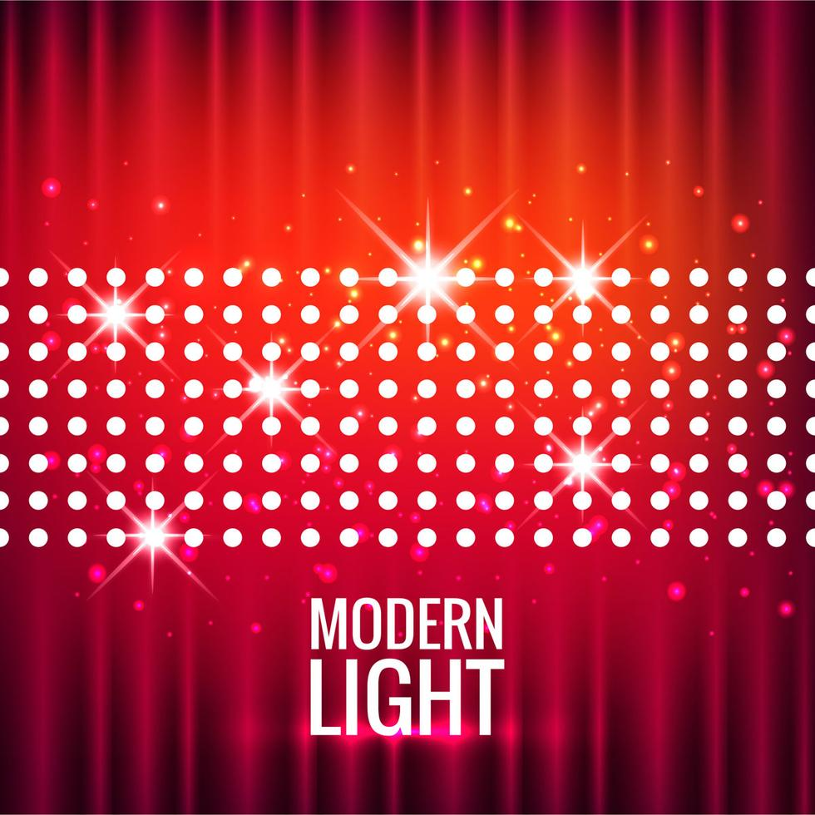

https://www.vecteezy.com/vector-art/252030-abstract-modern-light-background
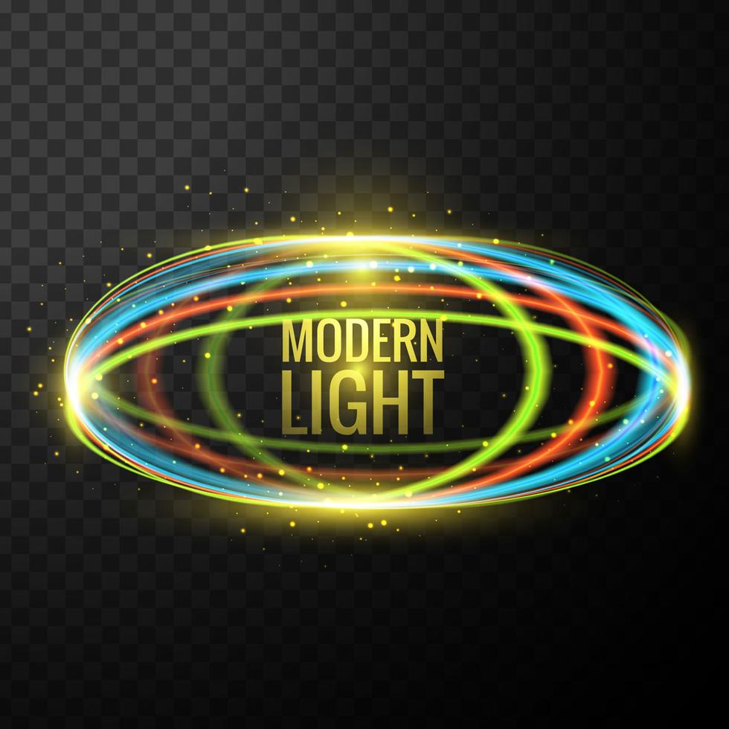

https://www.vecteezy.com/vector-art/210251-lights-on-starburst-background


https://www.vecteezy.com/vector-art/189238-stage-with-colorful-lights-background
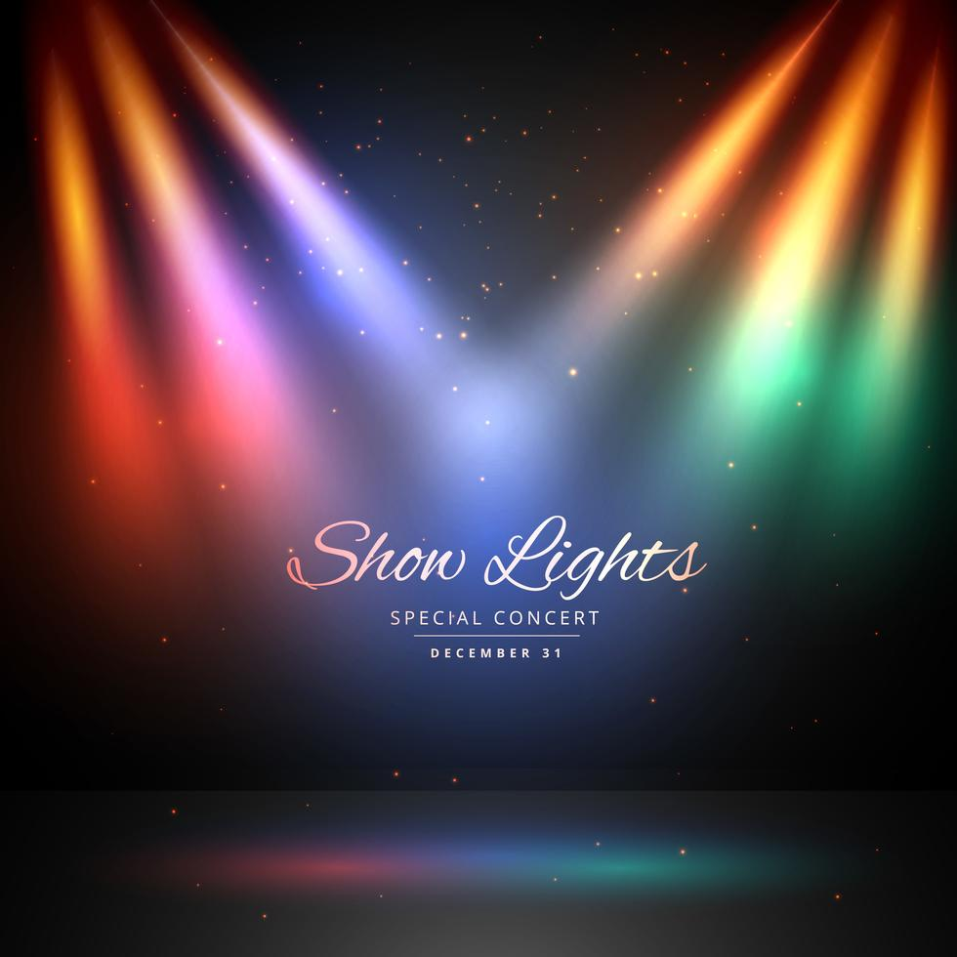

https://www.vecteezy.com/vector-art/196589-realistic-stage-lights-or-concert-spotlights-vector-transparent


https://www.vecteezy.com/vector-art/236969-colourful-lights


