Project Overview
We have recently created Cultural Values, and Purpose, Vision and Mission statements for a client’s business. We would like a visual representation created of each of these, to be hung on display in their office.
For this project, we would like four (4) graphic design prints drawn up that depict:
- Purpose
- Vision
- Mission
- Cultural Values
All print designs should use a recurring, common theme, and be reflective of the business’ colours (see attached logo.)
Business Details
Company Name: GippsAuto
Location: Australia
About the business: GippsAuto is a locally owned and operated, reliable and reputable mechanic. Offering a family and female friendly environment, they go the extra mile for customers when providing accredited automotive service solutions. GippsAuto puts the safety, security and reliability of your family’s vehicle above all else.
Target audience: Females, aged between 37 and 57 years old, who are family orientated, living locally, married and have between 1 and 3 children living at home.

Logo:
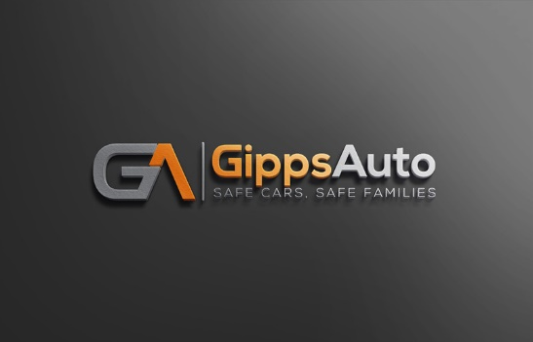

Design Specifications
Photoshop (PSD) format: All completed design will need to be in Photoshop (PSD) format before being handed over. This is to ensure that we can make alterations before printing if necessary.
Quality: All designs must be 300 pixels resolution or higher.
Purpose, Vision & Mission Designs Dimensions: The dimensions for each of the Purpose, Vision and Mission designs will need to be 30.5cm x 40.6cm (portrait, rectangle shape) with a surrounding 3.8cm border as it will be printed onto canvas matching these specifications.
Cultural Values Dimensions: There are no specific dimensions required for the Cultural Values so the designer should feel free to display them best they see fit.
Design Concept
The winning designs will be on display in the business so they will need to be very professional and reflective of the brand. All designs should use a recurring, common theme, and be reflective of the business’ colours (see attached logo.)
Please find details below of what should be included in each design.
Purpose
Imagery & Design: Designer is encouraged to use their expertise
Text to include:
Purpose
Providing vehicle safety and security to Gippsland families on our country roads.

Example of another business’s:

Vision
Imagery & Design: Designer is encouraged to use their expertise
Text to include:
Vision
We will earn our reputation for being the number one, family focused, automotive specialists throughout the Latrobe Valley.

Example of another business’s:

Mission
Imagery & Design: Designer is encouraged to use their expertise
Text to include:
Mission
Through the delivery of high-quality automotive services and customer experience excellence, we will instil confidence and security into our clients. We will build a solid platform of trust in which our entire industry will recognise the benefits.

Example of another business’s:

Cultural Values
While this will be produced as one design print, each individual value should be represented by an its own icon. All icon should then be displayed
Pride
We take pride in our workmanship, pride in our service and pride in the knowledge that we help to keep our clients safe, secure and happy whilst they are on the road
Imagery & Design: Designer is encouraged to use their expertise
Text to include: Pride
Honesty
We believe in providing an honest service, honest advice, open and honest communication and honest rates
Imagery & Design: Designer is encouraged to use their expertise
Text to include: Honesty
Respect
We uphold respect for our clients, for their vehicles and for the automotive industry in which we work
Imagery & Design: Designer is encouraged to use their expertise
Text to include: Honesty
Diligence
We will work diligently to find and communicate automotive solutions that accommodate the individual needs of our clients
Imagery & Design: Designer is encouraged to use their expertise
Text to include: Diligence
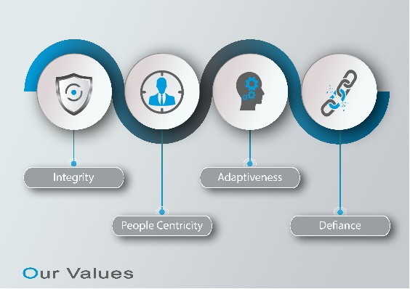
Example of another business’s:

