WHO WE ARE
5th Street Advisors is a privately owned independent wealth management firm and SEC Registered Investment Advisor. Founded in 2006 as a boutique advisory for successful individuals and families who desire a better solution than the mass market financial services offered by big banks and brokerage houses, 5th Street’s approach is client-centric, comprehensive, and unbiased.

TRUST IN INDEPENDENCE.
As an SEC Registered Investment Advisor (RIA), 5th Street is a “fiduciary,” meaning that we are legally obligated to act in the best interest of our clients. However, our commitment to the values of trust and loyalty underlying the concept of a fiduciary extends beyond our registered status. As a privately owned firm, we operate completely independent of any bank, broker-dealer, insurance company, or custodian. Consequently, in providing investment advice, we do not accept or receive any sales commissions or 12b1 fees, and are not under pressure to cross-sell internal financial products. Simply put, we’ve made a choice to eliminate conflicts of interest from our advisory relationships. We like it this way, and we think our clients do too.

WHAT WE DO
INVESTMENT MANAGEMENT
Your long term goals may never change, but the markets, the economy, and the world will. As an investor, this means your expectations of risk and return associated with different types of investments must change accordingly.
At 5th Street Advisors, we leverage our diverse experience in banking, trading, and wealth management to employ a pragmatic, disciplined investment strategy tailored to your specific needs. Our portfolios are globally diversified, designed to provide liquidity, tax efficiency, and, over the long run, level returns consistent with prudent investment management and each client’s individual goals and risk tolerance.

We offer four market risk levels to accommodate investors with different risk preferences encompassing comprehensive coverage of global equity and fixed income markets. Unlike single asset funds that are simple to benchmark, asset allocation funds have unique properties that make benchmarking complex. To that end we subscribe to benchmarking provided by the Morningstar Target Risk Index family designed to meet the needs of investors by offering and objective yardstick for performance comparison.
We often we inherit existing portfolios with legacy positions based on sentimental value and/or large taxable gains. We will work with you to preserve your legacy position within the context of the chosen appropriate risk model to meet your long term objectives and risk profile.
The four market risk models and their corresponding indices cover equity risk preferences ranging from conservative to aggressive

A portfolio focused on fixed income, appropriate for investors adverse to short-term loss and who can accept only slight fluctuations in portfolio value. Typically 20% in equity and 80% in fixed income and equivalents.
Benchmark: Morningstar Conservative Allocation Index

A portfolio with a primary goal of capital preservation and the secondary goal of capital growth, appropriate for investors seeking some growth but willing to accept only low levels of fluctuation in portfolio value. Typically 40% in equity and 60% in fixed income and equivalents.
Benchmark: Morningstar Moderatly Conservative Allocation

A portfolio with a primary goal of capital growth and secondary goal of capital preservation, appropriate for investors willing to accept a moderate level of fluctuation in portfolio value in exchange for greater growth. Typically 60% equity and 40% fixed income and equivalents.
Benchmark: Morningstar Moderate Index
A portfolio with an objective of capital growth, appropriate for investors modestly concerned with the level of fluctuation in their portfolio and longer term investment horizons. Typically 80% equity and 20% fixed income.
Benchmark: Morningstar Moderately Aggressive Index

FINANCIAL PLANNING
Comprehensive Financial Assessments
Serious financial planning is a highly valuable, though often neglected exercise used to examine one’s financial condition and plan for the future. Through a hands-on, collaborative process, our single engagement financial assessments are designed to shine a light on the fine details of your financial condition and provide analysis and strategic recommendations to set you on the path towards financial independence and security. In short financial planning takes away the guesswork out of managing your finances and helps you understand the implications of each financial decision you make.
The idea is to protect what you own, plan for life objectives, prioritize goals, and eventually pass along assets to the next generation.
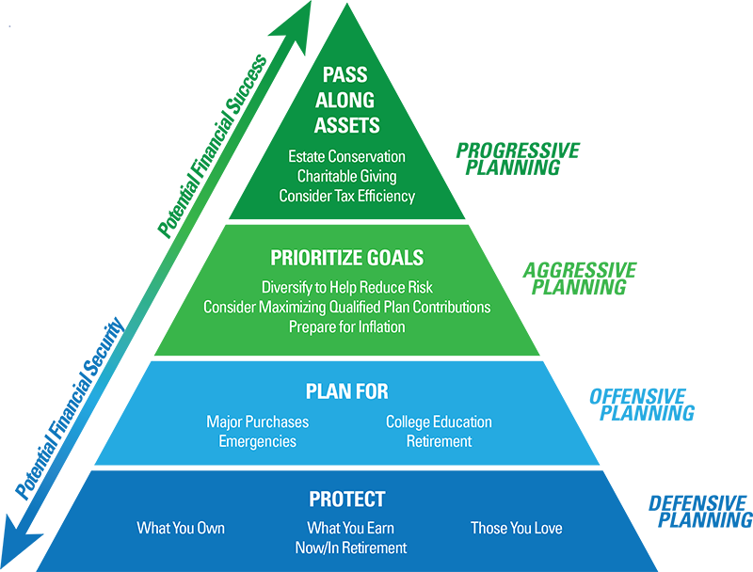

UNDERSTANDING THE PLANNING PROCESS
The planning process is detailed in the wheel below but can be summarized in six steps; agree to work together, gather information, analyze and strategize, develop recommendations, put plan in moition and monitor progress and stay on track.

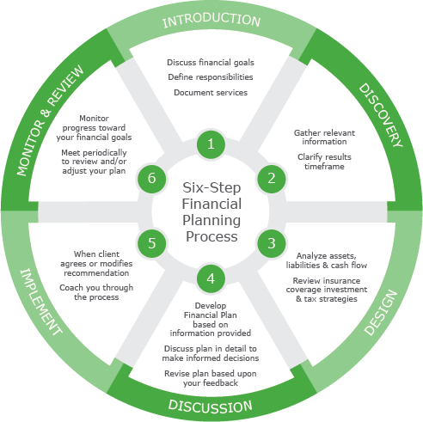
5th Street has two Certified Financial Planners on board with over 30 years in combined financial planning experience. In addition all Financial Planning and Comprehensive Well Management clients enjoy complimentary 24/7 access to eMoney, a leading planning technology solution to support every stage of life.

Putting it All Together via Comprehensive Wealth Management
A highly focused, client-centric approach to building wealth and financial peace of mind
At 5th Street we understand that our value depends on the depth to which we understand our clients and our ability to take that knowledge and offer dynamic advice as their needs change. Our holistic approach to wealth management unifies asset management with integrated planning solutions designed to place an ongoing, up-to-date, and full view of our client’s unique situation and goals at the center of every decision. Rather than being limited to portfolio strategies, the emphasis of the advice shifts towards an understanding of the individual’s entire financial entire condition, and the implementation and monitoring of comprehensive strategies.

Financial Planning | Wealth Management
In depth, single engagement planning sessions on specific topics, including but not limited to: Aligning Portfolio with Strategic Goals; Retirement planning; Tax Planning; Estate Planning; Insurance planning; Stock Option Planning; Business Succession Planning. The Planning includes  - Agree to work together  - Initial meeting to assess goals and gather facts  - In depth analysis  - Meeting to present and make Recommendations  - Put plan in motion  - Follow up meeting to assess progress | Integrated Financial Planning  - Everything included in Financial Planning, plus  - Ongoing planning on unlimited topics  - Aggregation of held away unmanaged accounts and consolidated view of financial condition via online portal  - Performance Reporting on outside Investments accounts  - Risk profile assessment  - Evidenced based risk analysis of portfolios  Investment Management  - Portfolio Construction and Management  - Goals Driven Investment Planning  - Quarterly Performance Reporting  - Quarterly Market Analysis Reports  - Management of outside accounts
Flat Fee  $5,000 plus travel expenses for engagements outside the Tri-State Area. | Annual Fee  Fees are charged quarterly, in arrears, based on the amount of assets under management (AUM).  - Up to $1,000,000 – 1% ($1,000 per $100,000 managed)  - From $1,000,000 to $2,000,000 - .75% ($750 per $100,000 managed)  - Above $2,000,000 - .50 ($500 per $100,000 managed)  Held away and aggregated accounts that we provide performance reporting are charged .10% ($100 per $100,000). Accounts held away where we report and manage are charged 0.25% ($250 per $100,000).
UNDERSTANDING OUR FEES
Clients typically engage 5th Street for either single engagement financial planning or more commonly through comprehensive wealth management. We charge a flat fee for single engagement financial plans starting at $5,000. Clients with $500,000 of assets under management receive financial planning on a complimentary basis.
FAQ

What is a Fiduciary and why does it matter? As an SEC Registered Investment Adviser (RIA), 5th Street Advisors is considered a fiduciary, and thus held to the highest standard of care under applicable law. A “fiduciary” owes its clients a duty of loyalty, must disclose any conflicts of interest, and must always act in the best interest of its clients. Surprisingly, many financial professionals are not legally considered fiduciaries, and thus do not owe their clients such loyalty. Although most financial professionals will hold themselves out as trusted advisors, many in fact are simply salesmen, paid on commission depending on what they sell you. Working with a fiduciary, therefore, is valuable because it ensures a level of objectivity in the advice you receive.

Do you take custody of client assets? No. 5th Street Advisors never takes custody of client assets. Typically our client’s assets are held in custody at Schwab or Fidelity, to industry leading custodians. In addition to 5th Street’s regular performance reporting, the custodian’s provide monthly account statements as well as 24/7 online access to you accounts.
What about financial accounts outside your primary custodians? At the client’s request, 5th Street will provide performance reporting and rebalancing on accounts held outside our primary custodians.
Do you provide analysis or “second opinions” on portfolios outside your management? Yes. 5th Street regularly provides analysis of portfolios outside our management as a well as ongoing performance reporting and analysis of such accounts. Our analysis is not only limited to gains and losses, but in depth analytics
What does your technology infrastructure look like? 5th Street Advisors uses best in class platforms to deliver our services, including Morningstar for performance reporting and research, Tamarac for trading, Riskalyze for personal risk assessment and portfolio risk analysis, and eMoney for financial planning.
How do I access my financial accounts? You can access your accounts online via the websites maintained by the custodian where you choose to keep your assets, either Schwab of Fidelity. 5th Street clients also have access to a Morningstar portal providing more in depth performance reporting on their managed portfolios. Additionally, our wealth management clients have access to an online wealth portal powered by eMoney, providing an aggregate view of all financial accounts, managed and unmanaged, as well as cash flow tracking, and other client specific financial details.
How can I track the performance of my portfolio?5th Street provides quarterly performance reports to supplement the regular account statements provided by your custodian, which can be accessed online or, by request, in paper.
How often will I receive communications from 5th Street? 5th Street provides quarterly performance reports on each client account under management, as well as quarterly newsletters providing market insights and reviews. Additionally, we undertake an annual review of each client’s portfolios.
How do I contact 5th Street with questions? All our clients receive concierge service and may contact us at any time via phone or email. We strive to respond to any question within 24 hours, but usually much sooner.
Who will I work with? 5th Street’s team is comprised of seasoned professionals with years of experience and top credentials. We work collaboratively to service all accounts, and most clients regularly communicate with more than one team member.

