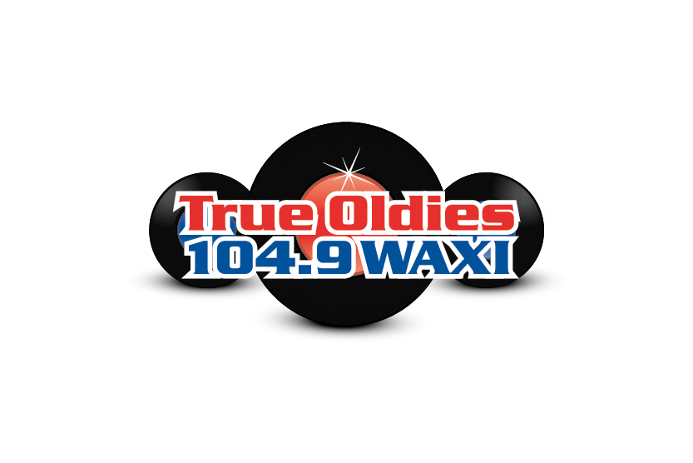

This is our current logo. We want to stay away from anything resembling this since we are going to playing a different format of music

