HEADING :PERTH HIRE AND SALES
USE perth hire LOGO

Concrete, Construction and Communication Hire Equipment

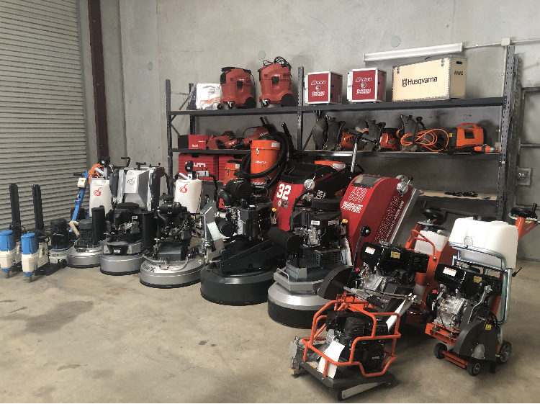

Honing, Polishing, Cutting, Drilling, Demolition and General Hire Equipment Available.
Diamond Consumable for sale- core barrels, diamond segments and specialized tooling

Good old fashion customer service with over 15 year’s experience in the concrete and construction industry.
We will BEAT any written quote from our competitors.

Find us on Facebook and Instagram
Contact us:
E: info@hireperth.com.au
W: www.hireperth.com.au
A: unit1. 38 Triumph Ave Wangara 6065
P : 0402 509 072
LOGOS of our suppliers.
Carbon diamond, superabrasive,hilti, husqvanara, MK diamond

