We are looking for a logo that captures the deep history and lore of Ireland without the overused hokey symbols(Clovers, shamrocks and leprachauns).
Here is our personal background in the about us:
“Two brothers, sons of Irish immigrant parents, recently got together and talk quickly turned to the magical summer they spent in Ireland with their family fifty years ago. Days were spent chasing the sheep, jumping over stone walls and running up and down hills in the rain. Nights were filled with stories of fairies and leprechauns. There was always a fiddle or tin whistle and a song in the room. An old Donegal fisherman poured Guinness onto the dirt floor of their uncle’s cottage and drew a picture of the mermaid he had seen. No wonder the two brothers, now men, vividly remember it all! This is the heritage the brothers treasure and cherish. They too had a story to share and this website was born.
Let the music, the dance, the writing and the artwork come alive! Have some Irish tea, warm yourself in a gorgeous Irish sweater, find the perfect gift for someone you love.
Two brothers want you to feel the magic of Ireland they did fifty years ago. Slainte!”

We are looking to celebrate the rich history of Ireland many don’t know:
Here are some examples:
The OGHM:
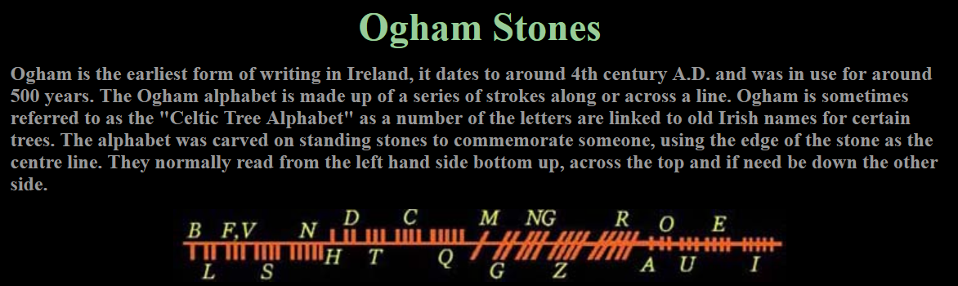

Examples of OGM Stones:
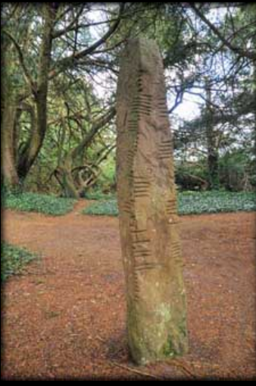
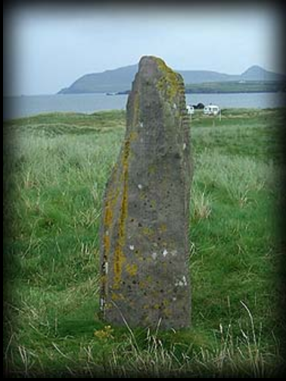

Great example of OGHM as art:
https://www.pinterest.ie/oghamart/our-ogham-art-prints/?lp=true
https://www.pinterest.com/oghamart/

Other Irish symbols that could be are acceptable are:

Claddagh Ring
The Claddagh ring, originated in the Irish village of Claddagh, is traditionally given to represent timeless love (the heart), loyalty (the crown) and friendship (the hands). The principal legend about the origins of the ring concern Richard Joyce, a silversmith from Galway in the 18th century. He was captured and enslaved by Algerian Corsairs. He never forget his lover and when he finally broke free fourteen years later, he went back to his motherland and offered this ring to his sweetheart as a commitment.
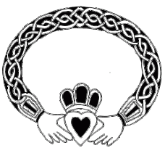
The Claddagh Ring

Celtic Cross
It’s the combination of the traditional Christian cross with a ring (a solar symbol of energy, a life source) surrounding the intersection. It became popular for funerary monuments and also spreading well beyond Ireland.
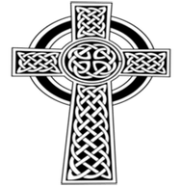
A Celtic Cross

Celtic Tree of Life
The Celts had many tree symbols which all designate the oneness with nature but with others meaning depending of the tree species. For example ash represents connection, wisdom, surrender. Willow signifies imagination, intuition, vision. And oak is for strength, stability and nobility.
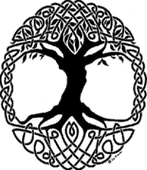
The Celtic Tree Of Life

Triquetra / Trinity Knot
It can be found in illuminated manuscripts (as a space filler or ornament) and in artwork on Celtic crosses and slabs from the early Christian period. Now, the triquestra is offered by a man to a loved one (as a necklace or a ring) and symbolize the three promises of a relationship such as love, honour and protect. It can also symbolize unity and trinity of soul, heart and mind or finally three distincts interlocked levels: physical, mental and spiritual.
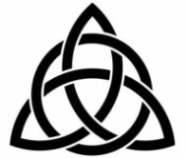
The Trinity Knot

Triskelion
Like the trinity, the triskel stands for unity of physical, mental and spiritual. It also symbolizes the eternal life, the flow of nature and spiritual growth.
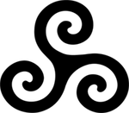
Triskelion

Brigid’s cross
It is a small cross usually woven from rushes, typically with four arms tied at the ends and a woven square in the middle. This crosses are associated with Brigid of Kildare, one of the patron saints of Ireland and are traditionally made in Ireland on St Brigid’s feast day, 1 February, marking the beginning of spring. Traditionally they were set over doorways and windows to protect the home from any kind of harm.
For much of the late 20th century it was used to represent the Irish national broadcaster Radio Telefís Éireann.
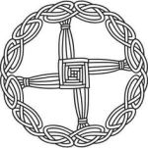
A St Brigid’s Cross
Here are our top competitors:
https://www.theirishstore.com/
https://www.irishshop.com/
https://www.blarney.com/
https://www.myirishjeweler.com/

So in conclusion we would like a clean contemporary design with little or no color that conveys the history of Ireland and does incorporate the OGHM symbol.
Ask for any clarification.

