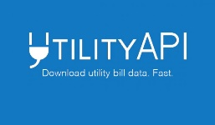


Sign Up for the Solar Subscription Agreement.
There is no cost

Securely Provide Generate Solar with your Utility information through UtiiltyAPI
We use the information only to credit your bill, generate your invoice, and provide clean discounted energy.

Solar Garden Produces Energy
which becomes Utility Credits
Credits Available for the property’s Tenants’ Utility Bills
Sign Up to Receive
Utility Bill Credits and
Save 5% for as long as you lease your space

© 2019 All Rights Reserved
2
Securely Provide Generate Solar with your Utility information through UtiiltyAPI
We use the information only to credit your bill, generate your invoice, and provide clean discounted energy.
Step 2
Contact Us
Click here
to learn more.

