Sailboat logo design

This project is to design a logo for a sailing catamaran. The boat is an Outremer 4X, the hull sides are white in color. See the following two photos for an example of where the logo will be placed on the forward top section of the hulls, similar to where the ship’s wheel logo is placed on the boat in the photos.

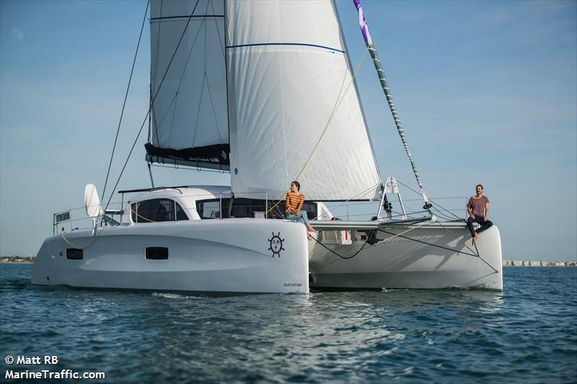

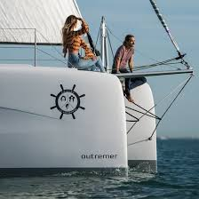

The name of the boat is PUFFIN, like the sea bird. We would like a graphic representation of a puffin that
use some of the colors of the puffin bird but make it abstract. We like the idea of it being a cool looking logo, but not obvious that it’s a puffin until you look more closely, so very abstract:

Here are some examples of logo styles we like.

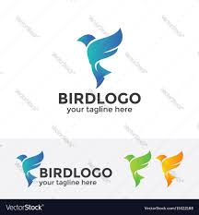











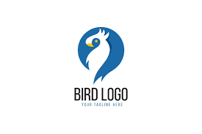





These photo shows the colors of a Puffin, there are plenty more examples online.
