MAKE A DIFFERENCE IN 2019
THE BEST WAY TO EXPERIENCE THE TRUE BEAUTY OF LORD HOWE ISLAND IS TO SEE IT FOR YOURSELF; JOIN OUR LHI CONSERVATION VOLUNTEERS PROGRAM IN 2019 AND BE INVOLVED IN A WORLD CLASS, AWARD WINNING HOLISTIC CONSERVATION EFFORT – PROTECTING PARADISE.
Quote: “[Lord Howe Island is] so extraordinary it is almost unbelievable”. Sir David Attenborough
Lord Howe Island located 600km off the New South Wales coast is renowned for its spectacular scenery, important breeding grounds for colonies of seabirds, and its rich biodiversity including many endangered and critically endangered species not found anywhere else in the world.
LHI Conservation Volunteers believe in protecting Lord Howe Island’s unique biodiversity while showcasing world class conservation in action. We are dedicated to empowering like-minded people to make a difference through robust citizen science, inspiring educational experiences, and tangible local conservation action.
Potential quote: Look deeper into nature and you will understand everything better

Small circles with images for each month
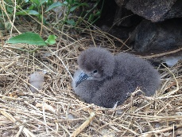
BIRDS OF LORD HOWE ISLAND – MAY 2019
Showcasing Lord Howe Island’s incredible bird species. Experience the amazing phenomena of ‘calling’ wild seabirds down from the sky as you assist in research into the life of rare seabirds.
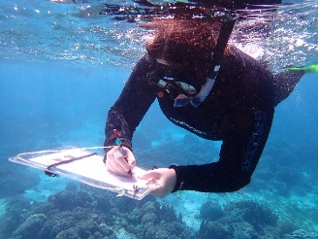
LORD HOWE ISLAND’S MARINE ENVIRONMENT – JUNE 2019
Our seabirds are being impacted by ocean plastic debris. Help survey Lord Howe Island’s diverse intertidal ecosystems and provide valuable data to help understand the issue and support solutions.

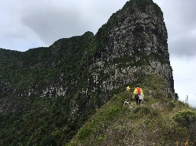
INVASIVE SPECIES – JULY 2019
Invasive weeds are identified as one of the most serious threats to Lord Howe Island’s biodiversity and world heritage values. Hike to remote and settlement locations and assist in weed removal with our experts, whilst learning about our world class Weed Eradication Program.

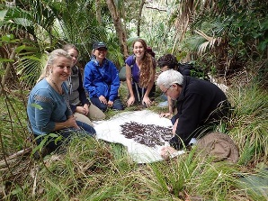
AMAZING INVERTEBRATES – AUGUST 2019
Rodents are voracious predators of invertebrates. The loss of invertebrates is particularly significant because invertebrates play an important role in maintaining natural ecological functions.
This month we will celebrate the discovery and revival of the rare Phasmid and the wider context of invertebrate conservation on Lord Howe Island and across the globe.
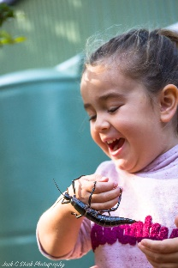
PROTECTING PARADISE – SEPTEMBER 2019
September will showcase the very best of our island conservation.
Lord Howe Island has a long history of sustainability and conservation programs ensuring the Island’s unique biodiversity is safeguarded. Recently winning the prestigious national gold banksia award as well as the sustainability award for government, adding to 2 Green Globe awards and a SERA award in 2018.

Protecting Paradise
Lord Howe Island is considered to be an outstanding example of an island ecosystem developed from submarine volcanic activity. One of the last settled islands in the world, Lord Howe Island’s almost untouched environment needs to be protected.
WorRld Heritage
In 1982, The Lord Howe Island Group was listed as a UNESCO World Heritage property, in recognition of the global significance of the island’s beauty and biodiversity.
ConservatiOn Volunteers
Connect with nature through conservation and contribute to data collection used to aid research on environmental issues.
AdvenTure
The perfect place for true adventure, unexplored environments, undiscovered species, all level hiking, unique activities and amazing views.
CitizEn Science
Citizen science is, reconnecting people with wildlife and the environment helping science and conservation and sparking imaginations and passions in the process.
World Class
Lord Howe Island’s renowned pristine natural environment is maintained through world-class conservation efforts that began more than 100 years ago and continue today.
RelaxaTion
Breathtaking scenery, pristine environment, no mobile reception. The perfect place to take some time out and relax.
For more details, visit www.lordhoweisland.info

AWARDS LOGOS AND LOGOS OF ALL PARTNERING AGENCIES


