Full text of the 2 paragraphs on page 1
Lord Howe Island and its surrounding marine park are located 600km off the New South Wales coast, and are renowned for spectacular scenery. An important breeding grounds for colonies of seabirds, the rich biodiversity includes many endangered and critically endangered species found nowhere else in the world.
The LHI Conservation Volunteer program believe in protecting Lord Howe Island’s unique biodiversity while showcasing world class conservation in action. We are dedicated to empowering like-minded people to make a difference through robust citizen science, inspiring educational experiences, and tangible local conservation action.

Make the website bold and capital (remove italics)
WWW.LORDHOWEISLAND.INFO (link to website)
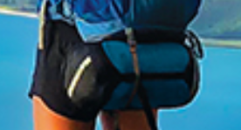
(Can you remove the white stripe on the bag)
Page 2
Capitalise the P in petrel = Petrel
Link the facebook address
Put a space between the i and LEARN MORE

Change September picture from the little girl to:
