Page 1
Did you change the font on ‘MAKE A DIFFERENCE’ please change back to the previous font and make the ‘MAKE A DIFFERENCE’ text bigger maybe 1-2 sizes
Please make LORD HOWE ISLAND bigger and in the previous font as well
Move 2019 from the row above down to make it Protecting Paradise 2019 instead
Please move the 2nd paragraph of text:
Join our LHI CONSERVATION VOLUNTEERS (make LHI CONSERVATION VOLUNTEERS - Yellow) program in 2019 and be involved in a world class, award winning holistic conservation effort – Protecting Paradise.
Up to look like this, and move the logo up also.
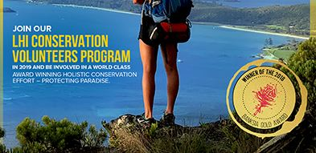

Change the quote to:


Increase WHITE text size on the first page by 2 sizes if possible
Centre web address and increase size

Page 2

Delete:
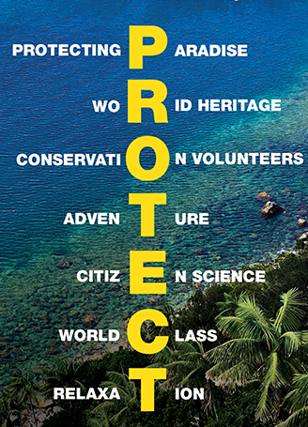

Make the text and images as big as possible in the space.
Zoom out slightly on the July and September pictures so we can see what they are better.
Change top 3 months (MAY, JUNE, JULY) text to the following configuration (2 paragraphs to match the other 2 months):
BIRDS OF LORD HOWE ISLAND – MAY 2019
Showcasing Lord Howe Island’s incredible bird species.
Experience the amazing phenomena of ‘calling’ wild seabirds down from the sky as you assist in research into the life of rare seabirds.

LORD HOWE ISLAND’S MARINE ENVIRONMENT – JUNE 2019
Our seabirds are being impacted by ocean plastic debris.
Help survey Lord Howe Island’s diverse intertidal ecosystems and provide valuable data to help understand the issue and support solutions.

INVASIVE SPECIES – JULY 2019
Invasive weeds are identified as one of the most serious threats to Lord Howe Island’s biodiversity and world heritage values.
Hike to remote and settlement locations and assist in weed removal with our experts, whilst learning about our world class Weed Eradication Program

Change August 2019
To Amazing Invertebrates (it is currently missing an s)

Now that we have the buttons, we can remove the text ‘For more details visit www.lordhoweisland.info’

Chang the ‘FOR MORE INFORMATION BUTTON’ to a ‘LEARN MORE’ button maybe with an i symbol like below


Make the edges of both buttons rounded.

