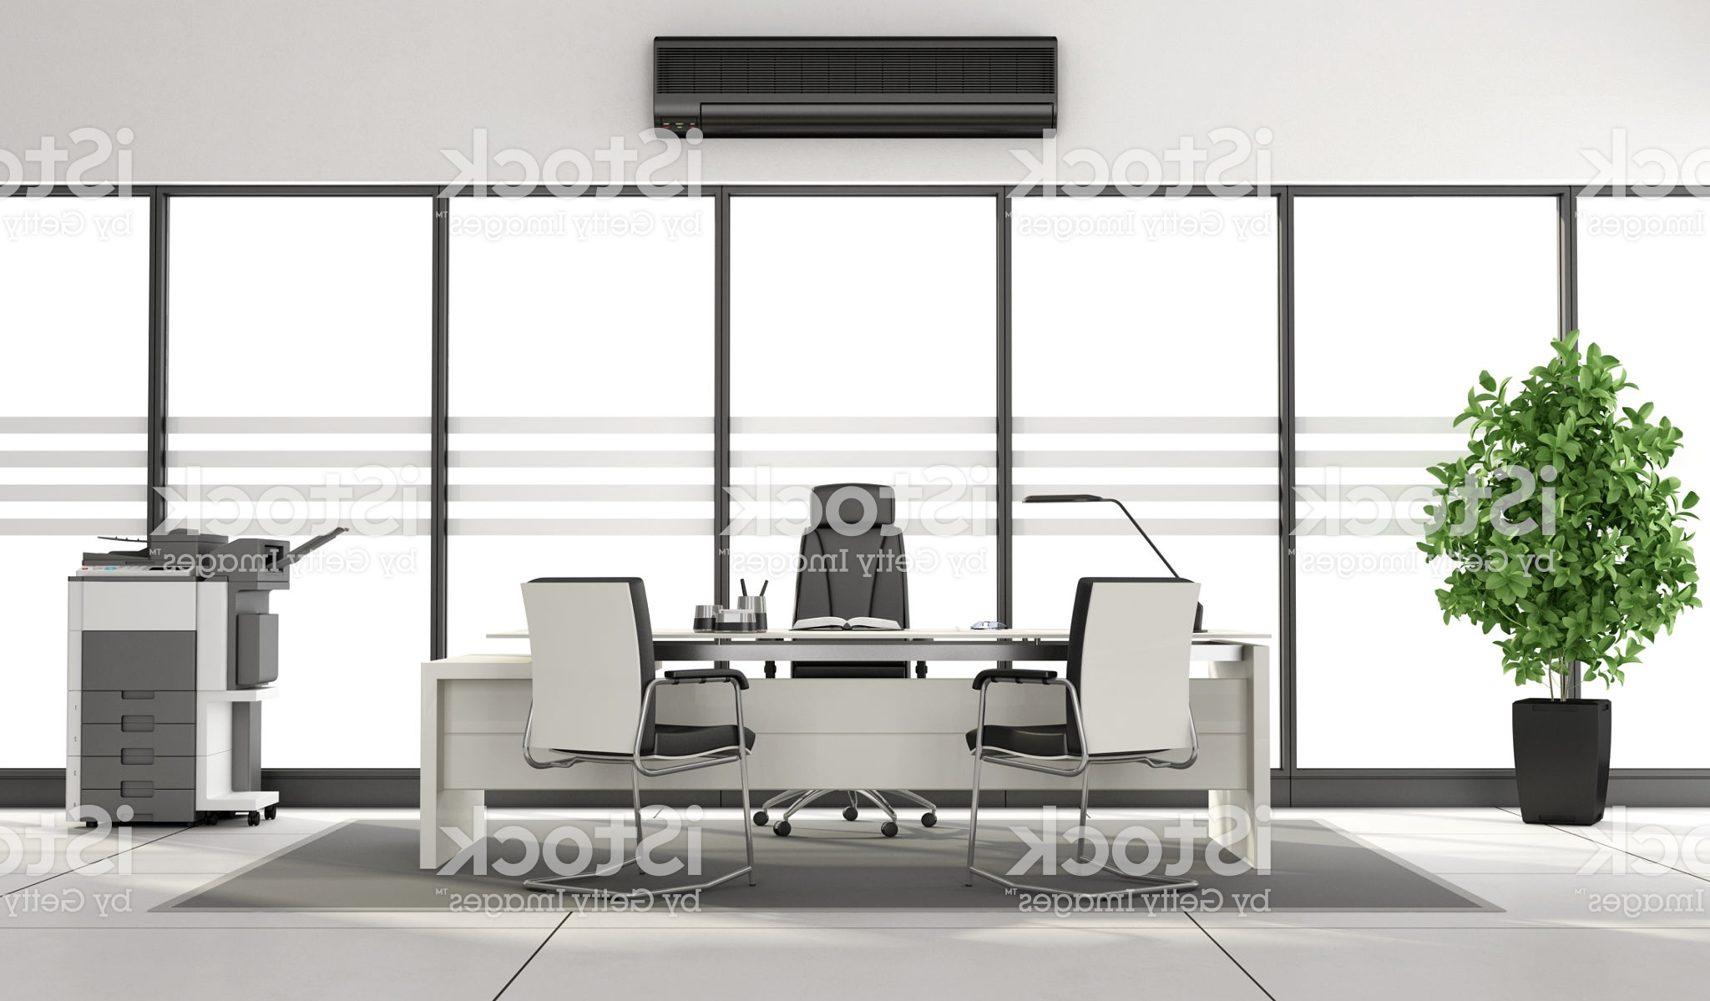

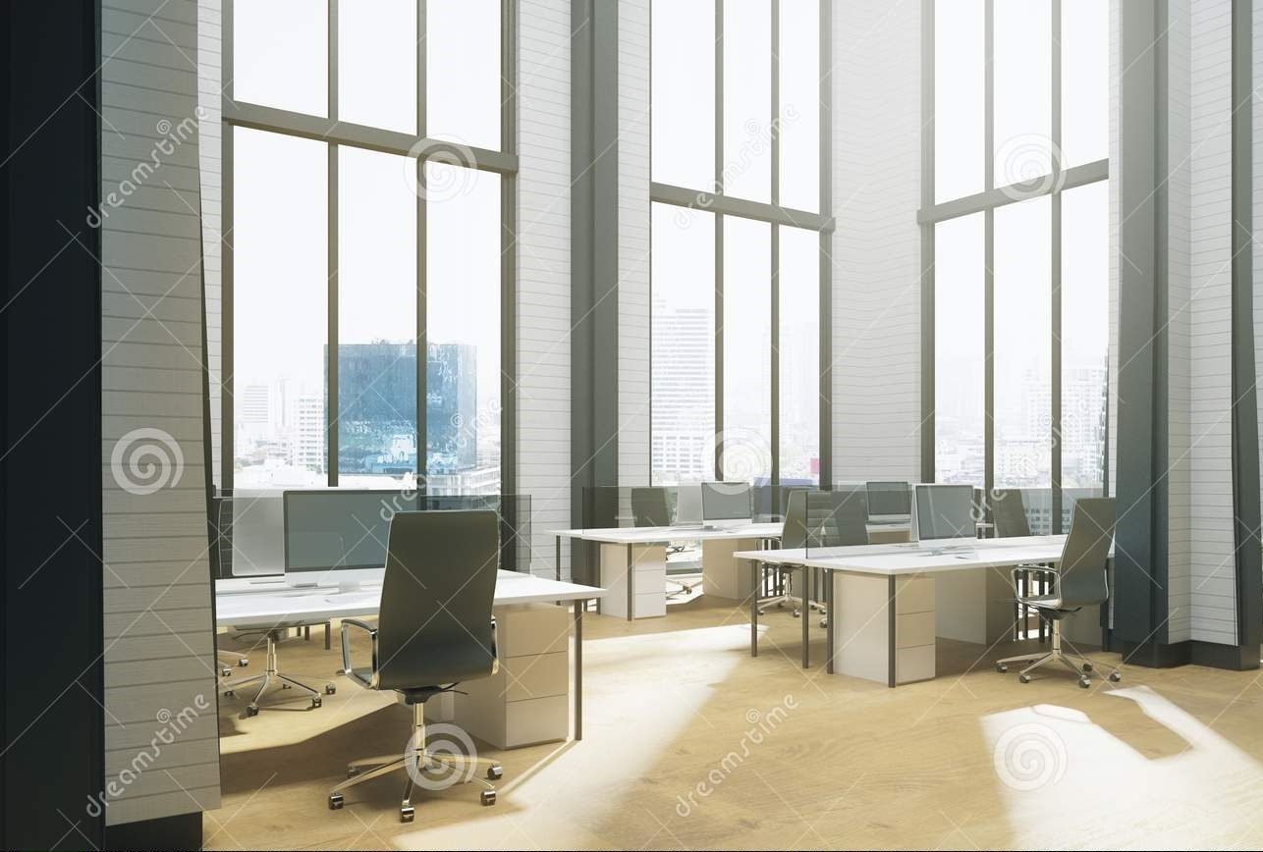

Freestanding A3/A4 Colour Printer
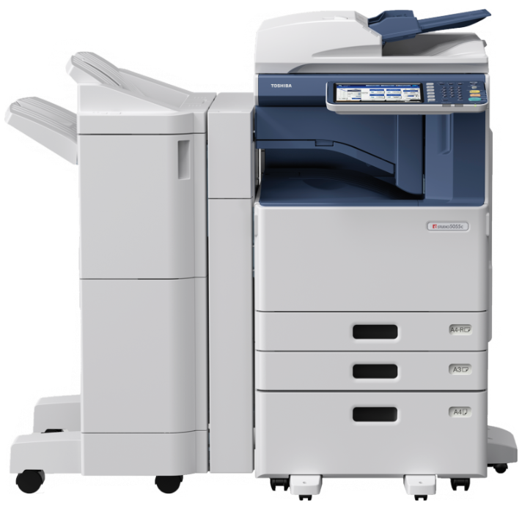
Includes All Toner& Service

Change plans to suit your needs

NO LOCK-IN

CONTRACTS

Small Business Plan

150
$
Discounted Colour Plan

Medium Business Plan

280
+GST
Per Month

Includes printer & 3000 B&W pages p/m
Excess B&W pages are 5c +GST and colour pages are 9c +GST
210
$
+GST
Per Month

+GST
Per Month

$
Includes printer & 4000 colour pages p/m
Excess colour pages are 7c +GST
Discounts for high volume users
Includes printer & 6000 B&W pages p/m.
Excess B&W pages are 3.5c +GST and colour pages are 9c +GST

$
5
That’s only
Less then
.50
$
9
+GST
per day

That’s just
7
$
+GST
per day

+GST
per day

Call 1800 63 63 44 or visit www.freeleasecopiers.com.au and quote Melboure B2B


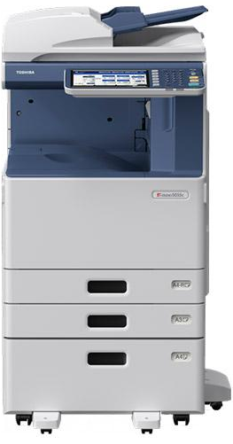
construction sites, contact us for more information

Other plans available for TV & movie production companies, schools &

No Lock-in Contracts
Fax, Hole Punch & Stapler options
A3 Printing & Scanning
All this from as little as $5 a day
Call 1800 63 63 44 or visit www.freeleasecopiers.com.au and quote Melboure B2B

Free Network Assistance
Booklet making

