FundsMX Logo Design Brief

1.0 ABOUT THE BUSINESS

Backgound
FundsMX has started a new business with the dawn of security tokens in the financial services industry.
Security Tokens – the future of Capital

We are at the dawn of a financial services revolution, and Security Tokens with regulated secondary markets are the vehicle that will literally transform the securities and wealth management industry. For the first time in human history any asset type -- from real estate, paintings, to private equity and sovereign wealth funds -- can be
offered globally as digital assets to investors in a highly secure, immutable, and decentralized trusted ecosystem. These tokenized, regulated investment assets are the foundation of the service options available on FundsMX.

What is FundsMX?
FundsMX is a digital asset marketplace and administration service for fund managers to launch and distribute Security Token based investment funds, private companies to source new capital, and stakeholders to securely invest in a new class of asset backed, regulated digital assets.

FundsMX offers the following core digital asset administration services:

- dEQ: Security Token Primary Issuance for Private Companies
- dSMA: Separately Managed Accounts for Digital Asset Model Portfolios
- dFund: Decentralized Investment Funds

FundsMX MarketPlace - Overview

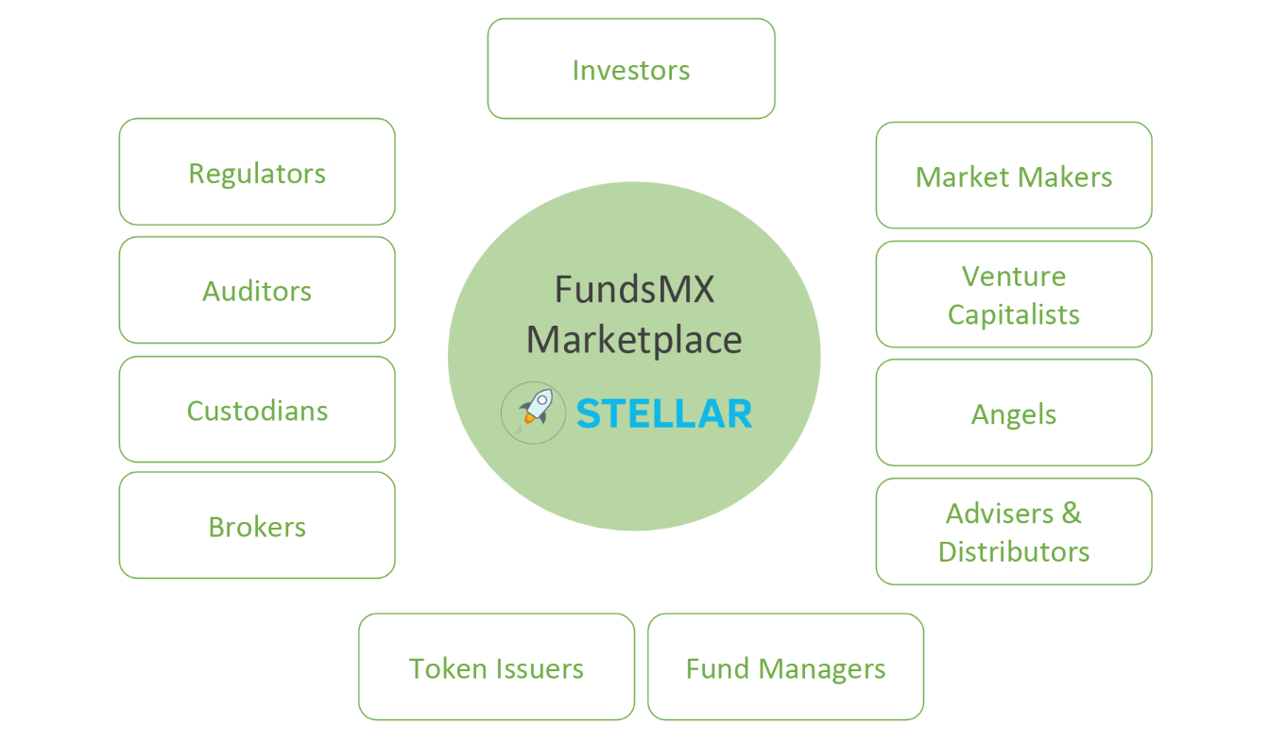

2.0 LOGO NAME TO BE USED

FundsMX

NB. There is no tag line
NB2. Can use symbols of an exchange in the X

  - Audience
Fund Managers, Private Companies
Investors
Venture Capitalists
Angels
Advisors & Distributors
Etc (see map above)

>> core audience are specialist investors
>> people with experience in cryptocurrency/blockchain investment technology
>> investors who have a high disposable income

4.0 Competitors

Polymath - https://polymath.network/
Swarm - https://swarm.fund/
Tzero - https://www.tzero.com/
Securitize - https://www.securitize.io/

5.0 Unique Selling Points, Values and Positioning

FundsMX is a business that is one of the pioneers financial service industry to harness the security token based technology, that is regulated and provides a vehicle for the wealth management industry to make investments that are highly secure, immutable, and through a decentralized trusted ecosystem.

Their core goal: Want to be known as the No. 1 - Asia security token issuance platform

>> what differentiates FundsMX is they not only offer security token issuance services for private companies raising capital, FundsMX are pioneering a new breed of mutual fund structure that is based on security tokens which will allow fund managers globally to cost effectively and efficiently launch new funds for their investors which immediately have a secondary market >> this is the future of ETFs.

FundsMX needs to be seen as/what values they have:
- A leader in the crypto-currency / financial services industry, a pioneer
- Highly professional, and a trustworthy platform
- Modern, the leading edge
- Reliable, secure
- Excellent customer service
- A regulated financial services entity which administrates Digital Assets, not a “crypto company”.

5.0 Colours, Font and Symbology

Colours: Blue, Green and/or Orange, White
(Research ref - https://www.prosperitycoaching.biz/a-psycology-of-color-and-your-brand/)

- Select a good shade of the colours above, like Tzero and polymath

Font: Modern, sophisticated, simple to read, no frills/clefs. We like the polymath and swarm font. Want the feeling/professionalism as the polymath logo

Symbology: A few options to try
- Can highlight/put focus on the the “X” from the FundsMX words, to give symbols of the financial exchange (highlight x, or enlarge, show movement) i.e. think about money moving, buying/selling, trading etc (try not to use arrows though)

- Can add a separate financial exchange symbology somehow – open to the designer i.e. in backgound, part of the letters, above or on side of logo – open to options)

- Can try combining the X to symbolize the exchange and a key (from the security token concept)

Ultimately, we prefer a professional clean, modern and sleek logo, with subtle symbology.

