Triple A Technology
Description: Blockchain solutions provider
Mission: Solving problems that matter
Vision: Create a collaborative environment for all organisation
About Us
Why Triple A?
Triple A Technology is a technology enabler that pledges to tackle issues that have plagued organisations for years. The company is lead by a team with tremendous expertise in the field of blockchain, mobile, IT, payment and financial sector. Being a global team, the company has influence in Singapore, China , France and more.
What can Triple A do?
Currently, Triple A is solving business problems using blockchain technology. If you have an issue that you would like to enquire, we would love to hear from you!
How can Triple A help?
Triple A technology leverages on the most advanced blockchain technology that might not be available a few years ago. If you are not sure if we can help you, you can contact us here!

A-loyalty
Tagline: Intuitive partnership solution
Problem
The value of loyalty points and programs are degraded.
In this day and age, majority of the businesses are offering loyalty programs to bring in returning customers. As collection of loyalty points become more and more common, there is no doubt that customers are starting to question the value of such points. In many cases, the rewards are either unattainable or limited within existing products in the store.
In a FORBES article, it is implied that the value of loyalty point is being questioned, with miles hard to accrue and exchange for rewards.
A quote from FORBES talking about loyalty programs:
“With the Citibank Thank You rewards program, you'll need 8000 points to receive a $50 rewards check. At this rate, your points are only worth $0.006.”

- Long earn-to-redeem rate
Small amount of loyalty point is relatively useless
- Slow integration
Process of seeking partnerships and reconciliation can take from weeks to even months
- Limited within sector
Point system is only usable between agreed partners that are usually in the same industry
- Lack of transparency
40% of all participating customers have the opinion that loyalty programs are rigged
“A nationwide survey of 1,500 U.S. consumers conducted by COLLOQUY during the third week of October shows that 59% say customer reward programs are not rigged, while 41% say that points, miles and cash back programs are rigged.”
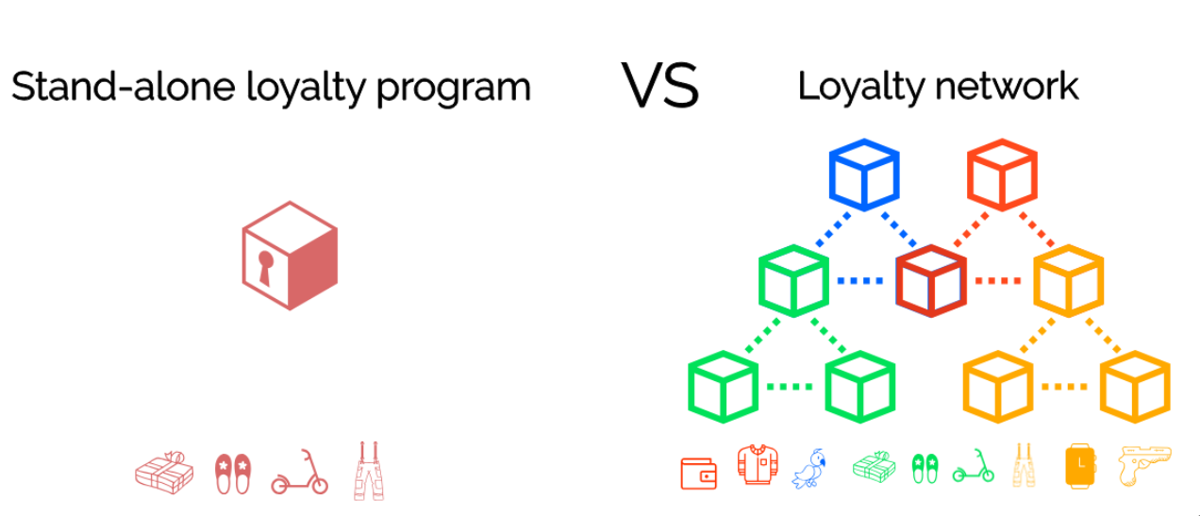
Difference between traditional loyalty programs in the current market vs our proposed idea

Why retention?
Retaining customers is less expensive than acquiring new ones. Not only do loyal customers ensure sales, but they are also more likely to purchase ancillary, high-margin supplemental products and services.
What is A-loyalty?
TripleA connects partners via A-loyalty to provide your loyalty points with more capabilities and brings unlimited cross-sector potential to your customers
Benefits:
- Limitless : Not affected by the amount of partners on the network
- Speed : Real-time settlement
- Transparent : Transactions can be viewed by anyone
- Cost : Eliminating manual efforts required for business partnerships
- Access : Available 24/7
Powered by blockchain
Powered by the most advanced blockchain technology, A-loyalty brings scalability, security and interoperability across different independent networks.

Companies can also increase business efficiencies using our compliance solution : A-KYC (Link to A-KYC tab)

Building an ecosystem of self-growth
In a traditional setting, most of the innovation and creativity stems from within an organisation. Based on blockchain, a single entity can now leverage on multiple sources to not only grow as an independent organisation, but also to become interdependent and mutually beneficial.

Example of usage

- Jane is a new Singtel account holder with 1 loyalty point.
- Jane wants to redeem a reward.
- All singtel rewards require a minimum of 20 loyalty points.
- Using A-loyalty, Jane is able to redeem for other rewards offered by other brands
- Jane redeems a reward with 1 loyalty point.

A-KYC
Tagline: Own your identity

What is KYC?
KYC , or “Know Your Customer”, is a process of verifying the identity of account holders, either before or during the time where business done.

Problem

Regulators around the world require banks to vet customers so that criminals cannot mask their identity through complex company and ownership structures to launder money or sidestep international sanctions.However, this is not an easy task, as sensitive customer data is being dealt, and the process requires tremendous manpower effort.
Also see: Deutsche Bank struggling to clean up money laundering problems

“What the documents show is that our internal processes are still too complicated,” it said. “So it is not about effectiveness, but about the efficiency of our processes.”
-Deutsche Bank Representative

- Friction

Average days for a bank to bring in new account : 24 days
- Heavy costs
Costs from manpower and compliance needed for KYC process results in 15-20% of total operational cost
- Different verification requirements
Credentials needed are fragmented in their own organisation and what is required can vary from country to country, businesses to businesses.
- Updating credentials
Keeping the credentials up-to-date can be both time and energy consuming for all parties involved
There is too much effort and cost needed.

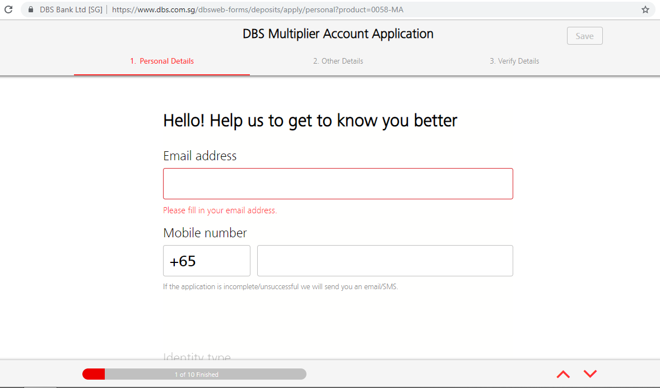
10 page bank account registration
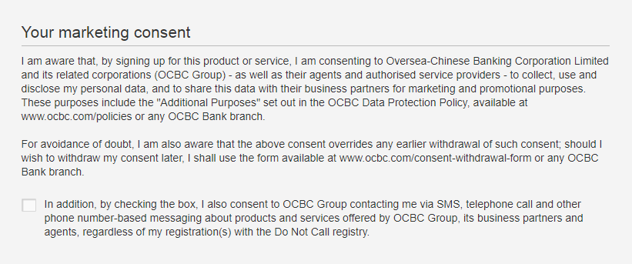
Retain full control and not forced to share personal data

What is A-KYC?

A-KYC is a compliance solution that facilitates real-time credential settlement in KYC processes. Account holders will be able to breeze through the typical sign-up procedures while not compromising security, achieving absolute control over one’s own personal data.

What is A-KYC supported by?

The three supporting pillars of A-KYC are:

Virtual Identity (VID)
VIDs can be created by an account holder and each VID is paired with specific credentials

Digital signature
A digital signature from an authority shows that the particular credential is verified

Distributed ledger technology (DLT)
An untamperable digital record that stores transaction.

Benefits of A-KYC
Save costs: Manpower and compliance cost reduced by 30%
Save time: No more unnecessary visits or waiting time
Reduced effort: Effort required from activities such as filing up of documents is eliminated
Secure: A physical KYC document goes through 6 officers on average.There is no need for that on A-KYC.
Easy integration: A-KYC can be easily integrated into existing technology such as QR codes for faster registration of accounts

Use cases

Bringing a positive change to business processes
In a highly digitized world, customers’ attention span are growing shorter and shorter. However, business processes such as KYC and onboarding of business partners still require manual filing, physical presence and even repeated visits.
It is time we change that.

Full ownership
No more centralized storage and databases.
We are giving you the ownership and full control of your own data. Total transparency, full disclosure. Together, we can change how personal information is being shared.

Benefits for:

Banks & Institutions
Streamlining KYC business process, eliminating need for manpower and lowering overall business costs

Businesses & Corporations
Empower cross-sector partnerships, increasing customer acquisition and retention rates. Zero downtime during integration of new partners.

Account holders/customers
Real-time transactions from both signing up (KYC) and redemption of points portrays transparency and security; brings peace of mind and confidence with engaged companies.
No more queuing to register with your favourite store!

Examples of usage

Opening of account

- Jacks wants to buy a beer on E-commerce website
- He select his products and add the product in shopping cart.
- While checking out, the website require him to register
- By scanning a QR-Code provided by the website using his mobile, those information are automatically provided to the website.
- An account is registered for Jack with the beer purchase order sent.

Sharing of data

- Annie wants to open a bank account.
- The banks requires a proof of address in the form of an invoice from an utilities service provider, but Annie has just moved in and she has not yet received any invoice.
- She scans a QR-Code in the bank with her mobile phone, and the bank receives her address certified by Annie's Internet Provider.

Authentication of data
- Mark wants to buy alcohol at a convenience stall
- The stall keeper asks for his identification to verify if he is of appropriate age.
- Mark scan the QR code available on the counter and the merchant receives a certification from the government that Mark is older than 21 years old.

(The only information that the stall keeper obtained is that Mark is above 21 years old)

Sample blog

With autonomous doors, car , drones and even delivery being very a real possibility (if not already) in the future, everything is sure becoming more and more accessible and convenient. However, not all is sunshine and rainbow. Apart from requiring less and less energy for every automated act which makes humans more and more lazy, people tend to forget one of the biggest drawbacks of having everything fast and on-demand : attention span.

One of the most evident sign of a decrease in attention span of people is when people have to constantly do things. No matter if it is queuing up in a bank or saving up to redeem for a better prize, people prefer instantaneous gratification. Need to fill in a form? Nope. Need to register for a program? Nope.

In banks, the most deadly ‘account-killer’ is a KYC (Know Your Customer) form. Among 100 customers, 25 would leave if they have to fill up a form, and within the remaining 75, 20 of them would change banks if they had to do a resubmission or update of their credentials in the KYC form.

In such situation, if any bank could offer some kind of solution that could enable a customer to sign up immediately without compromising security, people would flock there. Or is there?
Triple A’s A-KYC enables the streamlining of KYC process. Learn more here:

