DESIGNCROWD LIDARUSA TRADE BOOTH DESIGN DIRECTIONS

I have attached multiple photos for photo content. I would like for the top of the 10ft x 10ft trade booth design to say “Revolutionize Your Business” , We’d like our LiDARUSA logo with Fagerman Technologies underneath to be placed on the right vertically, along with anywhere else that may look nice.

The background can be whatever looks best, although we do like a background from before where it’s our mayan temple with a red transparent overlay. All of the images made of points are POINT CLOUD PHOTOS that could make for a cool background with editing.

We have a specific system we want on the booth design called a “REVOLUTION 120”. We’d like for the Revolution 120 to be displayed right below center positioning. Along with the photo of a Revolution 120 we’d also like 3 smaller photos below that can be created with graphic design. 3 little squares below that show:
1st square: graphic design of close up on points (like a close up of POINT CLOUDS) along with the words “200+ Points Per Square Meter” below.

2nd square: graphic design of letters “AGL” along with the words “100 M – 120 M AGL” below.

3rd square: graphic design of a clock with the words “100 Acres One Flight”.

We also like the words “On Sale Now” if there’s room around the Revolution 120 photo and word content to show that it’s for the Revolution 120.

Examples of systems:
Revolution 120: Below is the Revolution 120 system. You can tell it’s a revolution because it’s a BLACK laser head. 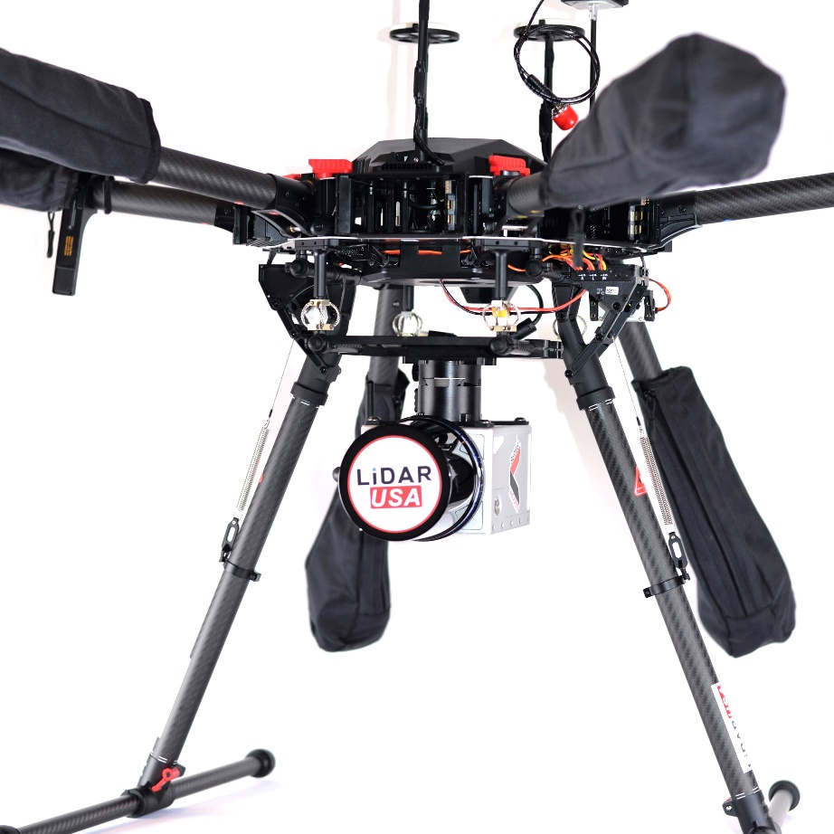

Point Clouds: Example….Mayan temple point clouds. Any photo that has points like this is a point cloud photo.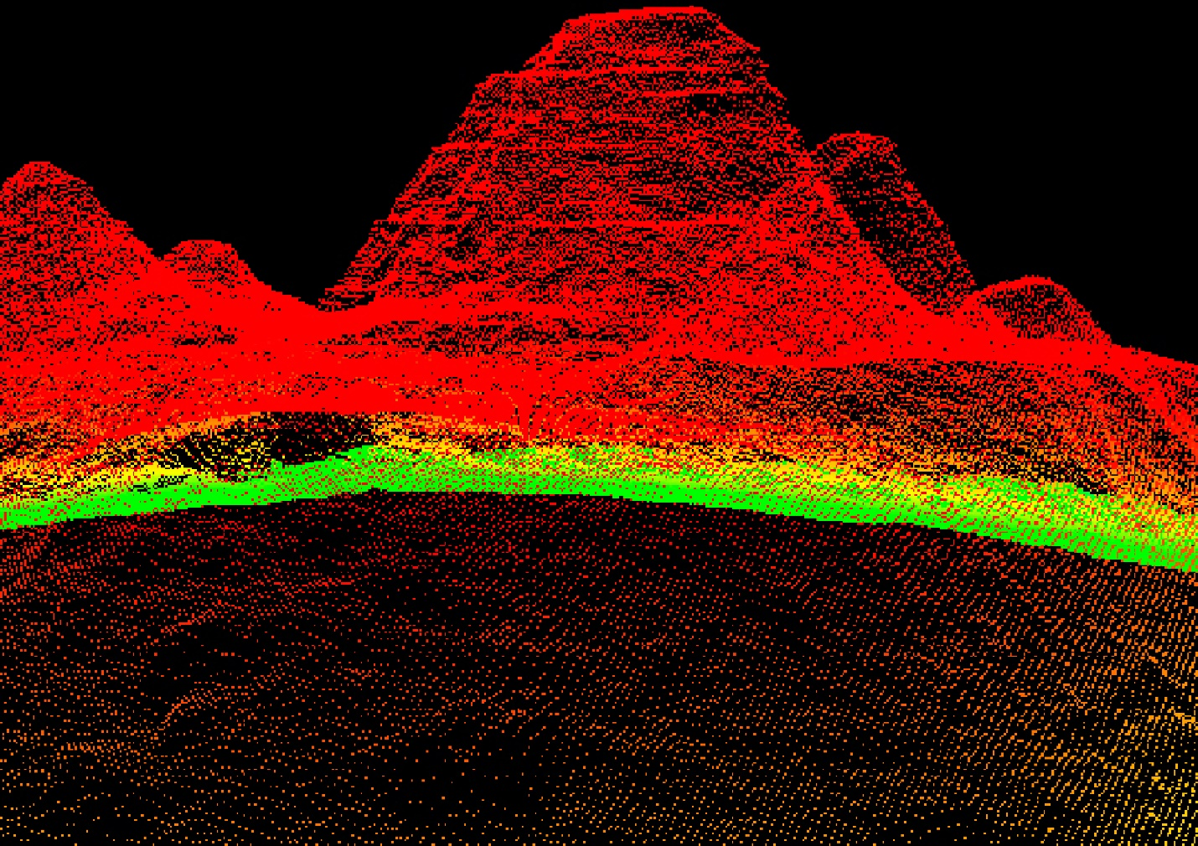

Correct Logo: This is the correct logo to use. 

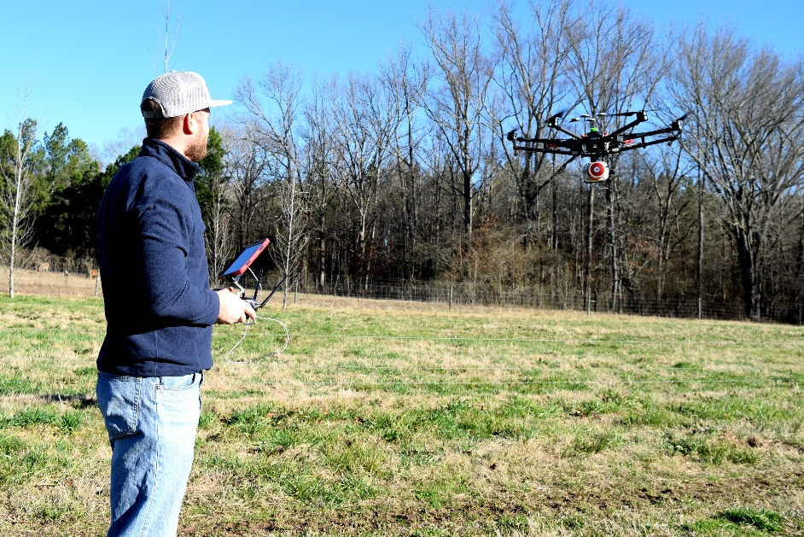
SPECIAL PHOTO INSTRUCTIONS: FOR BOTH PHOTOS BELOW… Please use these to crop, place and use either the top or bottom system. These are our systems on UAVs.

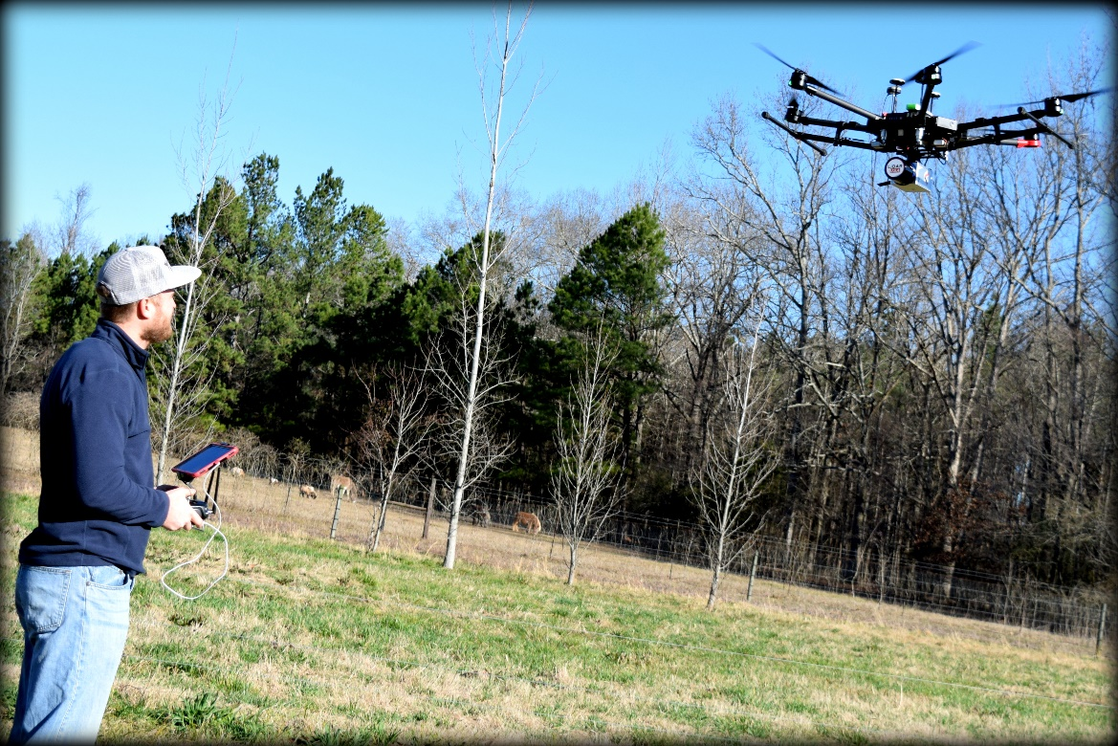

If you have any questions, please ask.

