At••

“Watch This First”
Click Here
Watch Now!
Your email
Your First Name

How a New Discovery
Sells More Wedding Cakes
and at Higher Prices!

Sales Solutions
Individual Sales Tools
Bundles Sales Presentations
Advanced Insider Bulletin
Write a Wedding Cake Book
Analyze Your Sales System

Our research is not just a game changer. It is the game changer. We’re rewriting the book for selling wedding cakes

I’m Ready to Dominate My Market Area…
I’m Eager to Boost My Sales and Profits…
I Want to Maintain My Sales…
I’m New to Selling Wedding Cakes…
- Click Here -

- Click Here -

- Click Here -

- Click Here -

Discover a sales growth secret that reveals the “Two Faces of Your Wedding Cake Business.”

Peek at a very effective psychological sales riddle called “The Insecurity Gap.”
Become the “World’s Greatest.” You’ll have an atmosphere so special, brides won’t think of using anyone but you!



More…

More…

More…

Use Cutting-edge Methods Proven to Generate MORE Leads,
Convince MORE Brides to Choose You, Get HIGHER Prices
and DOMINATE Your Competition.

Our breakthrough marketing and sales methods are possible due to the long-term
research studies we’ve conducted with 150, 000 brides over the past 12 years.

From the findings, we have developed new and revolutionary marketing strategies,
sales tools, and a complete transformational wedding cake sales system.

But, don’t take my word for it…let me “prove” the value and impact they will have
on your wedding cake business.

Enter Your Name and Email Address Below.

Each month you’ll receive our “Advanced Wedding Cake Marketing Advisory.” It’s normally available for a
$397 subscription fee. You’ll receive the first year… absolutely FREE.


Join our “Insider Advisory” for FREE.” You’ll receive the latest
research secrets while learning how to use psychology for gaining
a decisive advantage to market and sell your wedding cakes.

CLICK TO JOIN!
Your email…
Your First Name…
We dislike spam as much as you do. Therefore, we’ll never sell, rent, or give away your email address.

3333

Recent Blog Posts
Hire Us
Coaching
Consulting
Speaking
3-Day Workshops

Partner With Us
Spread the Word

Marketing Solutions
Cracking the Secret Code Course
Individual Marketing Videos
Bundled Marketing Videos
Gold Standard Baker
Advertise For Free
Analyze Your Marketing
Master Hierarchy Training

HOME ED’S STORY MARKETING SOLUTIONS SALES SOLUTIONS HIRE US CONTACT MEMBER LOGIN PARTNER WITH US BLOG

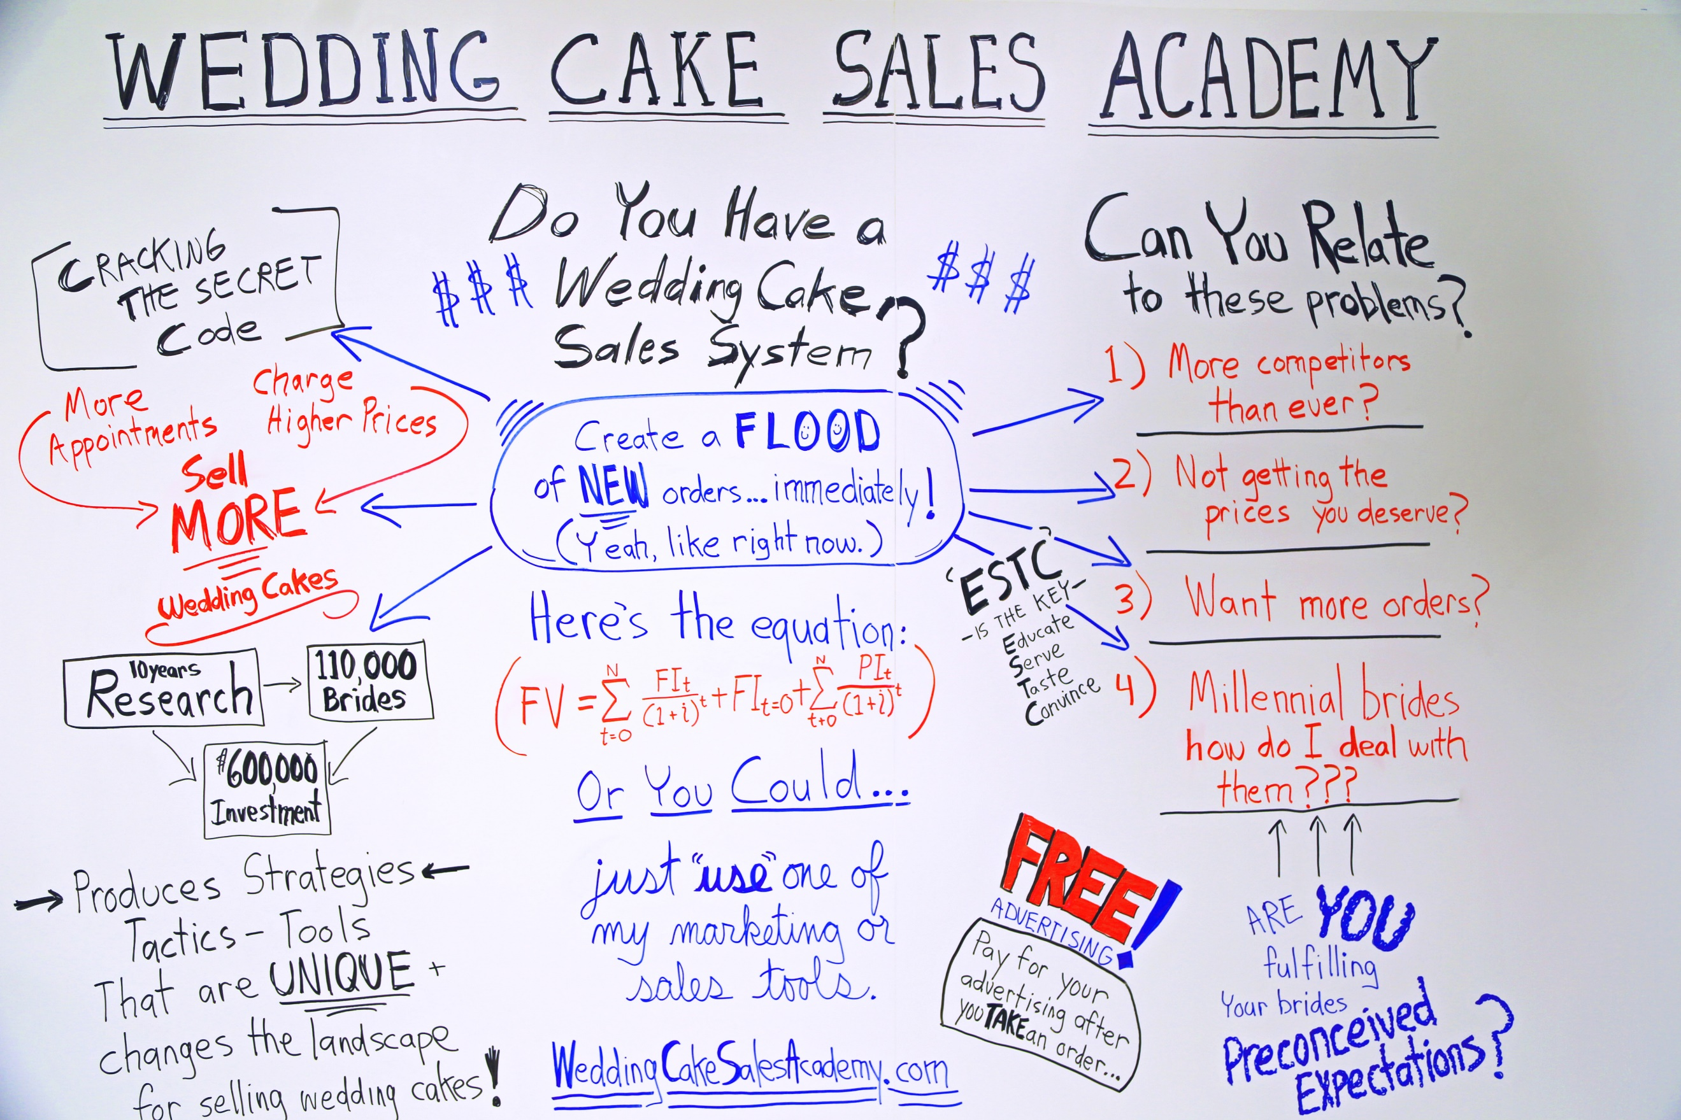

ED OTTO
AS SEEN ON








