

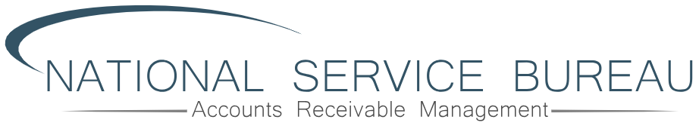
Mission Statement
Our Mission is Simple
We are, in every aspect, a service organization
It is always our mission, and out duty, to serve and protect our clients
Our Goal is Clear
Our goal is to deliver on each client’s definition of the ideal agency relationship – every single day
NSF is a service business whose entire focus is on long-term relationship building, by exceeding goals and expectations of our clients every single day.

The NSF Difference
An Empathy-Based and Consultive Approach. Our success in the recovery of debt stems from our strong dedication to honest and ethical collections. We treat everybody and all associates with dignity and respect. Embracing an empathy pace. Cooperative approach to resolving outstanding our overdue balances.

Our Affiiliations
ACA International

WCA Washington Collectors Association
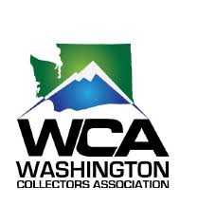
HFMA

AMBA American Billing Association
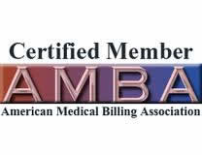
RMA International
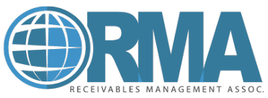
Executive Summary
National Service Bureau (NSB) is a national debt recovery agency found in 1986 and based in Seattle, Washington. We specialize in managing delinquent account receivables and we provide a range of collection services to help your business collect on past due accounts. Our goal is to proactiviley manage receivables to minimize risk by executing strategic and operational plans designed to assist our partners achieve financial expectations and stability.

Key Components
- Providing superior client service includes our “Positive Collections” approach
- Our conversations are based on non-confrontation approach built on coopertaiton
- Full compliance of all debt collection related laws
Shared Vision
- Outstanding customer relations
- It’s out job to increase revenue
- NSB defines a quality partnership by total value we provide our clients

Outstanding Consumer Relations

Responsive Client Services

Communications and Reporting

Complete Compliance

Highly Effective Data Security


Leadership
Key Personnel
David Coneyers
Online Access 24/7/365
We believe in total transparency as a fundamental element or a true quality partnership. We give our clients online access to their accounts 24/7/365.


Accountability
No matter how could we are – we believe that it is always room for improvement
We have developed a propority system of organizational self-appraisal under categories such as
- Client Satisfaction
- Use of resources
- Consumer satisfaction
- Complaint Prevention
- Competitive Performance
- Employee moral
Service Capabilities
- Collection Training and Seminars
- Payment Monitoring
- Free Online Collection Account Access
- Credit Bureau Reporting
- Electronic Payment Solutions
- Skip Tracing Services
- Automated On-line Payment Reporting
- Friendly Reminder Notices
- All credit cards accepted


Leadership
Key Personnel
David Conyers
Chief Executive Office
Dave founded NSB in 1986 and remains involved in the day to day operations at NSB. As CEO his primary responsibility his the high- level strategic operations for the company. As a hands-on leader, he is equally at home working directly with employees to foster excellence throughout the entire company. Through Dave’s leadership NSF has grown from a small, local collection agency to a company with a sound reputation and clients throughout the U.S.
David Conyers II
Chief Financial Offier
David NSB in 2009. He is directly resposbilile for NSB’s finance and compliance. Among his responsibilities, he oversees bookkeeping and trust account reconciliation, analyzes credit statistics capital structure, and other financial information.
David bgain his career in finance in 2005 with JP Morgan n Chase Securities in New York as in investment banking analayst. In 2006 he joined Société General Asset Management as a Hedge Fund Analyst in Distressed Credit Strategies. He hold’s a bachelor of ARTS degree in Economics from Williams College in Williamstown, MA.
Brandon Lee Conyers
Brandon joined NSB in 2002 first as a collector and then as a sales represented. He was promoted to his current role in 2006 where he oversees all collections activity. Brandon responsibilities include: recruiting, training, and managing all collection associations/
Brandon also manages all hardware, software, and outbound call functions. He builds and manages account flow procedures within collection software as well as audits collection files. In addition, he listens to call recordings with collection representatives to ensure quality and compliance.
Sarah Davis
Sarah joined NSB in 2018 bringing over 20 years of management and executive experience in service-based industries; Sarah holds a Bachelor of Arts in Business Administration from Gonzaga University of Spokane, Washington.
Sarah is responsible for ensuring the integration of key initiatives company wide. Including those for administration, client services, sales, marketing, recruiting, retention, and compliance. She is respomsible for process improvement and proactively develops systems designed to maximize business efficiency.
Stephanie Clifton
Stehanie joined NSF in 1998 and has been instrumental in the growth and development of the company. Stephanine works directly with clients to answer day-to-day questions about accounts. Including providing statements, connectivity, with our client site, and information about specific accounts.
Stephanie oversees all administrative functions of the company for client’s services. She is also able to initiate requests for customized reporting or other special projects

Core Values
Follow Through

Be Engaged
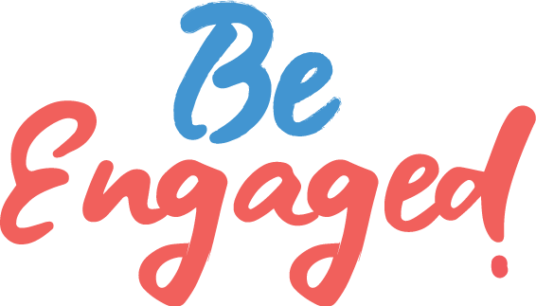
Think First

Be Respectful

Be Accountable
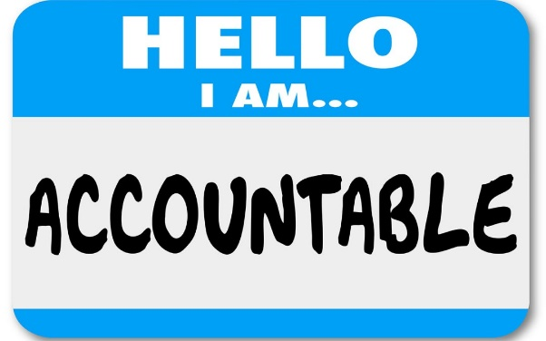

The NSB Difference
Quality and Excellence
Once again, we hope that you will give us the opportunity to work with you to tailor a program that will enable us to deliver on your definisition of the ideal agency partnership.
Our pledge is to work shoulder-shoulder with you to build the agency relationship that you want.
That is what defines who we are as an organization
That is the NSB Differences
Your Receivables Management Partner
(800) 798-1674
18912 North Creek Parkway Suite 205 Bothell, WA nsbi.net

