hugh rochester
  - Address: 35 Urunga Parade, West Wollongong, NSW 2529
  - Mobile: 0452 418 100 | Email: ioannoum01@dow.catholic.edu.au

  - 8 November 2017
Attention: Jane Edwards
St Mary’s College

Dear Jane
RE: Religious Education Teacher
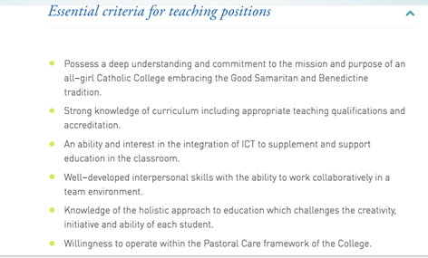

I write to apply for the Administrator role within your Finance Department and I attach my CV as evidence of my suitability for this position.
I am excited by this opportunity to join a dynamic and growing organisation within the health and wellness industry and, in accordance with your requirements, I offer the following skills and attributes:
- Strong Administration Background: I have 20 years of experience within business administration, customer service and finance roles and proven success in driving quality and efficiency and administration and reporting activity and delivering continuous improvement in financial performance through effective credit control and debt recovery.
- Excellent Numerical Skills with High Attention to Detail: Working within the Insurance and Financial Services sectors I have worked with a range of databases and software systems, managing customer data with the highest standards of accuracy and ensuring the integrity and timeliness of payment transactions.
- IT Literate: I have worked extensively with MS Excel and the MS Office suite and have demonstrated aptitude for learning new IT systems with ease, having adapted to the implementation of new finance and customer relationship management (CRM) systems within various organisations.
- Exemplary Communication, Customer Service & Relationship Management: Working in call centre environments and fast-paced service-focused roles, with B2B and B2C clients, I have demonstrated exemplary communication skills to establish rapport, trust and credibility with internal and external customers; resolving disputes and negotiating repayments and settlements.
- Organisation & Planning: I have strong time management and prioritisation skills, working closely with colleagues to monitor and manage workflow effectively across the team.
I thank you in advance for your consideration of my application and I welcome the opportunity to demonstrate the value I can bring to your team.
Yours sincerely,
Emma Hoyland

