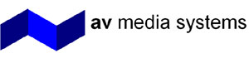

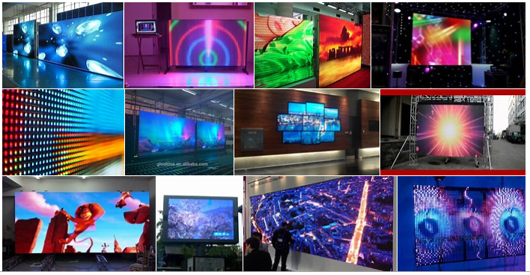

C.U.B.E. LED VIDEO WALL TECHNOLOGY GUIDE

WHAT YOU SHOULD CONSIDER?

1300 302 884
info@avsystems.com.au

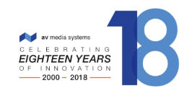
AV Media Systems has developed the C.U.B.E. LED Video Wall (exclusive to AV Media Systems). This is a reference guide on LED Technology and how AV Media Systems will work with you to select the LED display solution for your needs.
AV Media Systems will walk you through the journey of:
- Initial consultation
- Visual design
- Selecting the right product specifications to meet your outcomes
- Installation, design and implementation
- Training and after sales product service and support
LED display technology offers huge benefits in commercial applications due to the seamless and modular nature of the technology and its capability to operate in challenging environments.

No other display technology on the market has the ability to provide such superior quality, impact and scale more so than an LED Video Wall. AV Media Systems will work with you during the entire implementation process. We want you to be fully informed of the technical considerations, the implementation process including the financial investment and our customer service journey.

What Does An LED Display Solution Comprise Of?

In simple terms, a an LED Display solution consists of the following components:

- LED CONTROLLER

The LED controller accepts a video signal from a source device such as a PC or scaling switch and transmits this signal to each individual pixel on the LED display. Each LED video controller can manage a specific number of pixels and therefore it is common to have multiple LED controllers connected to a single LED display.

- LED TILE

LED panel
The LED panel consists of a number of red, green and blue LED’s mounted to a tile. The number of pixels on an LED panel varies significantly depending on pixel density and panel size. The video wall display is created by building a collection of LED panels.

Power supply
A power supply is required for each LED panel that makes up the full LED display. This supply can be remotely located in a comms room or incorporated into the chassis of the LED panel. It is essential that the power supply is of excellent quality to ensure longevity of the video wall.

Receiving card
This unit receives the video signal from the video wall controller and sends it to each individual pixel on the LED panel.
What Do I Need To Think About When Choosing A C.U.B.E LED Video Wall Display Solution?
CUSTOM DESIGNED FOR YOUR SPECIFIC REQUIREMENTS

We will work with you to ensure the content you want to display on your LED video wall is displayed at the highest resolution, brightness, picture size and pitch.
Your C.U.B.E. LED Video Wall will be custom designed to suit your specific environment it is being installed into.
There are a number of requirements that need to be considered and discussed during project planning to ensure that the best C.U.B.E. LED Video Wall solution is chosen and deployed.

DISPLAY CONTENT

Understanding the required content is essential to any successful LED Video Wall installation. This is especially important when considering what shape or aspect ratio the LED display should be.

Standard aspect ratios might not be as creative in physical design, but allow for simpler content creation.

When running multiple content sources through a video wall controller, content layouts and pre-sets should be coordinated during the Video Wall design to ensure the required content can be delivered onto the Video Wall.
Ideally, sample content should be created and provided for testing, or during the LED selection criteria.

SIZE

Industry guidelines apply to the overall screen size for LED solutions, as they do for other display technologies.

If an LED display is too small, it can be difficult to read detailed information. Too big, and it can be difficult to view all of the information in one single view.

Taking into account minimum viewing distances for pixel pitch as detailed below, AV Media Systems will recommend the most appropriate display size for your application:

Level of Detail | Example | Viewers distance from display
Fine Detail | Spreadsheet | 4 x Height of the Display
General | Presentation | 6 x Height of the Display
Video | Video | 8 x Height of the Display

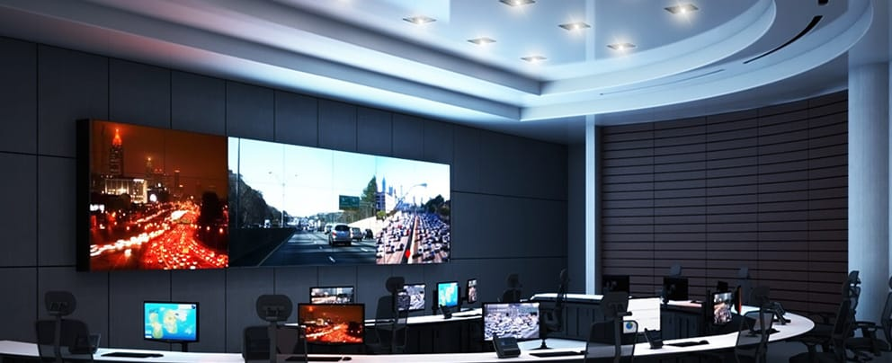
PIXEL PITCH
Pixel pitch refers to the distance between the centre of each individual pixel on the LED display.
As a rule of thumb, individual pixels are not clearly apparent from a distance of 1m for each mm of pixel pitch and this is one of the factors that should be taken into consideration when selecting the correct pitch for the environment. We will advise the ideal pixel pitch for your LED Video Wall solution.

Pixel Pitch (mm) | Closest typical viewer (m)
0.9 | 0.9
1.2 | 1.2
1.5 | 1.5
2 | 2
2.4 | 2.4
3 | 3

For presentation and data applications, it is recommended that the number of pixels in a display matches the resolution of the source material. This reduces the requirement for resolution scaling and mitigates the risk of detailed content problems, such as the grid lines on a spreadsheet not being visible.
In a standard meeting or presentation environment, we would typically aim for a display that natively fits HD (1920 x 1080), or UHD (3840 x 2160) resolutions. In this scenario, the pixel pitch will dictate the dimensions of the display.

Pixel Pitch (mm) | HD (mm) | UHD (mm)
0.9 | 1728 x 972 | 3456 x 1944
1.2 | 2304 x 1296 | 4608 x 2592
1.5 | 2880 x 1620 | 5760 x 3240
2 | 3840 x 2160 | 7680 x 4320
2.4 | 4608 x 2592 | 9216 x 5184
3 | 5760 x 3240 | 11520 x 6480

VIEWING ANGLES

The location of the video wall can have a significant effect on the quality of the image. Due primarily to the layered construction of the technology, viewing the image from extreme angles can result in colour or uniformity issues as individual pixels are obscured or blocked by the masking technology that provides contrast.
Care should always be taken to confirm that the technology chosen provides an optimal viewing angle, horizontally and vertically, for the final application.
We will recommend the best viewing angle possible matched to the screen size and pixel pitch.

REFRESH RATE

The refresh rate describes how many times each second the individual LED’s on a video wall illuminate to create the image. An illumination cycle for an LED pixel includes an electrical charge followed by a discharge. LED displays typically offer 2 options for refresh rate: 1920Hz or 3840Hz.
Choosing a display solution with the right refresh rate capability depends on the application.
Will the LED display be captured on camera such as in a broadcast presentation or conference?
For applications where the video display is not shown on camera, we would typically recommend a refresh rate of 1920Hz. This refresh rate allows the LED’s to fully discharge for longer between charge cycles, improving the contrast of the display. This configuration also provides the best longevity of the components due to the reduced stress over higher refresh rates.
The compromise of selecting 1920Hz refresh rate is the risk of moiré effect when the video wall is shown on camera. Moiré effect is a visual perception that occurs when viewing a set of lines or dots that is superimposed on another set of lines or dots, where the sets differ in relative size, angle, or spacing.
Configuring a video wall for 3840Hz mitigates the risk of moiré effect when captured on camera, but comes with the compromise of less contrast and more stress on the component compared to a display operating at 1920Hz.

BRIGHTNESS & LIGHTING

One of the major advantages of LED technology is the capability to operate at high luminance. This is especially valuable when the display is subject to direct sunlight such as in an open area or window.
An LED display is capable of up to 1000 NIT light output, which is beneficial when presenting content in an atrium, or to passers-by in an outdoor window display.
When configuring an LED display for use in a meeting or interior presentation space, we have to mitigate viewer fatigue. Best practice configuration ensures that the display would not output brightness of more than 3x the ambient light levels. In a typical indoor or meeting environment, this is typically circa 30-50% of the maximum brightness of the LED display.
If the display is likely to be captured on camera, we would typically set the brightness of the screen even lower, to reduce silhouetting any persons in front of the display.
As LED technology naturally loses light output capability over time, configuring for circa 30-50% brightness at initial deployment allows significant headroom to combat natural decay over the lifetime of the product.
When designing spaces that include LED technology, care should be taken to avoid direct light reflecting off the display and affecting colour and contrast.
INSTALLATION of your
C.U.B.E. LED Video Wall is where 18 years of AV Installation experience comes into play.

AV Media Systems custom design and manufacture mounting solutions that are visually appealing, unique and reliable. Mounting solutions for your C.U.B.E LED display include wall mount, ceiling mount (fly) and floor mount options.

Service accessibility is taken into consideration allowing for easy accessibility to your LED Display for servicing and cleaning .

MOUNTING REQUIREMENTS
LED video walls are built from many small tiles. A video wall can weigh hundreds of kilograms once built and the tolerances for uneven mounting structures are very small. Preparation and quality assurance for mounting the LED panels are key to a high quality final installation.
It is therefore essential that the supporting structure is both strong enough to support the full weight of the display and mounting hardware and constructed to tight tolerances.
Should a recessed mounting solution be preferred, manufacturer’s guidelines for heat dissipation requirements must be accounted for in the design of the video wall. This would include sufficient shadow gaps around the display or forced air convection from the rear if shadow gaps are not preferred.

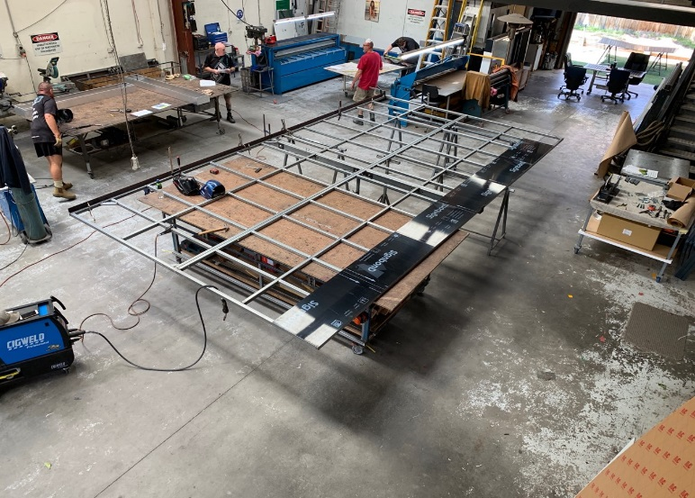

SERVICE ACCESS
Will there be access from the front or the rear of the video wall for servicing?
LED solutions are available in front, rear and dual service configurations.

AV Media Systems will advise the best service access solution depending on the physical mounting solution we recommend for your LED display.

POWER
LED display technology requires special consideration for power. The power requirement for each LED display depends on the size of the display, however an LED wall typically requires a number of outlets from a dedicated circuit.

HEAT
Consideration to heat management needs to be made when planning LED display technology deployments. The heat output varies significantly according to the size of the screen and the mounting solution.

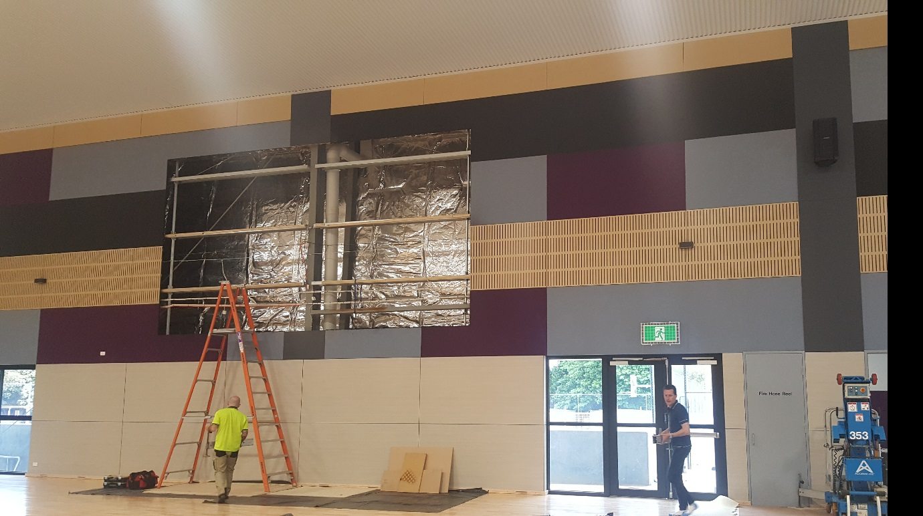
INSTALLATION ENVIRONMENT
OFFSITE TESTING

The C.U.B.E. LED video wall is run through intensive configuration and factory acceptance testing (FAT) prior to being dispatched from our factory.

Our factory testing of 72 hours of intense operation through a programme specifically designed to stress the components and identify and resolve any potential component weak-points.

Each LED panel is individually powered and run through a series of tests over 24 hours.

The LED panels are stressed at high brightness through red, green, blue, white and black colour cycles, designed to identify any weak components.

Component issues or failures are extremely minimal and are expected to be uncovered within the first 4 weeks of normal operation.

It is essential that the installation environment is suitable to support the successful deployment of an LED Video Wall.

AV Media Systems will work with you, your project stakeholders and your programme managers to ensure that the installation environment is clean and clear, dust free and safe prior to proceeding with the installation

DELIVERY TIMEFRAMES
Delivery of LED product is typically 10-12 weeks from point of order. This is due to the product being manufactured on order, and the shipping time required from our factory.
The standard shipping method for LED is by sea. Air freight is an option to shorten lead times if required within a shorter lead time.

CLEANING
Should the LED display require cleaning, specialist resources should be requested to carry out the required work. Although LED technology is very robust and durable, it can be damaged if it is handled incorrectly.
We will recommend a cleaning programme and provide an ongoing service solution for your LED Video Wall.

ACCEPTANCE CRITERIA
LED manufacturers offer varied tolerance for acceptable quantities of defective LED pixels in a display as standard.

AV Media Systems C.U.B.E. LED Video Wall offers you a pixel perfect display solution at time of sign off, and at completion of the bedding in support period, ensuring you are fully satisfied with your investment in your C.U.B.E. LED Display.

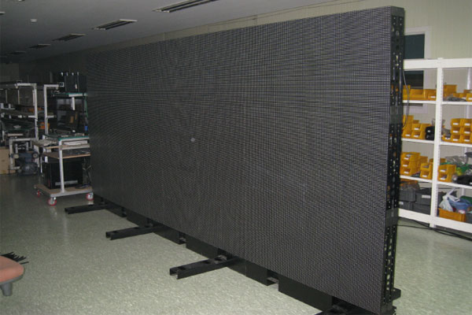

Ongoing Support
Your C.U.B.E. LED video wall is a large investment. Our experienced technicians will service and maintain your C.U.B.E. LED video wall. Our field technicians will troubleshoot, diagnose, replace, and repair (if necessary on your site), your LED display.
Our Commitment To You

We have installed and commissioned many LED Video Walls. This means that you benefit not only from our experience in LED Video Walls but also from our 18 years’ extensive knowledge and experience in very complex audio visual integrations that we have designed, installed and support.

Our integrity and commitment to quality, our materials and our commitment to our customers is why we have become the preferred audio visual partner to some of the largest state and national companies in Australia.

To discuss your requirement for a C.U.B.E. LED Video Wall in more detail, please contact us.

Our goal is to minimize your system down time and provide you with the peace of mind that comes with professional AV maintenance.

Our maintenance agreements on LED display technology will be tailored to your service requirements and business needs.

