Our Services www.springfieldgeeks.com
HARDWARE SALES  Servers  Workstations  Firewalls  Routers  Switches  TVs & Monitors  Wireless Equipment  Custom Check-in Workstations | INFRASTRUCTURE  Data & Voice Cable  HDMI & COAX Video Cable  TV & Dual Monitor Installation  Mounting Hardware  Wireless Installation  Office Sound Solutions  Custom Dental Cable  Video Surveillance
SOLUTIONS
Flat Rate Monthly Support
Secure Backups with our DDSVault.com
Secure Encrypted Emails & X-Rays
Practice Management Software Experts
HIPAA Compliance
Anti-Virus, Anti-Malware and Cyber Security
Data Recovery
Office 365 / Google Apps
Phone VOIP & SIP Trunks

ABOUT US  Computer Geeks offers a proven expertise in Dental Practices. We have trained engineers that specialize in Dental practice management solutions. We can handle supporting your Practice Management Software to installing IOCs, Remote & Sensors, Pano’s, X-rays, scanners, pen pads, and more. Being familiar with Digital technology and how your practice runs we are able to predict and plan for your growth by providing the correct configurations the first time and implementing the proper storage solutions you will require.  We know Dental! | READY TO MAKE YOUR TECHNOLOGY WORK?  How To Achieve Technology Bliss for Your Practice  - Schedule a FREE Network & Technology Evaluation  - Receive your Flat Rate Price and Technology Quote  - Sit back and let Computer Geeks take care of everything.  Don’t let Technology Departments, Hardware Vendors and Practice Management vendors Point Fingers at each other.  We collaborate everything and everyone for you, make one call to us and let us handle your technology.

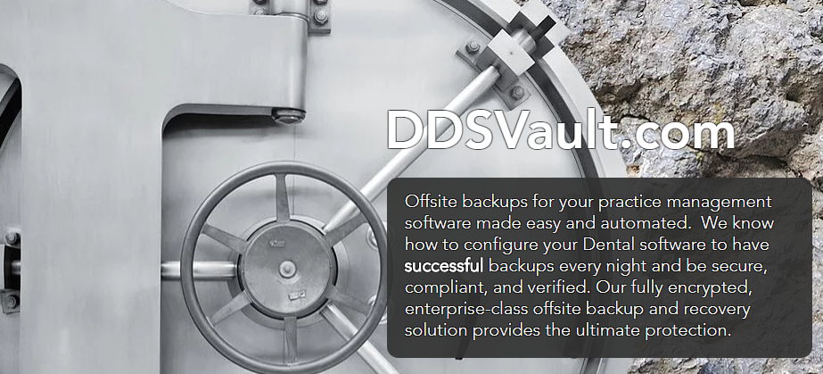

Get started today at www.ddsvault.com We don’t charge anything until we have confirmation that your Data has been successfully backed up on our encrypted servers.

