Contents
Overview 2
Site Design – Audience 2
Site Content & Design 3
Home Page 4
Home Page - Something with bars scroll with key messages, see www.level3essay.com 4
Email registration 7
Does this sound familiar? 9
The Essay Game 10
What’s the real challenge at Level 3? 11
Solution 12
Features 13
Essay Strategy 14
Review Outline 15
Home Page – Testimonials 16

Overview
- The website sells an interactive online course for a financial certification
- Online course materials are managed by teachable.com. This project is only about landing page design in Wordpress.
- Mobile version of the site should look as professional as desktop
- http://www.level3essay.com/ - I created this myself in one day to get some ideas. Looks terrible but
- http://www.level3essay.com/certification/ - This is what the designer delivered. This is below standards for me.

Site Design – Audience
- Male: 70%, Woman: 30%
- Well educated people (bachelor’s degree minimum)
- Passing exam provides career advancement
- Average age: 29 years
- Many use English as a second language. Plain English is preferred.

Site Content & Design
The site map will look something like this below, mostly text except for the front page.
- Home (see details below)
- The Essay Section (**)
- Recommended study plan (**)
- Registered Users (for student to log on)
- About US (**)
- Contact US
- FAQ (**)

** add section but leave empty for now, someone will add content in the future

Home Page

Home Page - Something with bars scroll with key messages, see www.level3essay.com


Key message 1: Prepare the Essay Section of the CFA® Level 3 exam
Subtext 1: First course exclusively dedicated to essay strategy preparation

Key message 2: The essay section is not just about knowledge but also about strategy
Subtext 2: Learn the unspoken rules behind the essay section

Key message 3: You are only one exam away from completing the program
Subtext 3: We understand how important is for you to advance in your career and recover your personal life

Examples of banners on top
I like this page:
https://www.schweser.com/
I don’t like this page:
https://www.efficientlearning.com/cfa/





Email registration

The Essay Checkmate Course
Essay Strategy for CFA Level 3 candidates
Subscribe to Section 1 for free here.

Pain (<<-- this is just a title, don't put this on the website)
Which candidate will score more points?

Candidate B
Candidate A

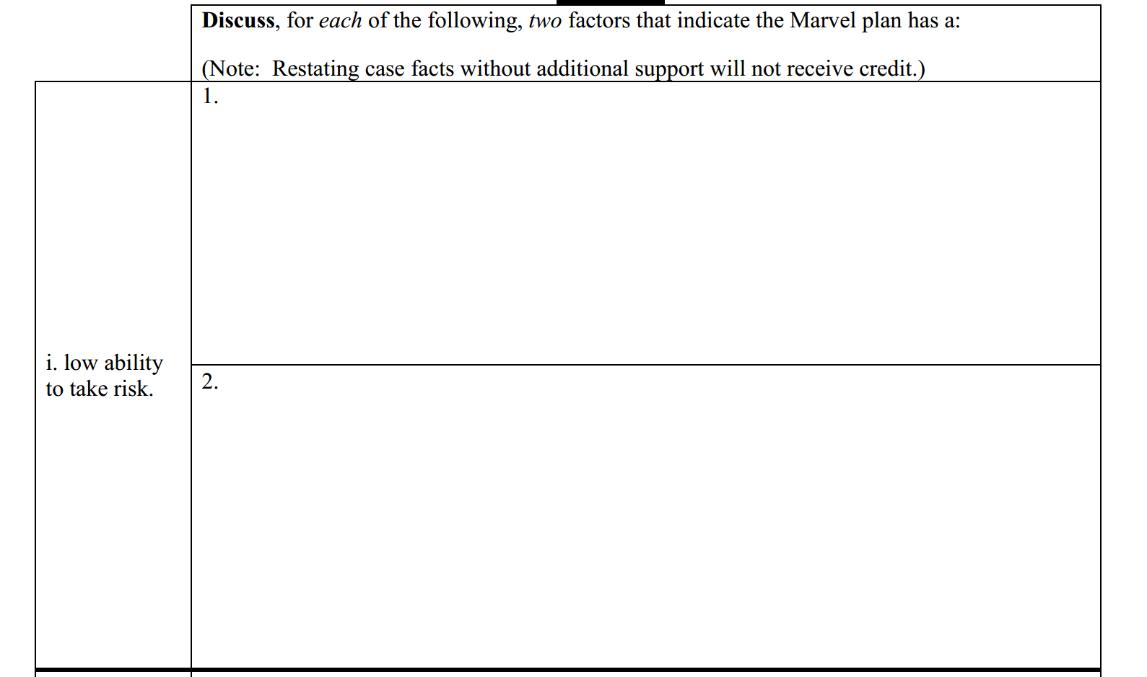
(Image to be updated with actual answers, for now just take this one)

Does this sound familiar?

“I’m not sure what to write for the essay section”

“I did a mock exam; how do I know my answers are correct? I can’t grade my own responses”

“I know the material, but still I didn’t pass! Why?”

Confused? You are not alone.

(Please propose image with go with text otherwise looks too dry)

The Essay Game
The CFA Level 3 essay section is different from anything you have seen before. You are expected to provide handwritten responses to essay questions. Using the same approach from Level 1 and 2 will not work.
Why?
This time, you are playing a different game.

To beat this game you need to master three key competences: Knowledge, Judgment and Essay Strategy.


Knowledge

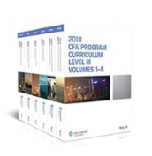
Judgment



Essay Strategy

What’s the real challenge at Level 3?


Candidates tend to spend most of their time covering the materials and doing mock exams. A little too late if ever, they realize there is something else needed... Essay Strategy.

(Please propose image with go with text otherwise looks too dry)

Solution
You can master Knowledge by actively reading materials

You can master Judgment by properly practicing and reviewing mock exams

Today, you can master Essay Strategy with The Essay Checkmate Course

 | The Essay Checkmate Course  Essay Strategy for serious CFA Level 3 candidates  - Learn the unspoken rules behind the essay section  - A systematic approach you can also follow  - Take the CFA Level 3 essay with confidence  - Developed by people who passed Level 3

Note: This blue chess king is the product logo. We need a logo for this, nothing extraordinary but can’t be an image from google or gettyimages.

Features
Essay Grading
Real Examples
Online
Pure Strategy
15-20 Minute Lessons

Grading of your handwritten response
Review real past students responses (good and bad ones)
Easy to follow. Watch any time you want.
No lengthy 50-hour videos programs focused on content
You are busy. We know it.

(Please propose image with go with text otherwise looks too dry)
Responsive design

Essay Strategy
A small investment with large return

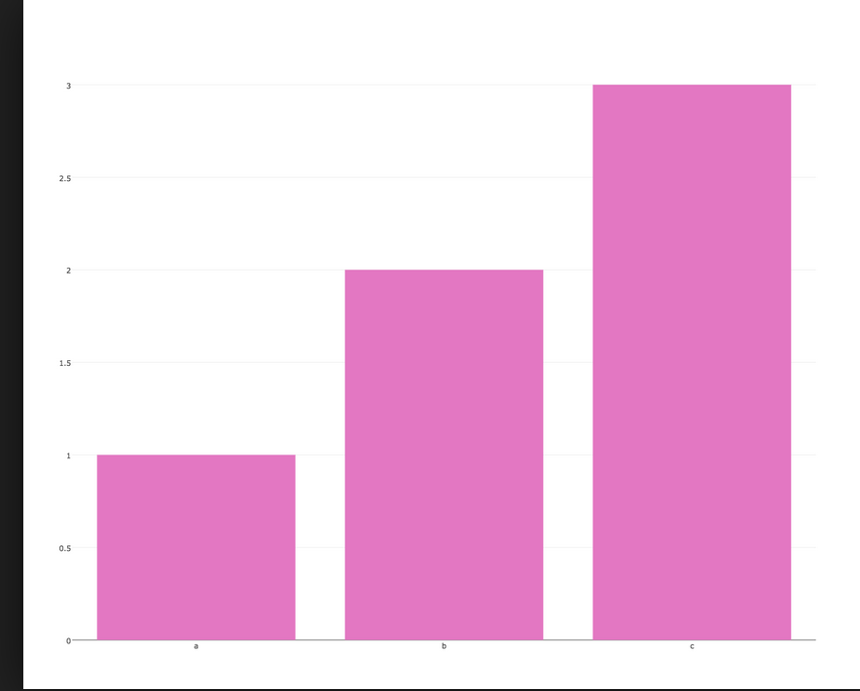
Hours needed to master
Mockexams
5 hrs
50 hrs (*)
300 hrs (*)
The Essay Checkmate
Materials

(*) Internal estimates based on June 2017 CFA Candidate Survey.
(Please propose image with go with chart)

Review Outline
This outline is linked to teachable.com
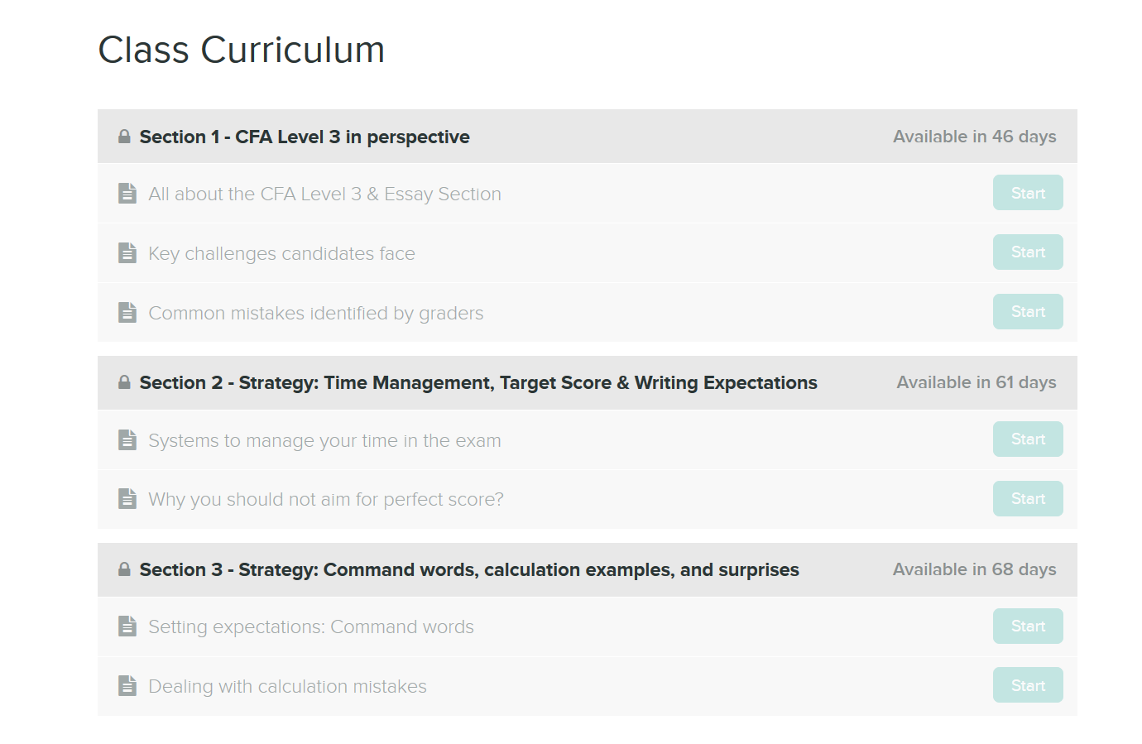

SUBSCRIBE

Home Page – Testimonials

We are working on this, fill in for now.

