Images are too dark
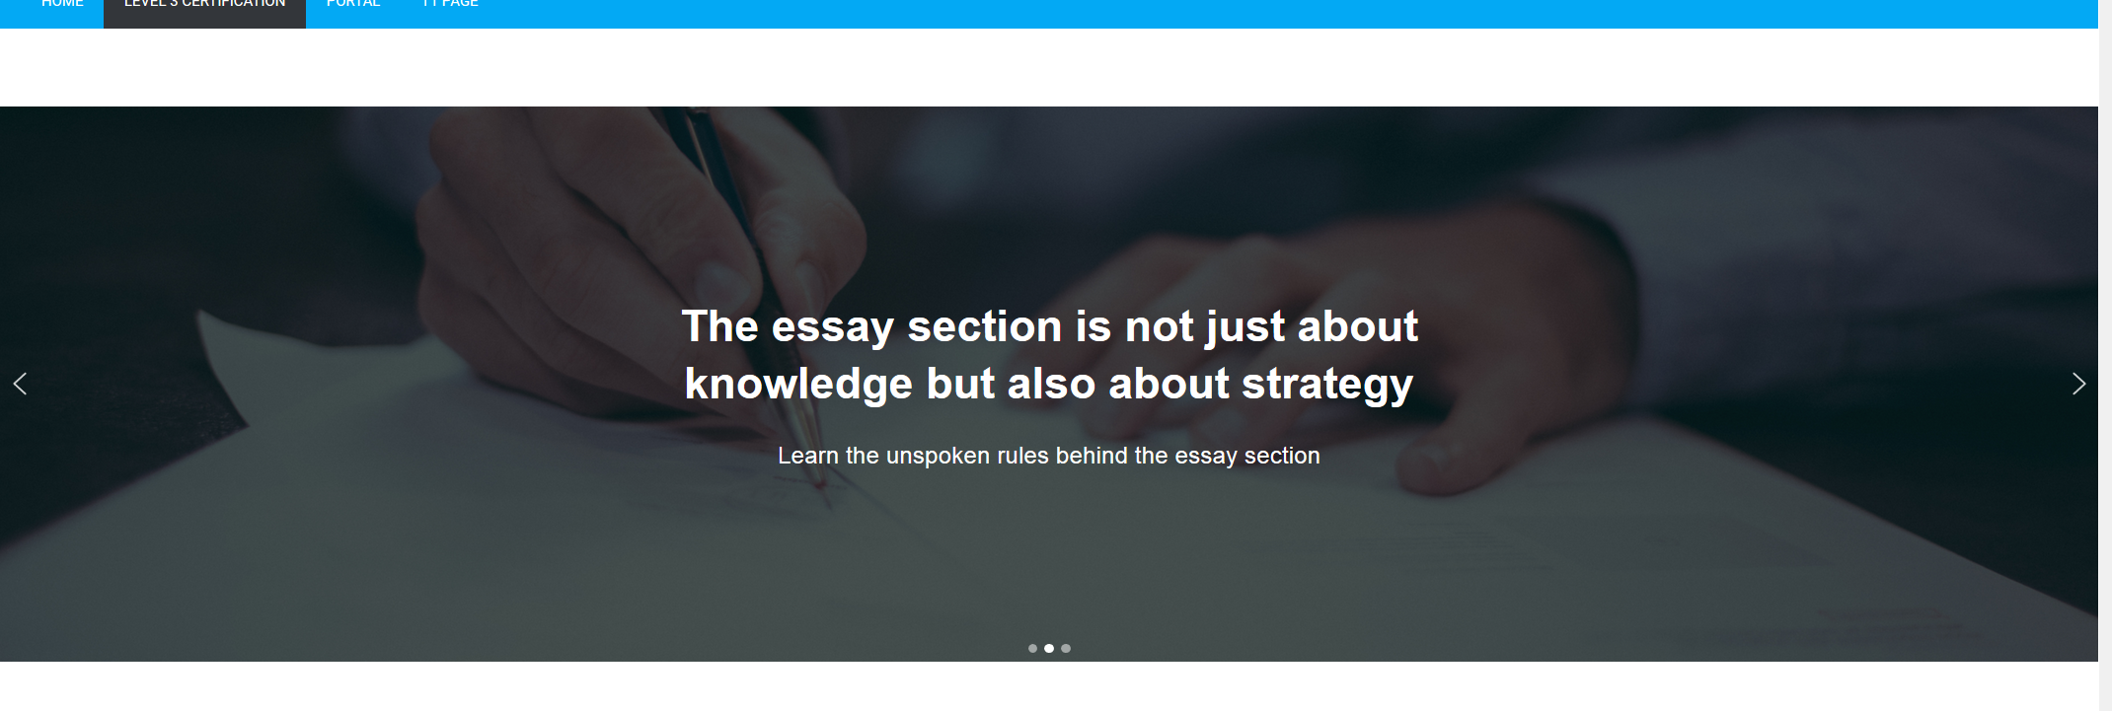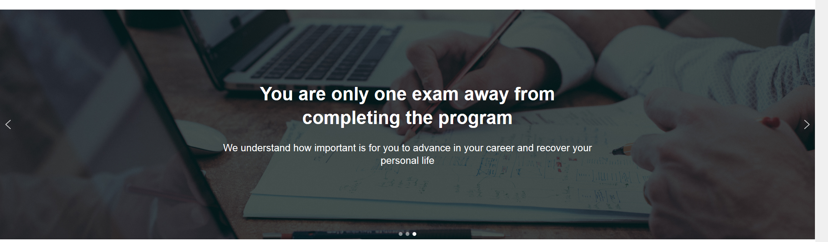
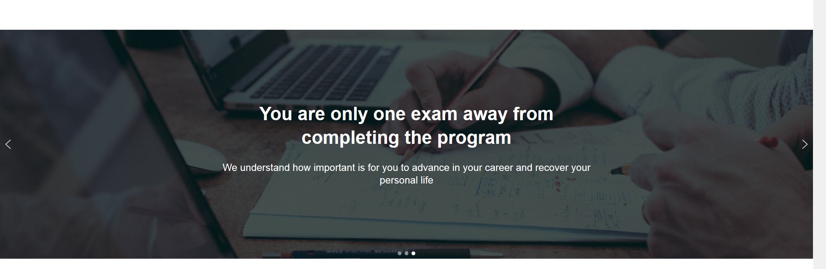

We can take more advantage of space by
- making it wider rather than higher
- move message to the left
- Add an on the left representing time saving (like a clock)

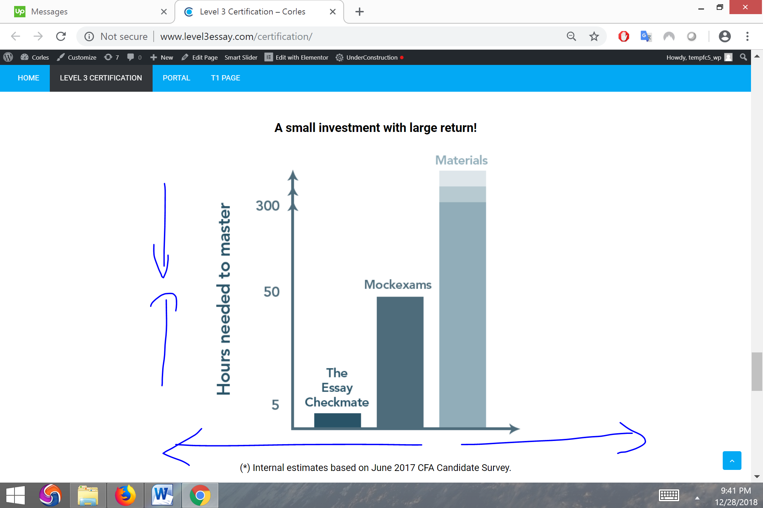

Top images
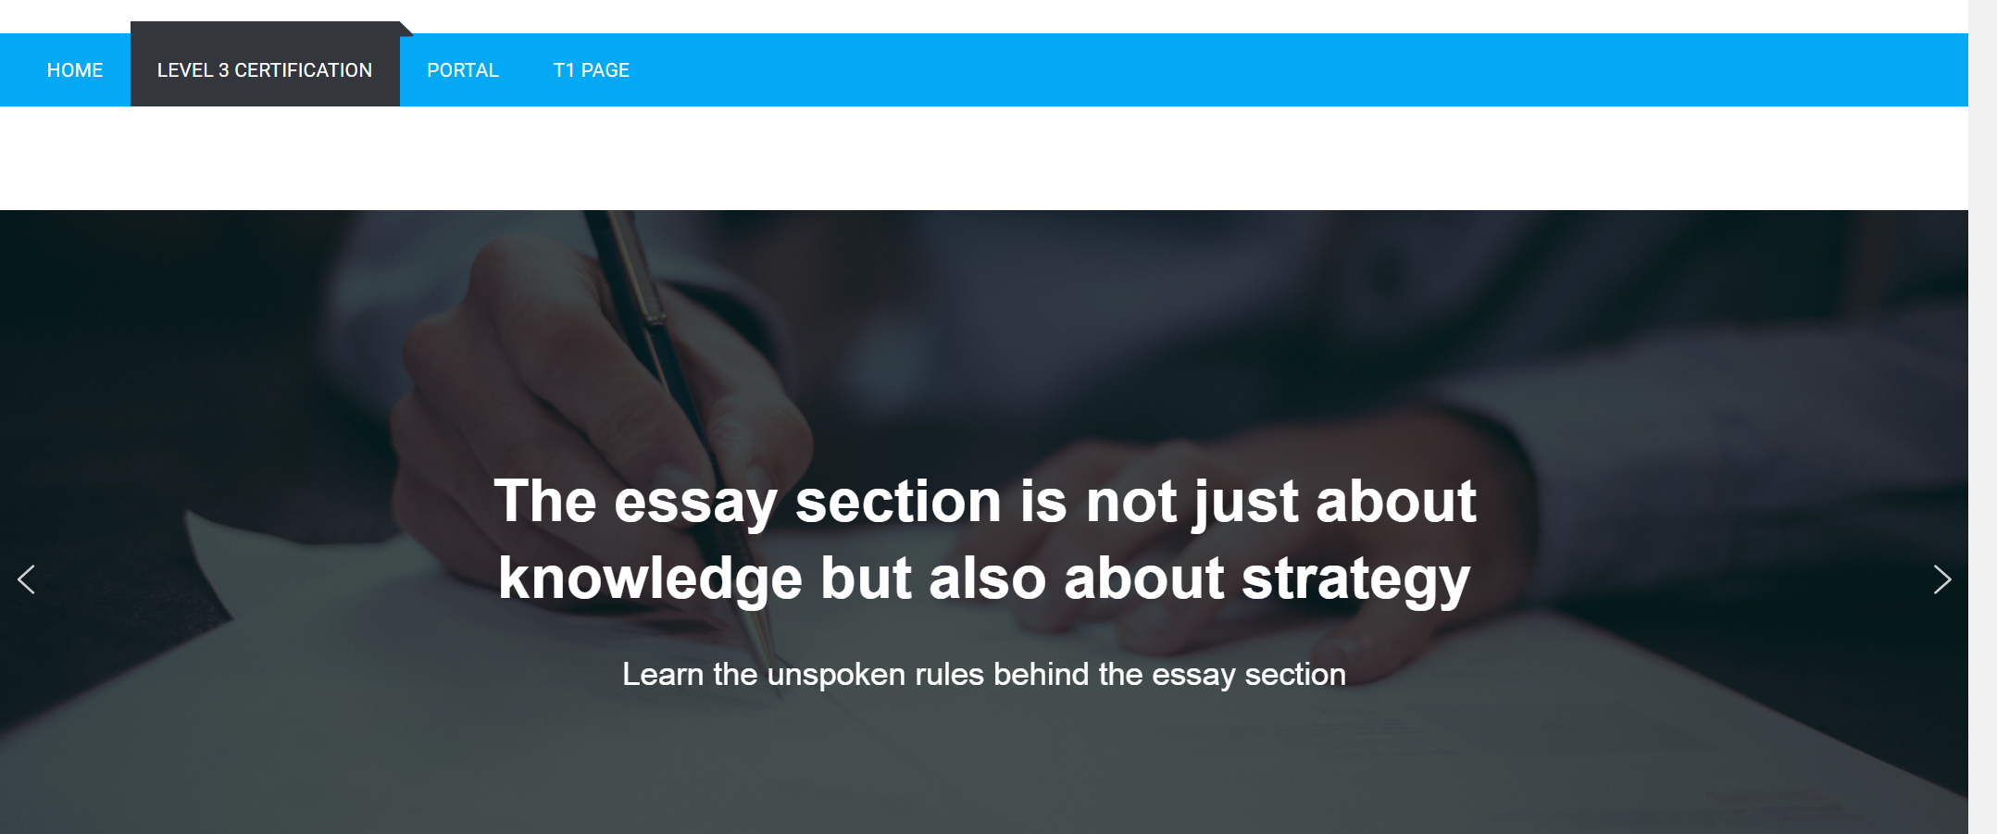
The site needs to be simple with just pure text looks a little dead, I think also because images are so dark. Here an example below of what I was hoping for the top bar.
http://unlockdesizn.com/html/corporate/bizroot/demo/index-multipage.html



Key 3 concepts
This image is critical because explains how the course fits in the whole picture

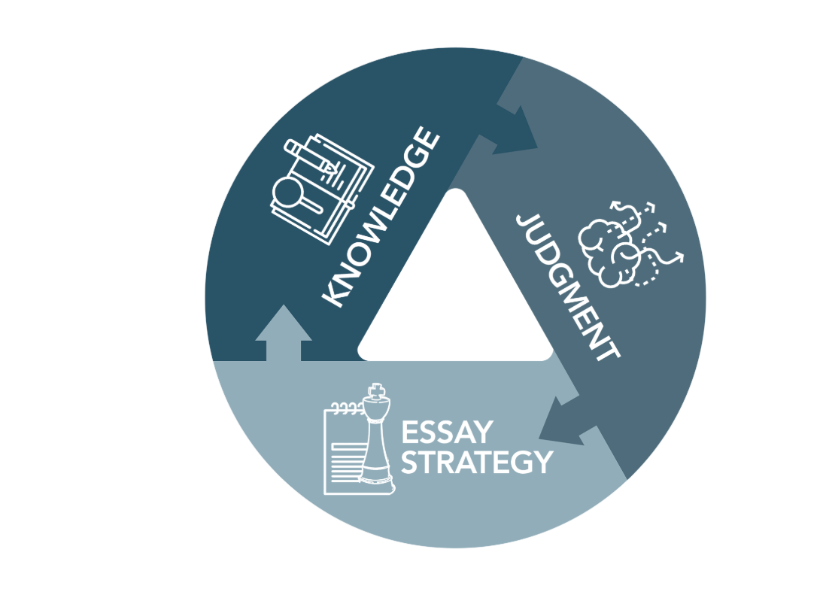
- Colors are a bit too dark. Better take light blue from bar below
- Please add motion: When you scroll down maybe pieces come together
- The words “Knowledge”, “Judgment” and “Essay Strategy” can be taken out and placed on the side without an angle
- In the middle show some image that represents success

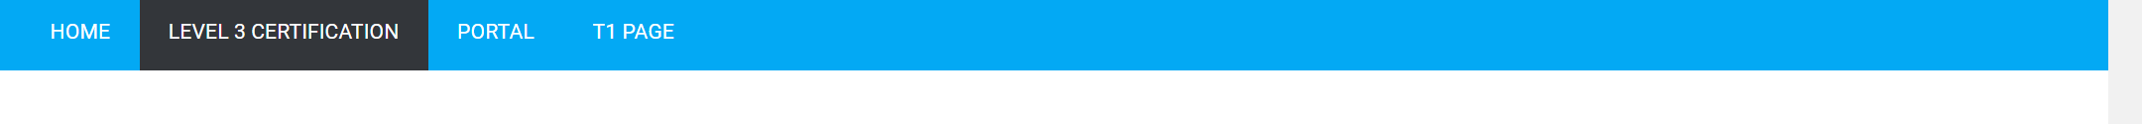

Home page, first thing you see
I would that the first thing you see is an image in full screen. For example:
http://stampedbysasha.net/
https://www.knnox.com/
https://www.thebetterfish.com/
Logo can go, expand space for main image
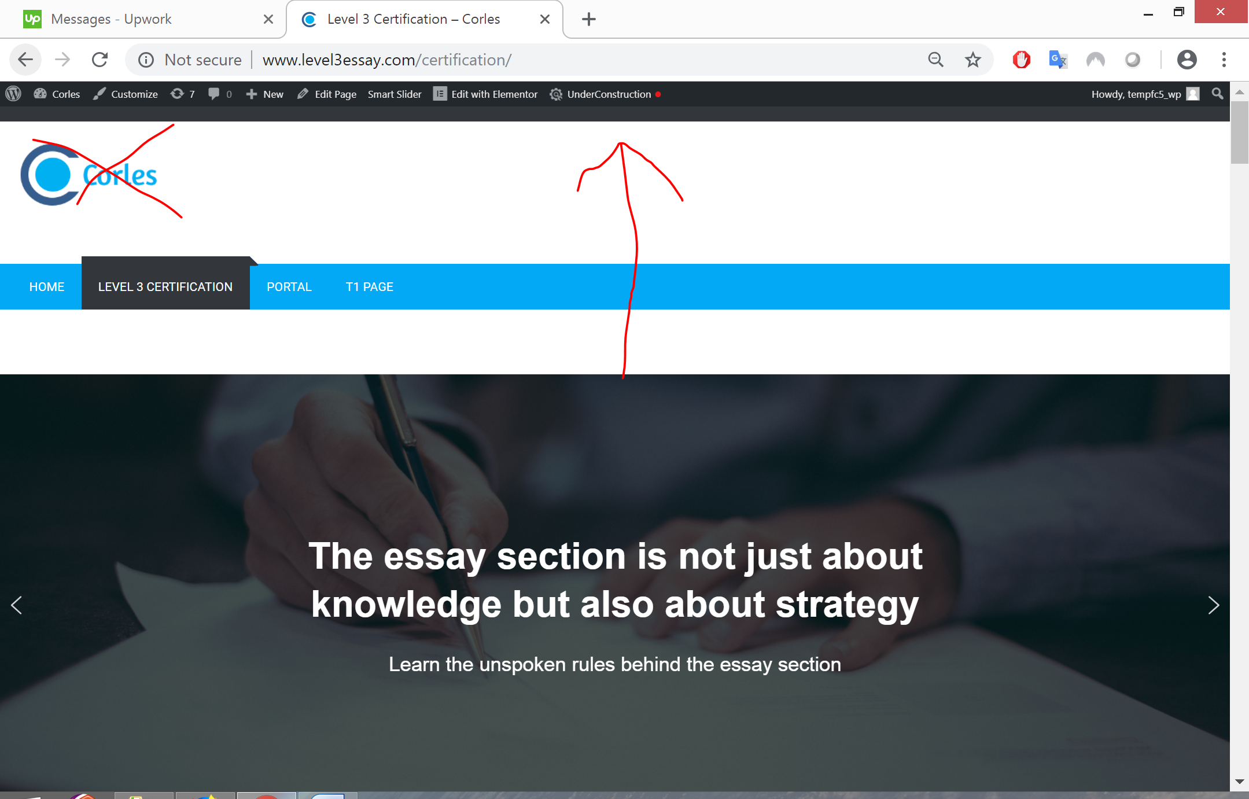

Course logo

I picked this image from Google just as an example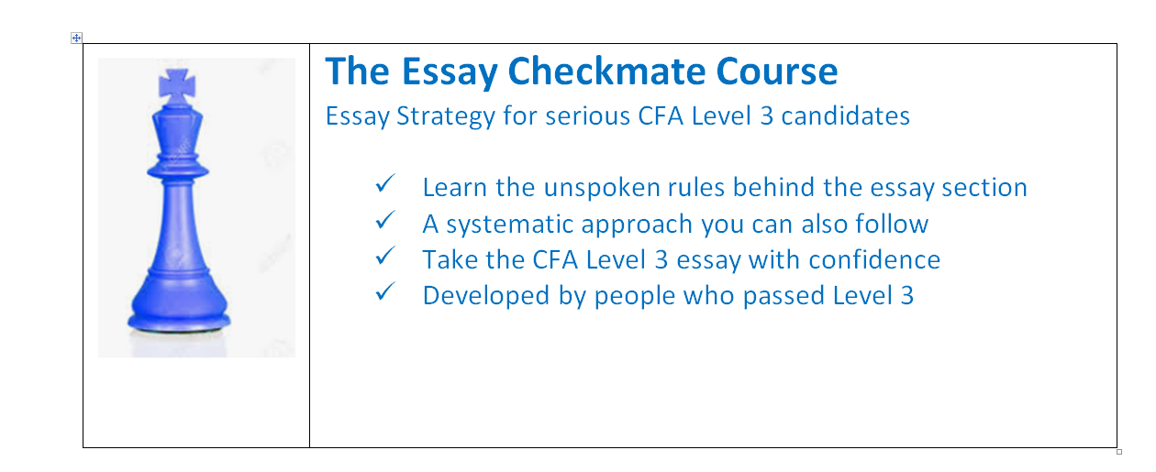

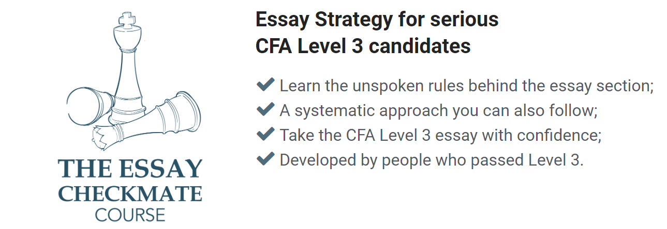
- This what the designer did, looks boring
- Maybe an additional element like a pen or notepad can be added.
- Needs to be blue
- Also having some like this somewhere:

