Brief Update V1.3 02/01/2019

As I don’t seem to be getting very far, I have decided to pull together (in my amateurish way!) as close a mock-up as I am capable of, to what I want.

I am still hoping you will contribute creatively and in a graphic sense to bring a quality professional layout to the package. Feel free to change whatever you like if you think it improves it.
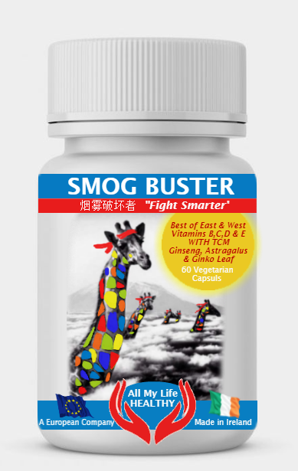

I used the following image to work from and did little else other than put some colour on the giraffes. Obviously we need to interpret the image and make it our own.

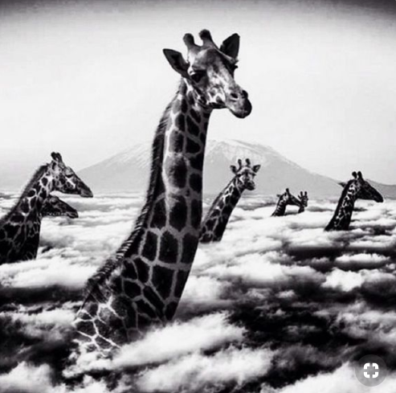

I like this as it is stylish and very clear that their heads are above the clouds/smog. I like the density of the cloud and the darkness of what is underneath. If we are to add colour to the clouds and the area underneath it should be very muted - dark grey/blue - like this image below.
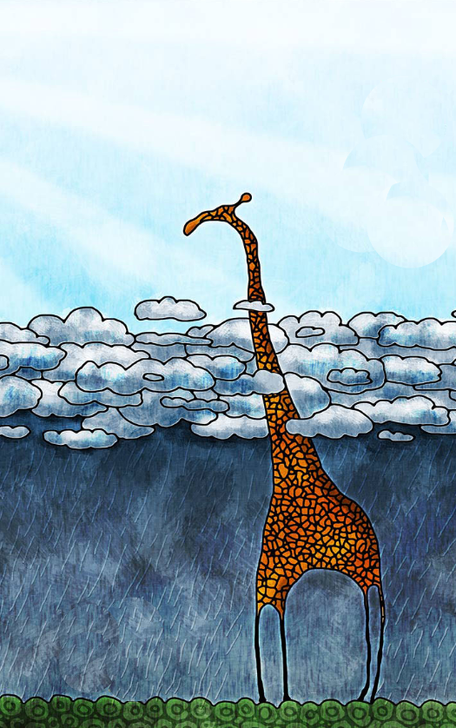
If we are to add some colour to the sky in our image, I like the the very subtle colours used in the sky here with the suns rays suggested in white.
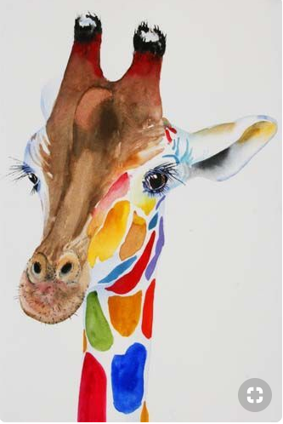

We should go for something along the look of this guy for our giraffe. I think it’s important to have the giraffe make “eye contact” with the viewer. I suppose if I were to look for some change to him it would be to make him a little more interesting. He is after all a very clever giraffe, fighting pollution by keeping his head above the smog!

I want to see a full mock-up with all sides and elements included (QR, Bar, Ingredients panel etc.)

Chinese text (used in the red strip at the top - will probably change later)

This is the text I used in my mock-up.

烟雾破坏者

Logo at the bottom

I just stuck this in for now. The second part of this project, which I am only activating now, is to do a business logo. Company trading name will be; All My Life Healthy

We are in the “Wellness” industry.
Logo will appear on this “Smog Buster” product and on future vitamin and supplement products as well as in print (corporate livery) and on web and social sites.

Keep it simple and compact. It needs to work well in both small and large scale applications and be reversible.

The shape I used in the mock-up is possibly a good way to go as it keeps it compact and not too linear.

