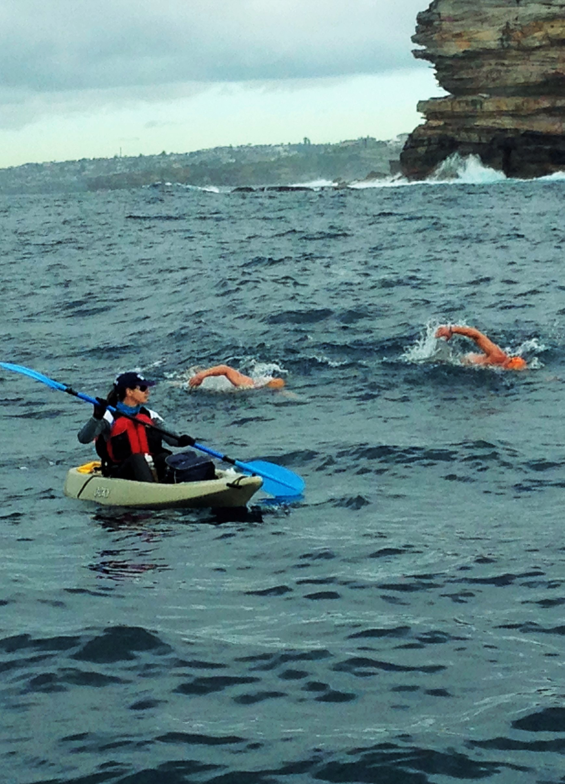

Openwater +

Swim Coaching and
Training
www.thirroulswimadventures.com
0416126586

