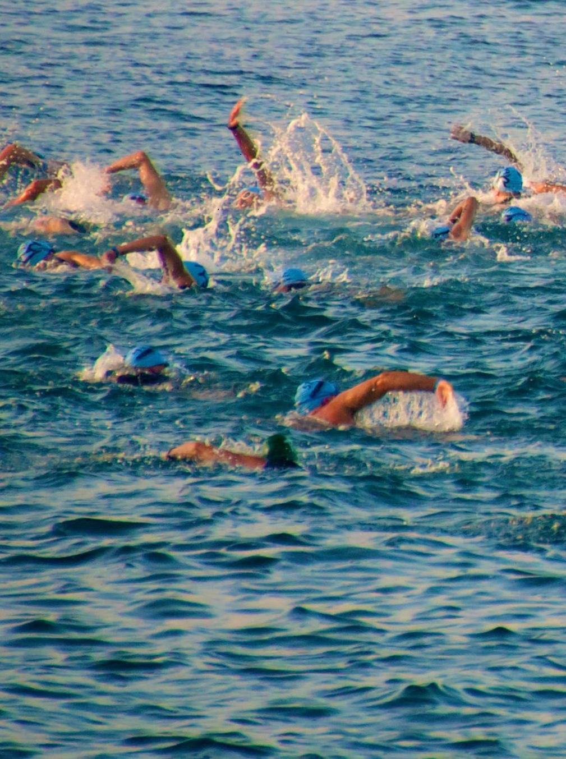
Openwater +

Swim Coaching and
Training
www.thirroulswimadventures.com
0416126586

Session Focus: Example Date/Time: You Choose

Get Started Notes
Loosen muscles and activate energy systems

Kick / Drill Set
Develop leg strength, improve
body position and rotation, master key
technical swimming skills

Build Set
Increase cardiovascular function and muscle
activity in preparation for an extended main set

Main Set
Focus of the session, combinations of
exercises with correct form to target development
of energy systems and muscles

Swim Down
Recover and unwind, restoration of normal
cardiovascular and muscular function

What are you waiting for? Call now to discuss
your swimming challenge

