Company Details

Name of Company: Healthy Paws Forward Veterinary Hospital

Exact name to be used in logo: Healthy Paws Forward Vet Hospital

Tagline or Slogan: n/a

What we do: Veterinary care for pets (dogs, cats & ferrets primarily), including spay/neuter and wellness services (vaccines, deworming, dental care), surgery, weight/nutritional management, pain management.

Our services may expand in future to include a variety of other aspects of veterinary medicine to further promote a healthy, pain-free life.

What makes us unique:
We provide an all-encompassing and collaborative approach to medicine and pet care to promote a healthy, pain-free life for our patients and peace of mind for our clients.

We want to add life to pets’ years, not just years to their life.

Adjectives to describe us: Compassion/Caring, Skilled/Knowledgeable, Trustworthy, Integrity, Communicative/Transparent

When thinking about our company, images come to mind: Paws, Pets (dogs, cats, ferrets), Health/Medicine (ECG tracing, long life, freedom, happy pets & owners, arrows (with respect to forward)

Target Audience

Targeted customer base: All pet (primarily cat, dog and ferret) owners. Women typically make the vet decisions for the pets.

Age group of target audience: 20-60yrs. Millennials a big part of our clientele.

Design Details

Color schemes: Any combo of blue, green, black. No pink or purple, blue/orange or blue/brown combination.

Click here to see images of Greenville Humane Society. Replace the green with a nice blue. The logo should fit in with this type of look.

Type of look we are trying to achieve:

- Unique
Vets do a very poor job in creating logos and branding their companies. Many logos look self-made (common font w/ a schematic pic of a dog/cat) or are quite simplistic – pet silhouettes with stethoscopes, the vet emblem, a medical cross and hearts are all pretty common. If any of these are included, it would have to be done in a unique way.

- Professional, but not too corporate feeling.

- Kindness/compassion

- Clean/not too busy with easy to read font

- Horizontal
Note: We advertise in local sports arenas. Logos should be able to easily be manipulated to fit into these specs and be EASILY READ once the logo gets a lot smaller. The sports teams do the creative work themselves.

Patches on Sports team mascots are: 5” wide by 3” tall, 5” wide by 4” tall, 8” wide by 3” tall and 9” long by 3.5” tall with a recommended text space be no taller than 2.75” tall (on the last dimension only).

LED image file sizes (pixels): 14688 W x 48 H, 1952 W x 32 H, 1264 W x 32 H and 200 W x 160 H

Names and websites of competitors:
Competition
VCA Clinics (https://vcacanada.com/) – largest corporate vet throughout the city. This would be the only truly branded clinics in our industry. Used to be called Associate Vet Clinics (link to their logo only).

McKnight: www.mcknightvethospital.ca – my previous clinic; I am competing with what we built there.

Closest in Proximity:
Creekside: http://creeksidevet.ca/
Nolan Hill: https://nhvh.ca/
Sage Hill: https://sagehillanimalhospital.com/
Panorama: http://laservetcalgary.ca/

Mobile Vets:
http://vetstogo.com/
https://montgomeryvillagevet.ca/
http://vetsonwheelscalgary.ca/

Examples of logos that we like:

We would like our logo to be simple, but unique, either with a great image that sums up our name.

I REALLY like when the image is worked into the font of the logo, as in: Meow Foundation, Veterinary Dental Specialists, Doberman Diversity Project, H2Oil, or like the inconspicuous arrow imagery in the FedEx logo.

I like:
- the clean lines and the logo for Ferret Rescue & Education Society
- The simplicity of Embark
- Known brands: WWF, Firefox,
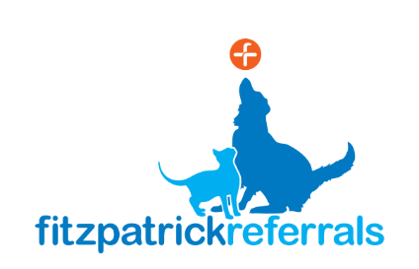

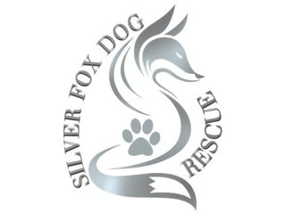 Prob a bit too busy, but kind of classy.

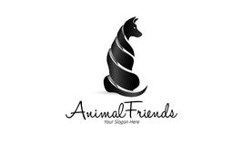 Font not legible, but like that the image is clean

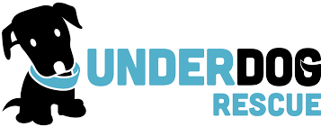 Like the shape, easy to read, simplicity in & use of colors, that the tail is worked into the name, but too cartoon-y

What we DON’T LIKE:

Too simple/commonly seen in our industry:
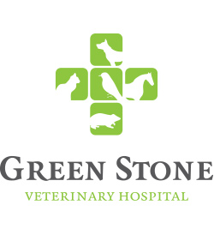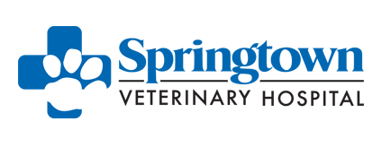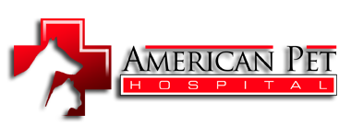



These are too cute/cartoon-y:
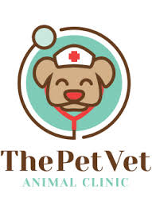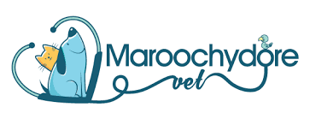

Too busy:
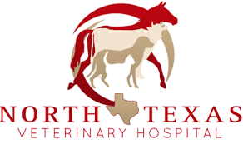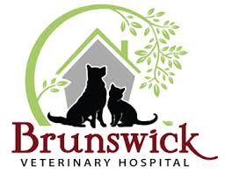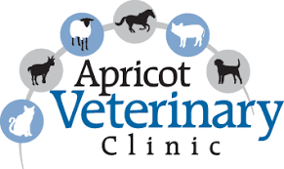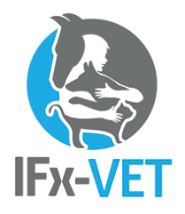

First attempts at logo:
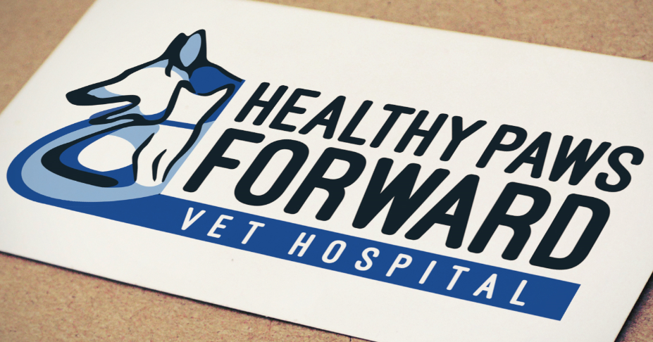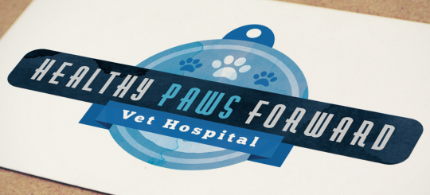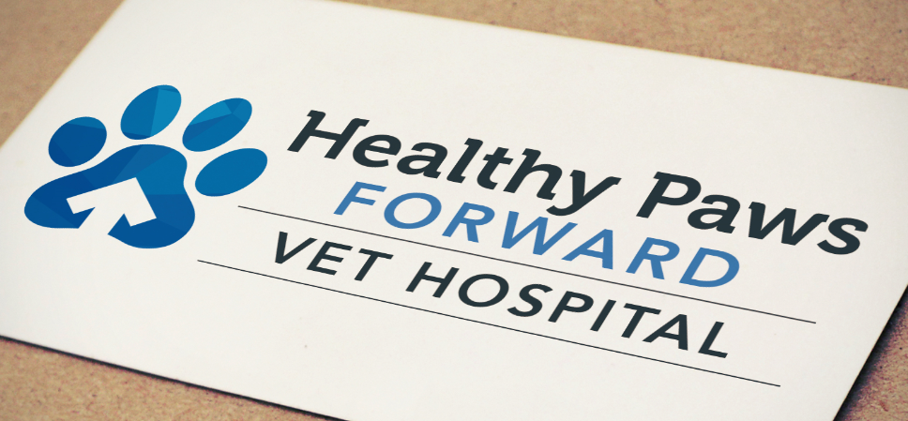
Logo (left): Too busy. Many people didn’t even see the cat in the left logo. I do like the text used, easy to read, would make the “Healthy Paws” bigger than the forward and “Vet Hospital” larger.

Logo (middle): Too busy. Font too small to read & image was interpreted as a Christmas ornament by people.
Logo (right): WAY too simplistic. Looks cheap.

