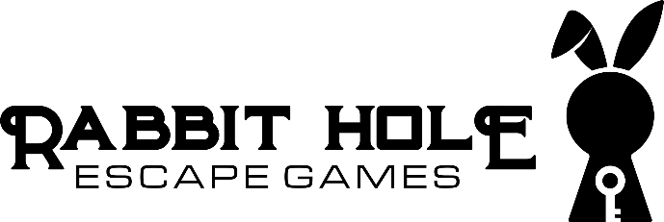 Presents….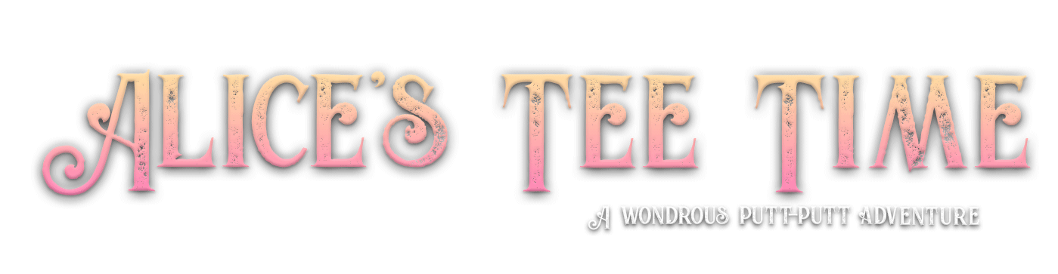

Business Requirements for app

General Game Info
Alice’s Tee Time adventure is a physical 9 hole mini-golf game that combines putt-putt and escape room puzzle elements. We have built a themed game room in Alice in Wonderland décor and entwined many tech props that players use to solve mini-puzzles. It follows the story of Alice in her odd encounters with many Wonderland characters. Players have to solve puzzles, which trigger doors to open, or actuators to move (which may be blocking their shot) so they can continue putting through. The technical props all vary and their reset functions also vary- some reset after a time limit, and some reset when the room is set back to ground zero. We are relying on players to follow simple instructions so the teams behind them can start their hole from scratch (at a non-winning start point).
The need for an app
Just as in mini-golf, Alice’s Tee Time will be scored. Although old-school pencil and paper score keeping is classic, it can be inconvenient. Having an electronic scoreboard is ideal and fun for players. Also, there are times when we need instruct players and provide information before or after completing a hole. Above all, the app will be used as a self-guided clue system. If players are stuck, they get to pick if and when a clue is presented.

Details of app design
- Pre-Game
  - A login code is required. A code will be given to players upon arrival and expires daily. We don’t want players to download the app in advance and navigate through the entire course looking at clue options etc. An invalid code will not allow them to proceed. We are open to the easiest method of providing unique codes each day or per team. Generally, we already have their email from their booking, so we don’t need to capture emails.
  - A rules of play should be the first thing players see and read when opening app. They should ACCEPT and acknowledge that rules have been read. Players should be able to re-read the rules later on as well. General guidelines like: Don’t sit, stand or climb on the props. Maximum number of strokes, penalty shots, don’t swing your putter over your knees, pictures allowed- but not ones that give away answers or clues to the games.
  - A tutorial of app icons. The icons for a players sequence should be explained here.
  - Explanation of scoring and badges
  - The next screen should prompt players to enter the number of players on their team and provide a team name. The max is 3 players. The max team name shouldn’t be longer than 30 characters. Players should have the ability to add and edit their names. If two players are chosen, then the third name should be removed.
- Hole screen layouts:
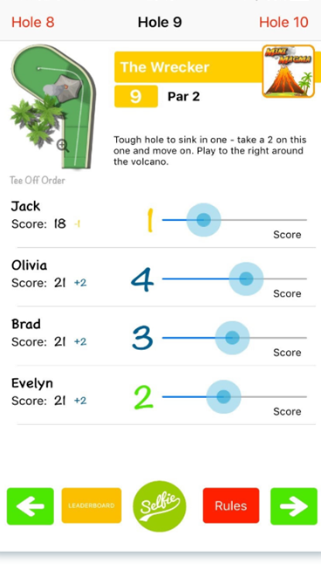
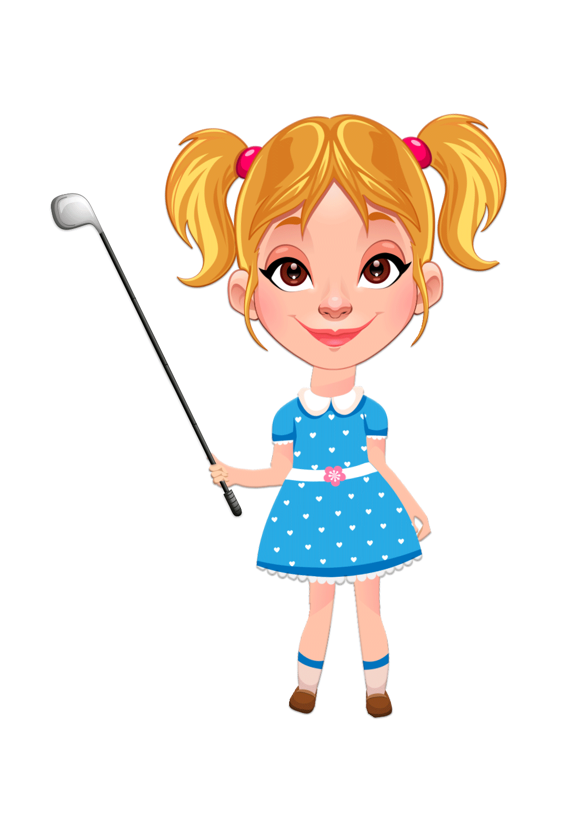



Clue Please
Rule 42: All persons more than a mile high to leave the court
Submit Scores
Badges
  - Each hole (1-9) will be titled and should be displayed along with the hole # and par for that hole. The titles are quotes from the book.
  - Sequence icons need to be displayed to show the order. Sometimes, a player needs to solve the puzzle before putting, but other times, they need to putt, then solve. It could be simply an icon of a ball and putter, arrow, then a puzzle piece.
  - Each player sets their score for that hole. A slider bar moves to the desired score, or a pop-up screen that allows players to select values 1-6. A subtotal score is displayed as an accumulation (but does not include clue points or badge deductions). The +/- is their score compared to par.
  - Buttons on the bottom: Clue Please, Selfie, Badges, Rules and Submit Scores. See below for more details.

- Clue Please Button
  - A new menu displays with 4 options following the hole selected that they need assistance on.
    - “Nudge me +.5 point” clue (+.5 points will be added to each players score at the end). This is a subtle hint.
    - “Little Lost +1 point” (+1 points added to everyone’s score) A more direct hint is given.
    - “We give up +1.5 point” clue (+1.5 points added). This tells them exactly what to do to solve the puzzle.
    - “Nevermind, I don’t need a clue” Returns to the scorecard.
  - Players can choose multiple hints per hole. For instance, a player uses the nudge me hint, but still needs some extra help, so they choose Little Lost as a second hint. If they have already used Nudge Me, and click it again, another .5 points will not be added so only one point addition per clue type will be added. If they have used all 3 clue types, a warning message should be displayed that they have used the maximum amount of clues and return to scoreboard.
- Badges Button
A menu displays showing the badges icons and how to earn. This is informational, and does not display which badges they have earned. Informs players that badges will be awarded at the end of game. Badge types:
    - Rabbit: 2 points reduction for completing game in under 35 minutes
    - Cheshire grin: 3 points reduction for sharing their selfie pic on social media
    - Mad hatter’s hat: 4 point reduction for taking zero clues
    - Dodo: 2 point reduction for taking 1 or 2 clues entire game
    - Deck of cards: 2 point reduction for having less than par, or par score.
    - Tart: 1 point reduction for having multiple hole-in-ones.

- A selfie button
This button brings up the phone’s camera. A border image will be shown and automatically added to their photo including the game “Alice’s Tee Time” and our Rabbit Hole logo. A pop up reminder to not take pictures of game answers or clues. A share button to social media is also an option for players. We want to encourage them to take a photo and share (extra points awarded for doing so).
- Rules button
This is the Rules of Play, previously displayed in Pre-game.
- Submit Scores
This is a two part confirmation. First, after everyone’s score has been inputted, the players should click the Submit Scores button. Once this is clicked, they cannot return to that hole’s scoreboard. A prompt should appear confirming they have completed this hole and warns them they cannot edit their score. A Yes Hole completed, or Return to scoreboard option should be displayed. Second, if yes was selected, a message appears that either tells them they can move on to the next hole, or provides them with instructions of resetting before continuing. The message will be unique for each hole. A reminder message should be prompted that confirms they have reset the hole as instructed. The next hole is not displayed until the players have confirmed their completion of that hole.

- Scoring:
  - Players input the shot score per round by sliding a bar to represent their score and a summary of scored points is accumulative per person.
  - End of Game Scoring. This menu becomes active after all 9 hole’s scores have been submitted.
    - Two summaries are displayed as: Individuals and Teams
      - Individual score. The team score is the total of all individuals
      - Clues (Points added). Team score is total clues for everyone
      - Badges with icons (Point reduced) Team score is total badges
      - Total Points. Team score is total of all above.
    - A leaderboard menu displays the top (lowest) TEAM scores of the past 30 days. The team’s name is displayed along with their point value.
Unique holes:
Hole #1
Everyone will have the same score. This hole is unique in that players have 7 holes in which to choose to putt into. 3 of the of input holes are correct and reveal pieces of puzzle. Players can rotate who’s putting, but their combined score of how many shots will be recorded. This hole has a max of 7 shots. These instructions will be posted physically, but a reminder message will be prompted here.
Hole #8
Players will not be putting with their golf balls. Instead, a game of croquet will be played and croquet balls will be provided at this hole. The croquet balls pass through object sensors underneath the hoops. But only one sequence of hoops will initiate the actuator, and we only want one player to perform this sequence. Therefore, we need the other players to pass through a different sequence of hoops (cards) so the object blocking the hole is not triggered early.
To force players to putt through different hoops, a specific sequence will appear on the screen of which cards they must putt through. This will depend on the number of players.
If 3 players, the first player will be shown a sequence of cards: Jack, 10, 9, 8 of spades. The second player will be shown 8, 9, 10, Jack of Spades. The third player will be shown Queen, Jack, 10, 9 of spades.
If 2 players, the first player will be shown 8, 9, 10, Jack of Spades and the second player will be shown Queen, Jack, 10, 9 of spades.
If a solo player, only the Queen, Jack, 10, 9 of spades will be shown.
The screen will direct player one to shoot first through all the hoops and then wait until the last player has shot through the hoops. A confirmation pop up will be clicked after each player has shot. After all players have gone through the hoops, the screen returns to the scoreboard screen.

