


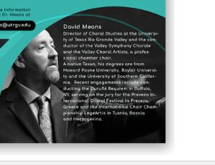
Would like to see these elements as the footer at least on the back. And perhaps on the front you can work in your ribbon like you have on back.
This should be two separate bullets
- Meet the artist opportunities
- - Post -concert discussions led by Dr. David Means.
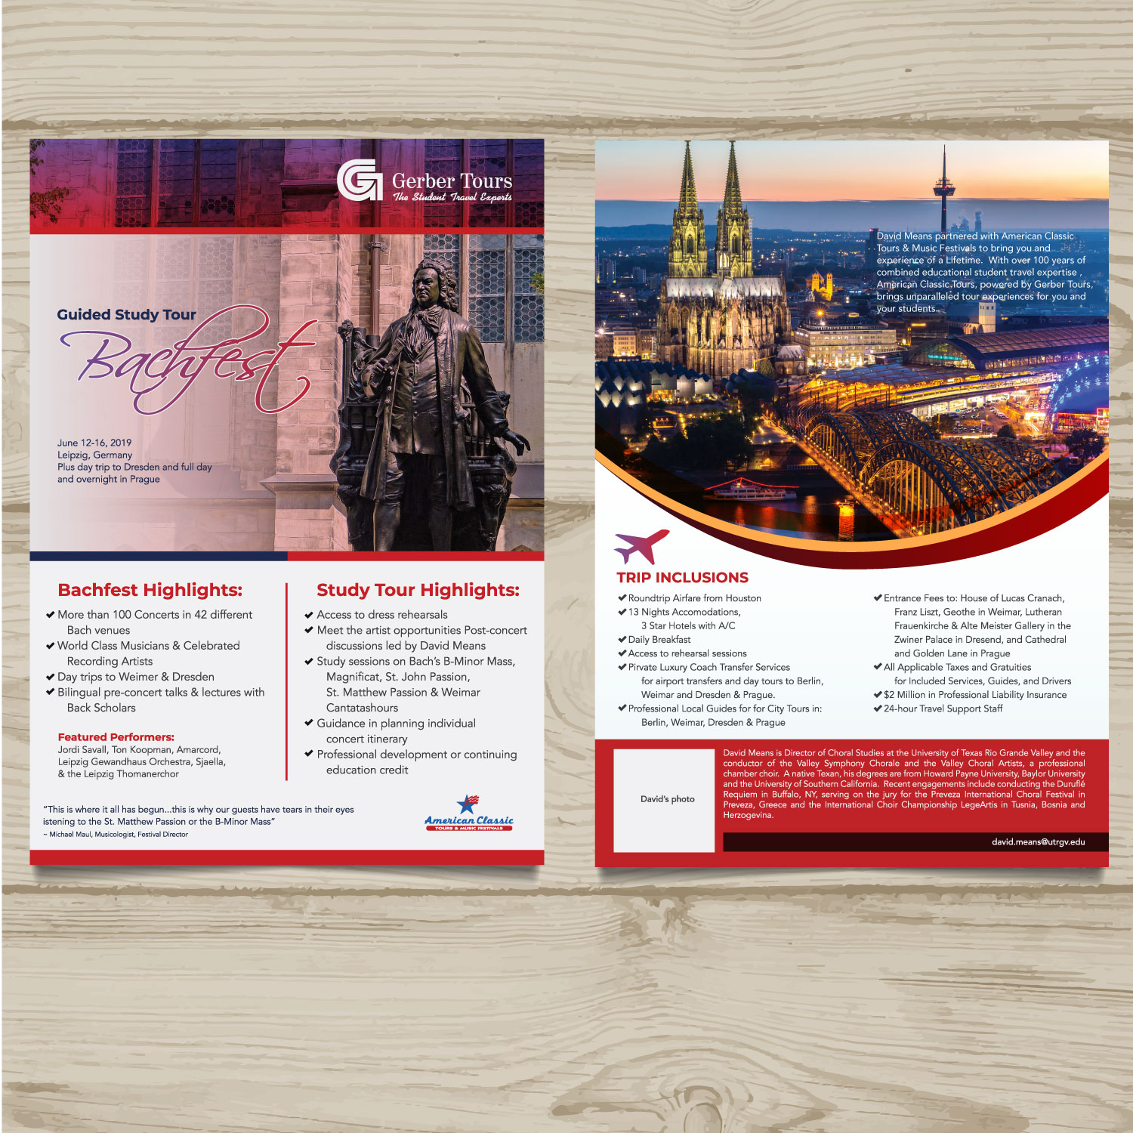
Logos don’t belong in these locations.
Would like to try a creative element here with David’s picture. Like the image below. Can be in color like you have if we are able to read text.
Delete the extra for
New content, see below. #3
Put in a box where image shows through (ghosted) like you did with the Gerber Logo on the front. Also, there is new content. Please see below. #2
Make this block/section smaller to accommodate new content and additional elements we would like to see.
Quote should be italicized
Bach Scholars
Like the gold in the other ones you sent.
Make height of this section/box thinner.
This way you can move text and image up.

1. Plus day trips to Wittenberg and Weimar, and guided tours in Berlin, Dresden, & two nights in Prague!
Like the blue and gold in the other ones you sent.
This info really needs to pop. Needs to be larger and stand out. See examples of other designers below.
Also, there is new content for below Leipzig, Germany-see below #1
2. After many years of attending Bachfest, Dr. David Means has partnered with American Classic to create a memorable study tour centered around the 2019 festival. American Classic Tours, powered by Gerber Tours, is utilizing their more than 100 years of combined travel expertise to design a custom tour for all who love the music of the Baroque era.
3. Entrance fees to: Franz Liszt-Haus, House of Lucas Cranach, National Museum & House of Goethe in Weimer, Lutherian Frauenkirche, Gallery of Old Masters – Zwinger, Castle of Prague, St. George’s Basilica, Old Place, Golden Lane, and the St. Vitus Cathedral.
See how these really stand out.



