
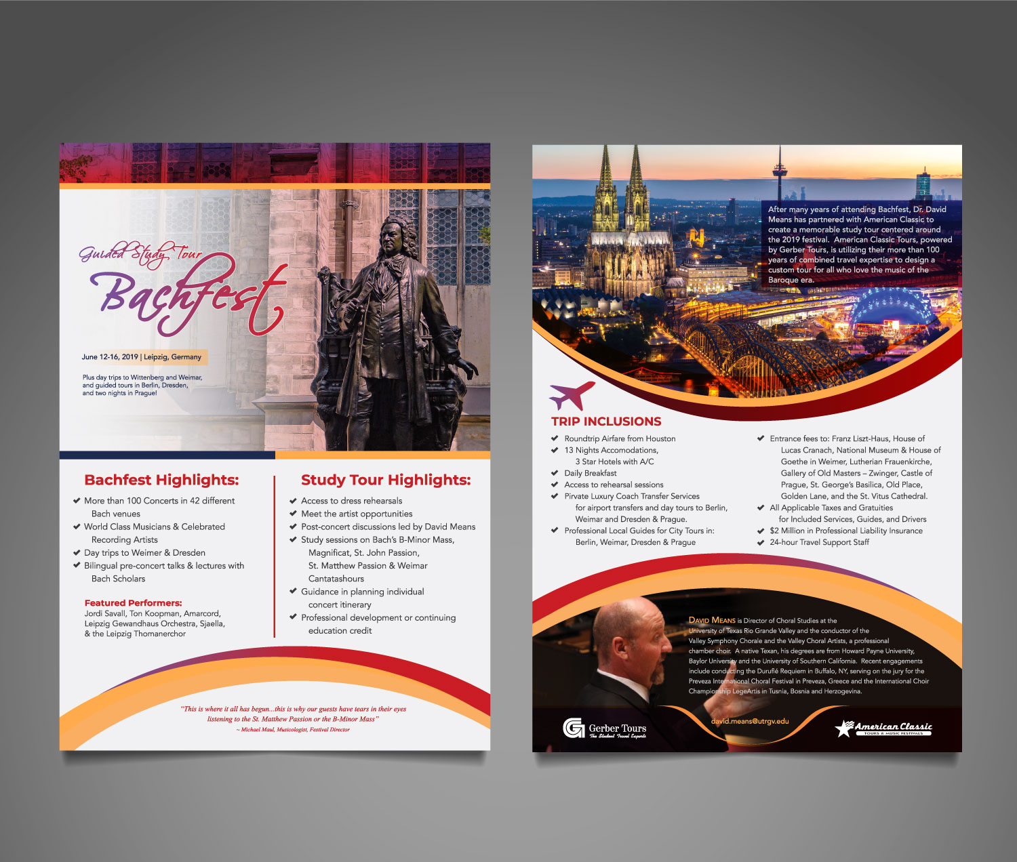
Whether you use this element at the top or the bottom we would like to use the colorful version you had previously.
Need to add this content:
Your trip begins in Berlin and ends in Prague
Need to add the price somewhere as a call out.
From $1,995
Need to add content:
*Roundtrip air available
They want the logos at the top of the back page because that is what the paragraph over the image is referring to.
Need to add this content
Contact Info:
Dr. David Means , Tour Leader David.means@utrgv.edu
Maureen Noonan, Tour Specialist
516.629.4606 | maureen@amclass.com

