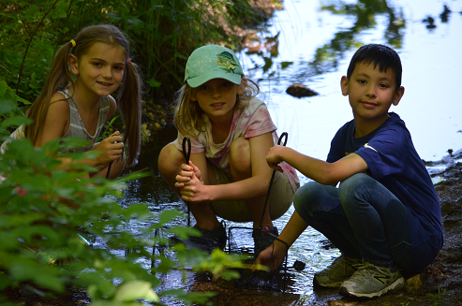
A revitalized Denton Lake can do so much for children like Emily. Research shows that playing outdoors will (1) enhance Emily’s ability to learn, (2) stimulates Emily’s creativity, (3) increases Emily’s sense of well-being and (4) improve Emily’s social skills. Research also shows that youth who attend Christian summer camp grow to interpret all of life through a lens of faith.
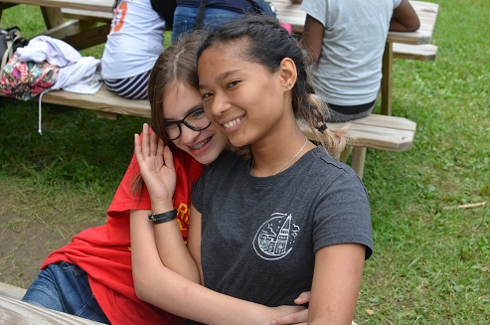
You can help us provide Emily and children like her by taking advantage of the Revitalize Camp Denton Lake Matching Challenge
- $100.00 will buy: material for a picnic table
- $250.00 will buy: materials to improve the tent frames
- $500.00 will buy: materials to repair the bath house roof
- $1,000.00 will buy: a new tent to replace one damaged by tornado
- $5,000.00 will buy: half the roofing material for Denton Dining Hall
If you haven’t done so, please donate today.
Click here to Donate to Bring Back Denton and choose "Bring Back Denton"

