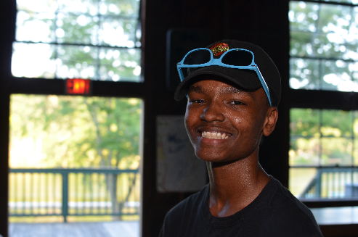
Unfortunately, too many of our children spend more time playing video games and watching TV than having fun playing outdoors. Emilio, an average 13-year-old, spends about 300 hours a year playing video games. That’s because many parents wonder where they can find a safe and engaging place for their children to experience nature and engaging activities with peers.

The Board of Directors of Holmes Presbyterian Camp and Conference Center decided to create a space that is safe, meaningful and fun by issuing the Revitalize Camp Denton Lake Matching Challenge. They will match on a 1: 1 basis every dollar given or pledged to the campaign by December 31 up to $20,000.00.

Please help us create a space where children like Emilio experience nature, connect with other children and have fun! Take advantage of the Revitalize Camp Denton Lake Matching Challenge and donate today.
Click here to Donate to Bring Back Denton and choose "Bring Back Denton"

