I have recently registered a new business in bespoke luxury wedding and event planning. The company name is Allure International. It shall operate out of the Netherlands and intends to serve an International client base. We specialise in British weddings; set in luxurious locations (In England); land houses, castles & palaces. Think James Bond meets Jane Austin.

The target market is the upper middle class to the jet set. The client will have money to spend; perfection, glamour, elegance and the wow factor will be essential. It is a niche market and my logo and website should stand out as such from the hundreds of shabby chique, DIY styled wedding planners.
The design should be luxurious, yet elegant. In no way should it be Kitsch.

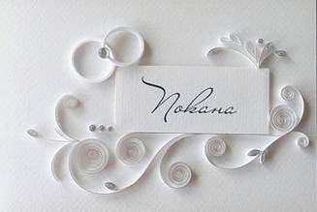
A design that I like is this,
But please see my analysis
Below.

I absolutely love this design. I also love that it looks 3 dimensional. BUT. The swirls feel squashed up. And; the rectangular card in the middle with the name on it needs to go, leaving just the letters. I like that the two rings symbolise weddings.
I wonder if to convey the events side of the business maybe a delicate balloon and champagne glass or a champagne bottle could be added? My fear is this would make the logo too busy. Maybe two logo’s are needed; exactly the same EXCEPT for one has rings and says Luxury Weddings and the other has the balloon & glasses and says Events?

I love the italic text style on the above image, but it needs to be an easier style to read. Refer to the image below, (Most welcome home).

The silver on the swirls and rings is beautiful. But there needs to be some colour in the logo. Maybe in the text or on the symbols (rings, glasses) or the swirls?
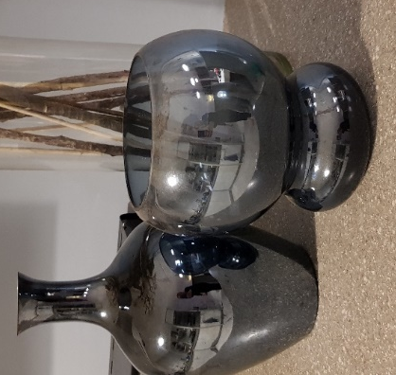
The colour scheme: I ABSOLUTELY love the deep metallic blue on these vases below so if this could be incorporated with maybe silver or grey I think it would be stunning and timeless. Otherwise I like pastels in the turquoise/blue’s | greys and silvers | Rose gold |
I absolutely hate PINK, purple, yellow, yellow gold, green and red.
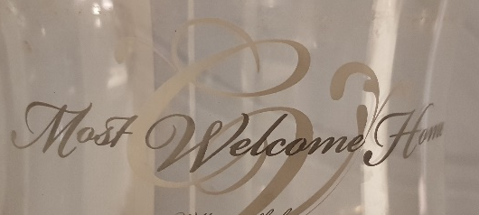

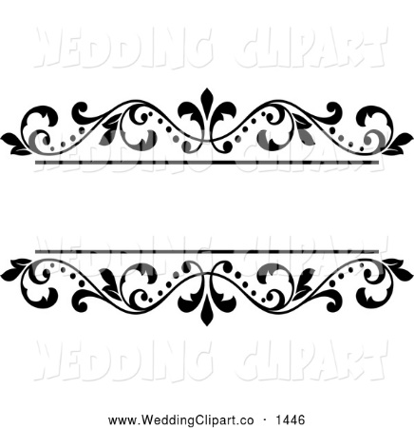
What I absolutely don’t want to see is something like this:

 or this

I hope that I have given enough information to go on. I can always be reached via telephone on +31621598181 or via email at info@allureinternationalweddings.com

Yours sincerely,

Tamara Gray

