Avire Displays Creative Brief
Aim
To update the displays content by creating new arrows for our drag and drop layout designer. The arrows should then be added to the entire displays portfolio in all size ranges. Avire displays range includes touchscreens, multimedia screens (video and pictures) and picture screens (pictures only).
Current Layout Examples
Below are some examples of the layouts that are currently being used, please also refer to the catalogue and video of our touch displays attached.
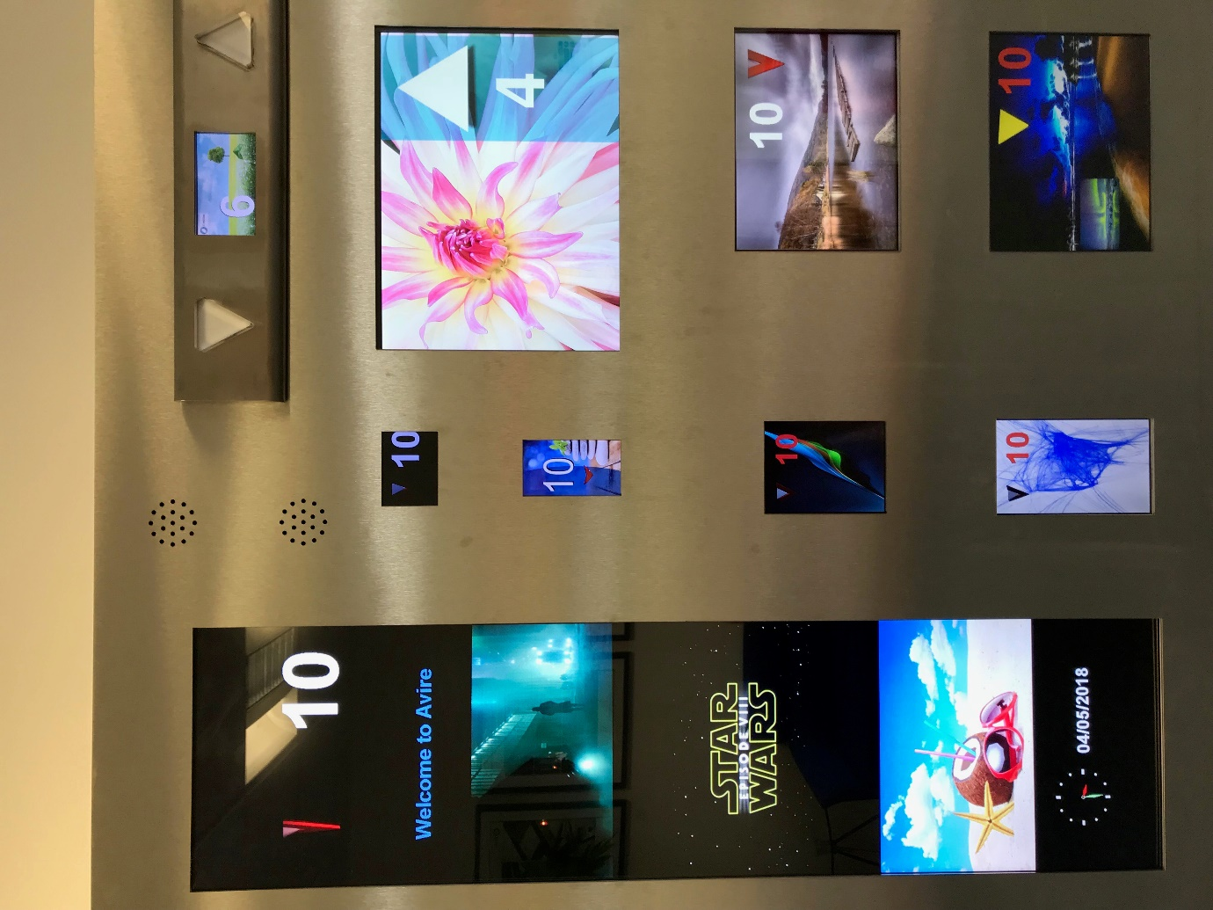



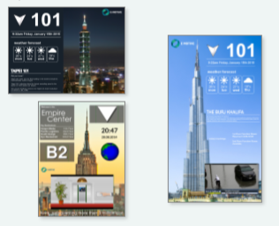

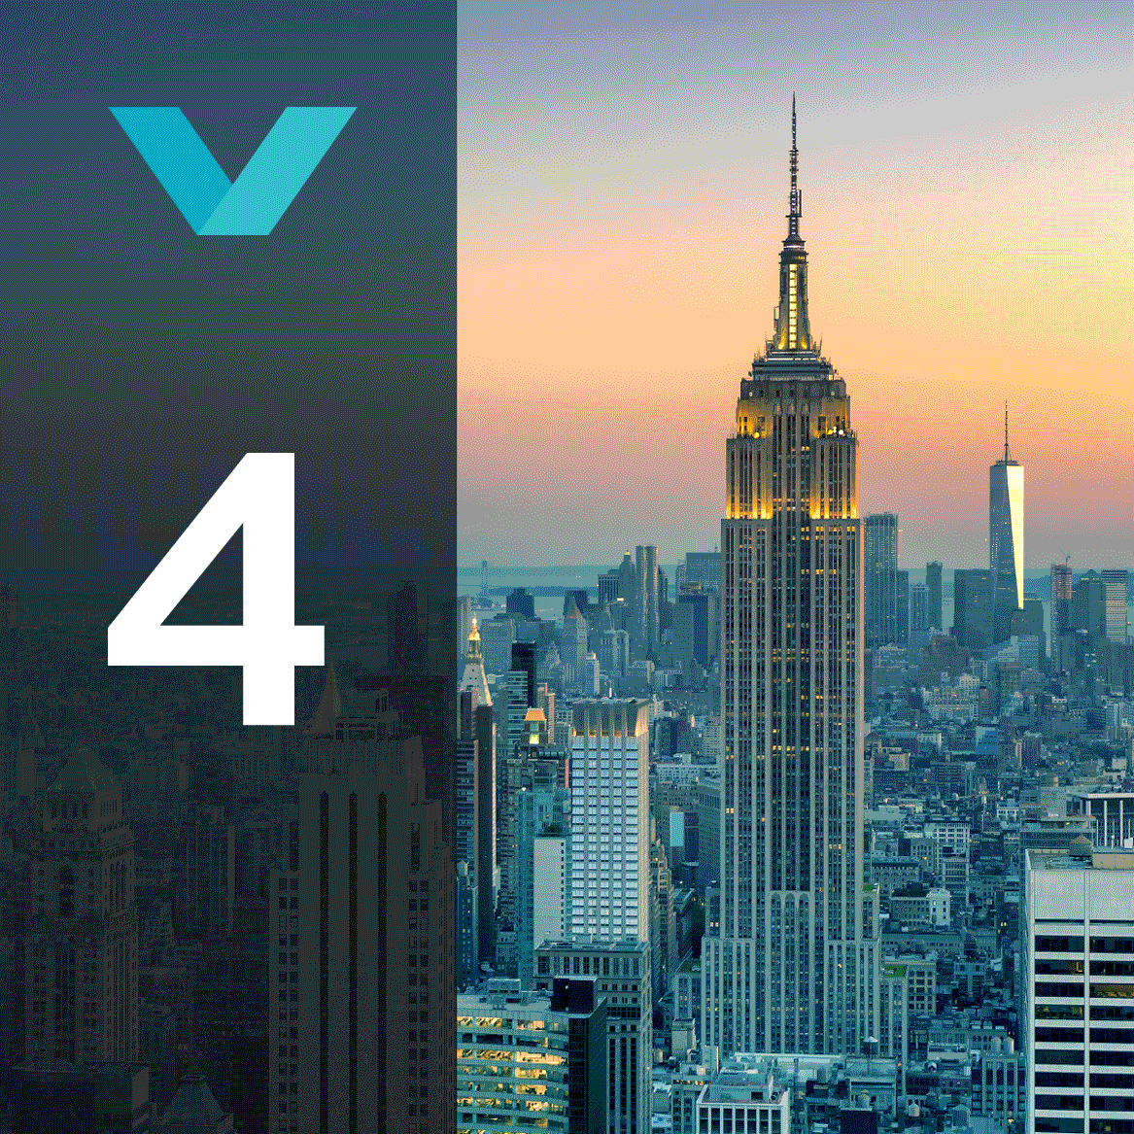
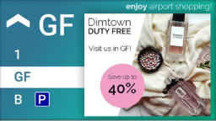

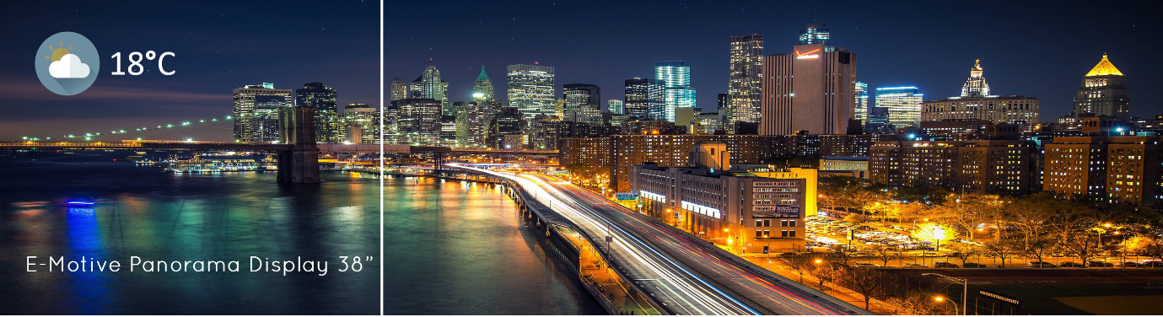

What is in scope for this project
- Up and down arrows both static.

File Formats
For Static Arrow:
Files in PNG format, as well as original design file (Adobe Photoshop ideally). Static arrows will generally fade in and out depending on if the lift is going up or down. Background must be transparent. Resolution 400 x 400.

Output Quantity
Type | Quantity | File Format
Static arrows | 5 | .PNG & Photoshop

