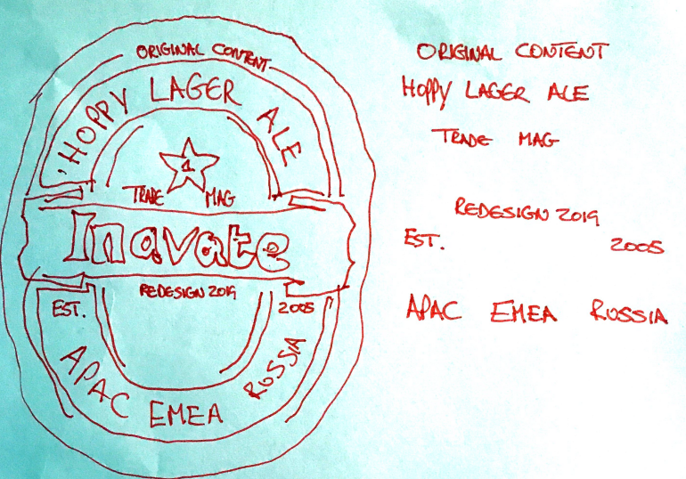
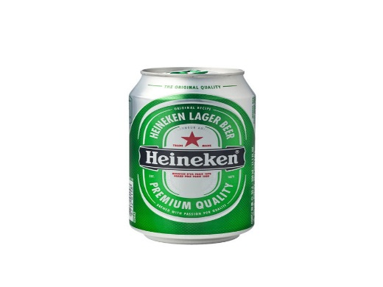
InAVate EMEA was launched in 2005 to satisfy
the demand for independent and authoritative
information about Pro AV technology, systems
design, integration and management.
Our industry knowledge and quick response to
market demands spurred the launch of the now
globally recognised InAVation Awards, Russian
language edition and InAVate APAC.

Raise a can to our new logo.
Drink to our new look magazine.

5.4% ABV – The Integrator’s Choice

