Capstone Project Mentors:
IFT | Dec 30, 2018 Professor Damien doheny
professor carlos rodriguez
Story Art.net
By bader alnaemy & chris rasmussen

Table of Contents
Table of Figures 3
Acknowledgement 4
Abstract 5
Team 6
Declaration of originality 7
Project overview 8
Project Description 8
Project Motivation 8
Project Goal 8
Project Target Audience 8
User Stories and Acceptance Criteria 9
User story 1 9
User story 2 9
User story 3 9
Personas 10
Development Tools 11
Languages 11
Front-end / Scripting language 11
Back-end languages 12
IDE 12
Deployment environment 13
Local-server 13
Local-database 13
Live-server 13
Live-database 13
USER Guide 14
Source Codes: 23
Collections Preview 23
Image Quick Preview 24
Update user profile 24
Art Storage Upload (PHP) 25
Art Storage Upload (JS) 25
Project Sketches 26
Flow Chart 27
Wire Frames 28
Login 28
Main page 29
ERD (Entity Relationship Diagram) 30
References 31

Table of Figures
Figure 1 - Persona Image (Lisa) 10
Figure 2 - Persona Image (Fred) 10
Figure 3 - Login Page 15
Figure 4 - Main Page (Before Login) 15
Figure 5 - Main Page (After Login) 16
Figure 6 - Home (Menu) 16
Figure 7 - Upload (Menu) 17
Figure 8 - Upload Page 17
Figure 9 - Category Selection 18
Figure 10 - Image Preview (Upload Menu) 18
Figure 11 - Upload Progress 19
Figure 12 - Manage Art (Menu) 19
Figure 13 - Art Management (Gallery Page) 20
Figure 14 - Edit Image 20
Figure 15 - Image Preview 21
Figure 16 - Artist Profile 21
Figure 17 - Update Profile 22
Figure 18 - Collections Preview Source 23
Figure 19 - Image Quick Preview Source 24
Figure 20 - User Profile Update Source 24
Figure 21 - Art Storage Upload (PHP Source) 25
Figure 22 - Art Storage Upload (JS Source) 25
Figure 23 - Flow Chart (Story Art) 27
Figure 24 - Login (Wireframe) 28
Figure 25 - Main Page (Wireframe) 29
Figure 26 - Entity Relationship Diagram (Story Art) 30

Acknowledgement
“Any accomplishment requires work and effort of many people. Therefore, it is our foremost duty to express our deep regards and gratitude to our Teachers (Prof. Damian Doheny, Prof. Carlos Rodriguez) under whose guidance and supervision we were able to undertake this project.
Secondly we would also like to thank our parents and friends who has helped a lot with support and valuable suggestions and feedback in finalizing the project within the limited time frame.”

Abstract
Our project is an attempt to fill in the gap left by traditional art websites with regards to users who are interested primarily in sequential images. StoryArt.net is an online image gallery with features that make it much easier for users to enter metadata for multiple files or display their art in any order of their choosing.

Team

Bader Alnaemy (Coder, Visual Designer, Document Technical Editor)
Bader chose the technology for the project, created the back end of the website, and coded most of the
front end. In addition to writing the code for the website functionality, Bader handled the appearance
for the site as a whole. He also created the visual design for both the poster and the booklet.

Chris Rasmussen (Artist, Site Architect, Writer)
Chris conceived and designed the overall website, creating the specifications for the features and
planning the site layout. He handled most of the writing and provided the majority of the art used in the
project.

Declaration of originality
StoryArt.net is a creation of Bader Alnaemy and Chris Rasmussen. Art displayed in the user gallery “Akemi” is used with the creator’s permission. All other art was either created by Chris Rasmussen or is unrestricted by copyright. This project has never been submitted to any other academic institution or business.

Project overview

Project Description
StoryArt.net is an online art gallery designed to display image collections and give artists greater control
over the uploading and displaying of their art, while simultaneously making it easier for viewers to locate and enjoy art that is meant to be viewed in a particular order.

Project Motivation
Virtually all popular art or image sites such as Imgur, DeviantArt, and Tumblr, are designed for browsing
of individual images; the methods for uploading a multi-image series are poorly implemented or
non-existent. Similarly, these sites are designed with the assumption that people may look for similar
images ("cute cats") but not exact images ("Mr. Whiskers' Bath"). The project was first conceived when
an attempt to upload, tag, and correctly arrange a set of 20 images took two hours.

Project Goal
The intent of this project is to accommodate artists who frequently create or look for image sequences,
a simple sounding task that is in fact rather difficult from a programming standpoint. The goal is to
drastically reduce the time and effort required to upload multiple images and make it easier for people
to view them in their intended order.

Project Target Audience
While anyone uploading large batches of images could benefit from our project's upload interface,
artists who use multiple images to form a narrative, such as comics, and anyone with a large amount of
metadata to apply to their images are likely to experience the most dramatic benefits from our website.

User Stories and Acceptance Criteria

User story 1
As an artist, I want to display my art online so other people can see it.
Acceptance criteria
- A person will be able to register an account on the website.
- A registered user will be able to upload files that are in standard image formats (jpeg, gif, png, etc.).
- Uploaded images will be viewable to anyone visiting the website.

User story 2
As a gallery owner, I do not want to have to enter the same information repeatedly when I upload files. Acceptance criteria
- At any point while entering metadata for one of multiple files to be uploaded, the user will be able to copy the entered information to all other files in that upload.
- The user will be able to edit the metadata of individual files.

User story 3
As a comic reader, I want to be able to go directly from one page to the next page in the comic. Acceptance criteria
- The page displaying an image within a folder will contain direct links to both the previous image and the next image within that folder.

Personas
Lisa    Figure 1 - Persona Image (Lisa) | - Has a degree in graphic design  - Works as a graphic artist in the video game industry  - Writes and illustrates their own comics, which is available for free online | - Wants to eventually create comic books for a living  - Uses their free comics to practice their skills and learn what their strengths and weaknesses are
Fred    Figure 2 - Persona Image (Fred) | - Is a sophomore in college  - Plans on becoming a software engineer.  - Is a big fan of science-fiction | - Spends much of their leisure time on the internet  - Prefers free comics and stories due to budget constraints

Development Tools

Languages

Front-end / Scripting language

HTML5
The standard programming language for explanation of the appearance and the contents of the web pages, HTML (Hypertext markup language). Html5 is an upgrade for standard html. The design goals for html5 is to provide enough support for multimedia on devices that require responsiveness i.e. mobile devices. It also provides adequate new ways in which it enhances the interaction with documents i.e. parsing rules, new attributes, protocol and MIME handler registration. (Dymock, 2018)

CSS3
Including colors, layouts, fonts etc. CSS is the language for describing the presentation for web pages. CSS level 3 is an upgrade from CSS level 2. The main advantages include introduction of modules. The purpose of modules is it allows the completion and approval of specifications more swiftly. The new features also include selectors, text effects and layout, page generated and media content, multi-column layout etc. (Bradley, 2006)

Bootstrap
Bootstrap is the framework for designing web applications and websites. Bootstrap can be categorized down to three main files:
- bootstrap.css – a CSS framework
- bootstrap.js – a JavaScript/jQuery framework
- glyphicons – a font (an icon font set)
Additionally, bootstrap requires jQuery to work. (Kira, 2017)

JavaScript
When we discuss the building blocks of a web page, JavaScript comes at the third place. Html and CSS being the other two. JavaScript is a scripting language. The programs in this language are called scripts. They can be written right in the HTML and executed automatically as the page loads. The browser compiles the JavaScript code. JavaScript is also used to make changes at the front-end of the web page based on user’s action on runtime. (Bouwkamp, 2016)

jQuery
jQuery is a comprehensive, fast JavaScript library. jQuery simplifies HTML document traversing, event handling, animating, and Ajax interactions for rapid web development. The purpose of jQuery is to make use of JavaScript much easier. It simplifies JavaScript. jQuery has built in functions that are programmed in JavaScript. (Narayan, 2011)

Back-end languages

PHP (CORE)
PHP is the server-side scripting language. To fetch a record from the database and display it on the front-end of the page, PHP is used followed by the MySQL queries. Unlike html, css and other scripting languages, php runs on the server. PHP is server-side scripting language, it executes on the server and only the output is downloaded on the client's computer. (Sonali, 2007)

MYSQL
MySQL is a relational database management system based on SQL – Structured Query Language. The language is used for a wide range of purposes, including data e-commerce, and logging applications.
The most common use for MySQL however, is for the purpose of a web database. It can be used to store anything from a single record of information to an entire inventory of available products for an online store. (Moore, 2018)

IDE
Notepad++

Deployment environment

Local-server
WAMPSERVER 3.0.6 (64-BIT):

Local-database
phpMyAdmin

Live-server

GoDaddy INC. [US]
Economy hosting:
- 1 CPU
- 512 MB RAM
- 250,000 FILES
- 100 ENTRY PROCESSES

Live-database
phpMyAdmin

USER Guide



User Guide
1. Type https://storyart.net/login.php in browser for login
2. Type https://storyart.net to go to the main page

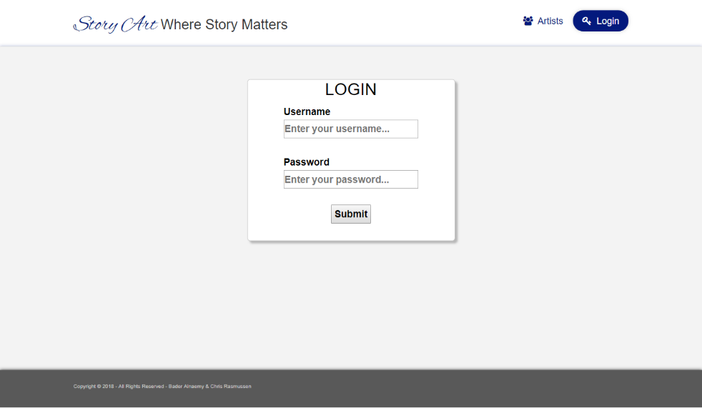
Two options are available at the login page:
- Artists
- Login: Enter the username and the password and press “Submit” button

Figure 3 - Login Page

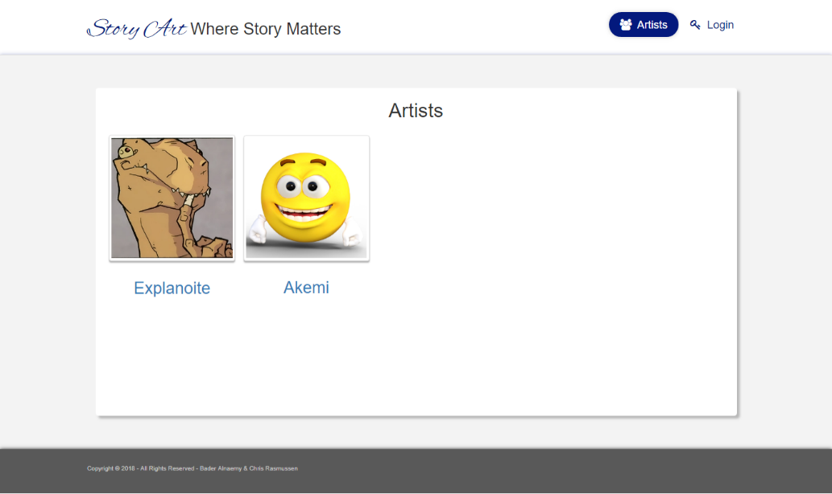
Artists page will show all the artists of the site, by clicking on the avatars, the user can view their gallery.

Figure 4 - Main Page (Before Login)

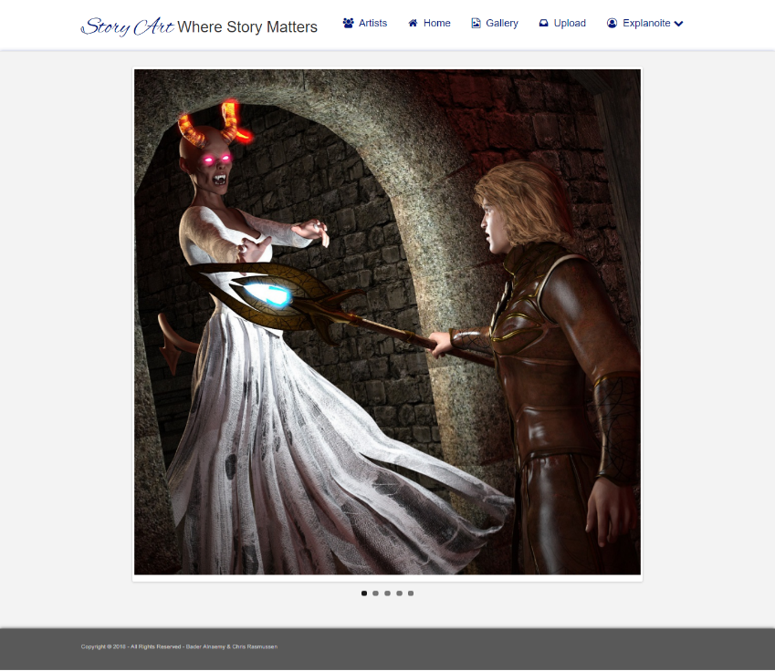
The options available at the main page are:
- Artists
- Home
- Gallery
- Upload
- Dropdown with profile and other options

Figure 5 - Main Page (After Login)
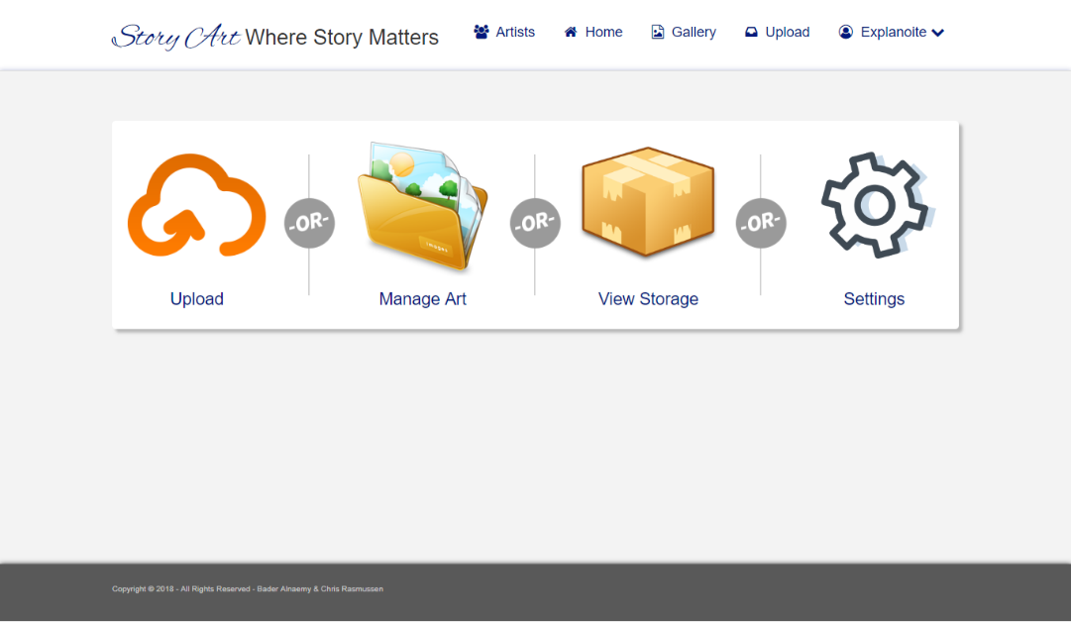
“Home” has the following options:
- Upload
- Manage art
- View storage
- Settings

Figure 6 - Home (Menu)

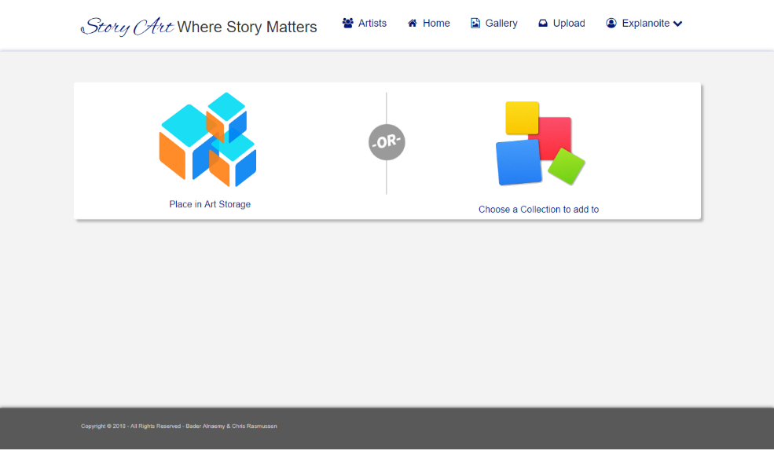
From uploads we can either upload in “Art Storage” or in “Collections”

Figure 7 - Upload (Menu)
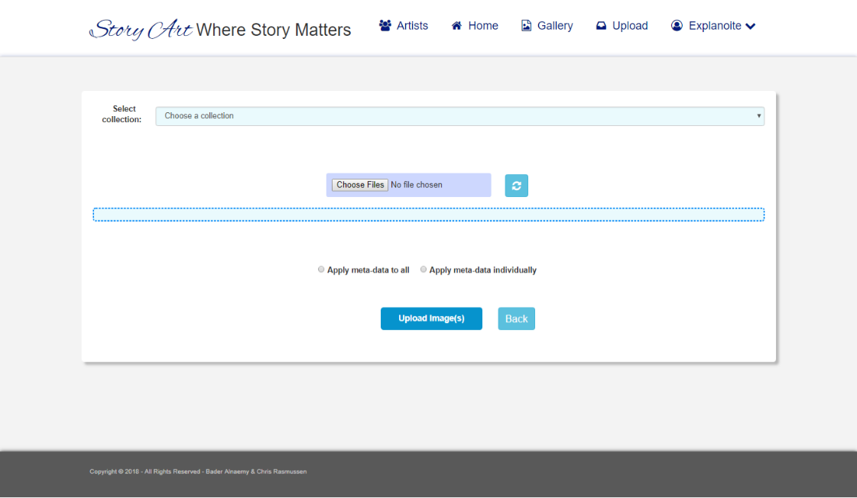

The upload page rather looks simply but with a lot of handy features. In order to upload image(s), you can follow the following steps.

Figure 8 - Upload Page

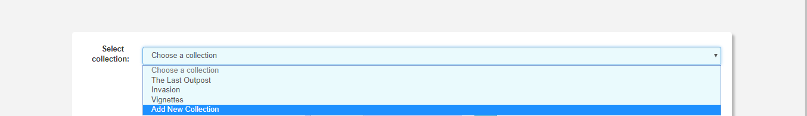
Figure 9 - Category Selection
Choose an existing collection or add a new collection.

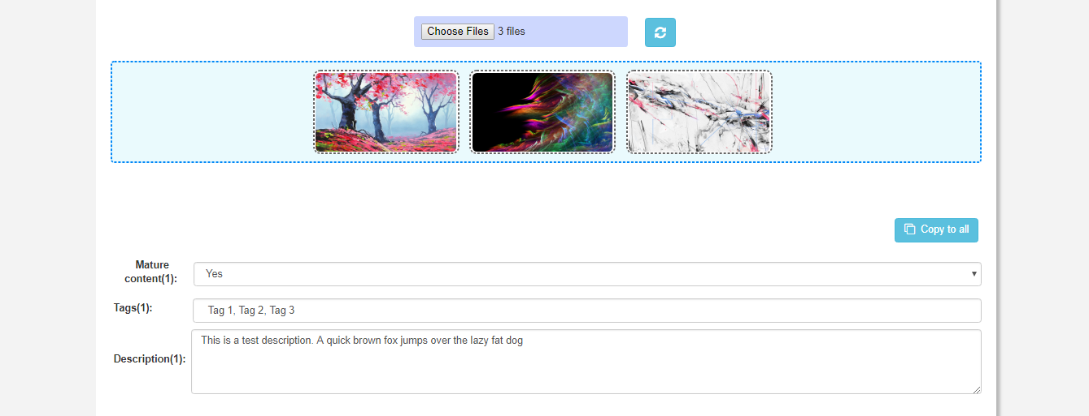
Figure 10 - Image Preview (Upload Menu)


You can upload a single image or multiple (max 20). The images can be dragged left and right in order to decide in which order they will be displayed in the gallery to the user. Each image has its own meta data (mature content, tags, description). You can add the meta data individually or can click on “copy to all” button to copy same info to all the images. If you want to make a change you can click on “refresh” button.

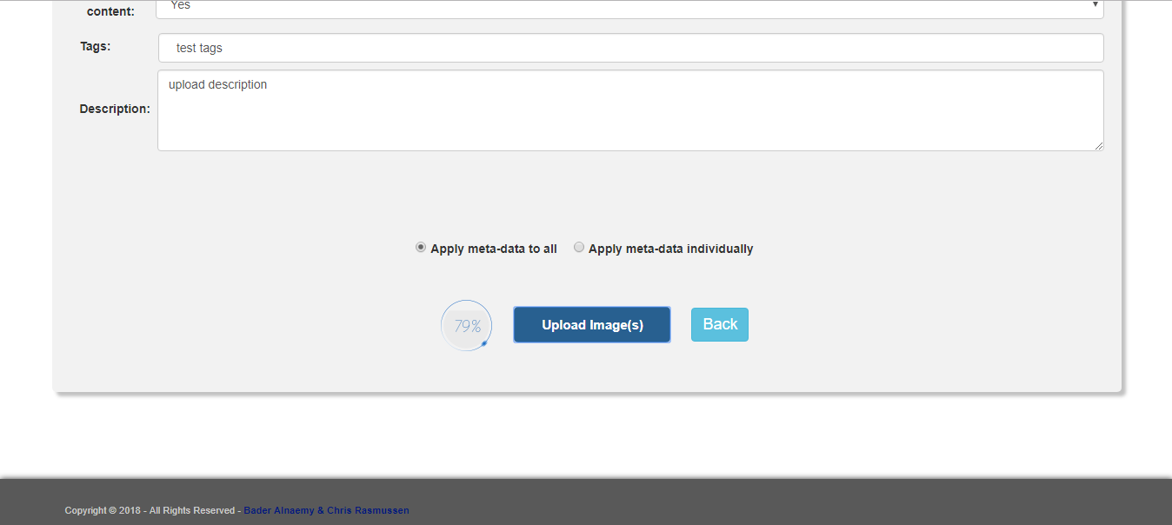
Figure 11 - Upload Progress
When “apply meta-data to all” is selected, all fields are hidden and only one set of meta-data fields are shown which will apply on all the images and when “apply meta-data individually” is selected, the meta-data can be entered for each of the fields. The upload progress will be shown when the upload image button is clicked.
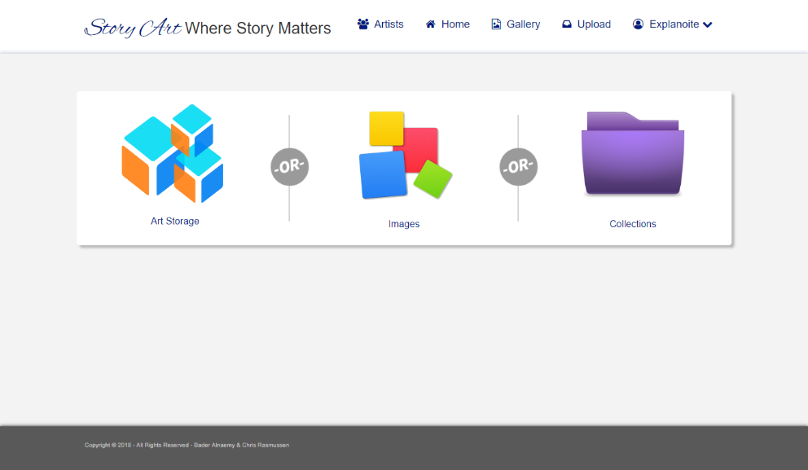

The “Manage Art” option under “Home” allows the user to manage uploaded art work or even the complete collection can be deleted.

Figure 12 - Manage Art (Menu)

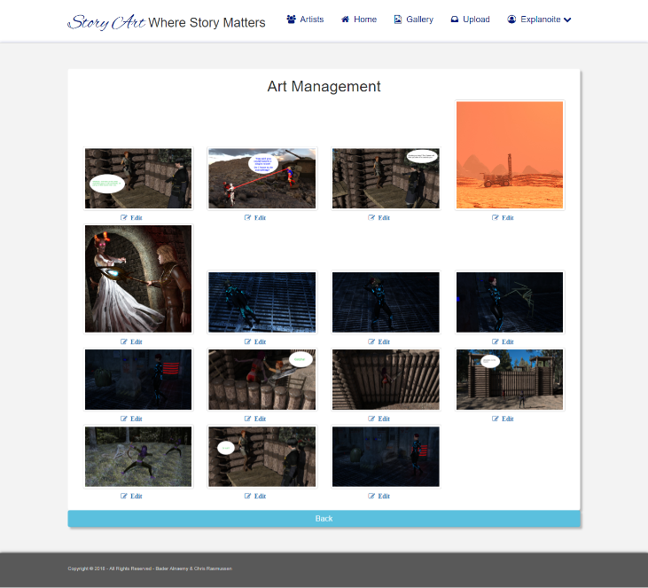

User may click the “Edit” option to navigate to edit menu for a particular image.

Figure 13 - Art Management (Gallery Page)
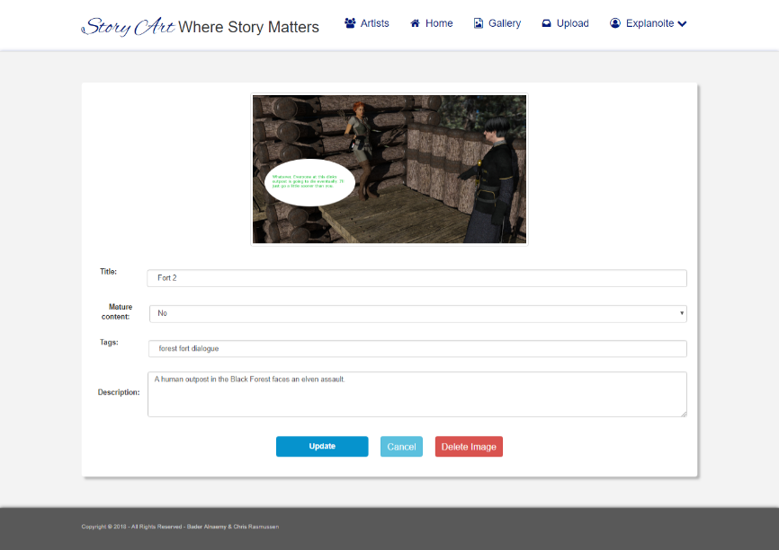

Image can be deleted by pressing the “delete image” button or the image meta-data and title can be updated

Figure 14 - Edit Image

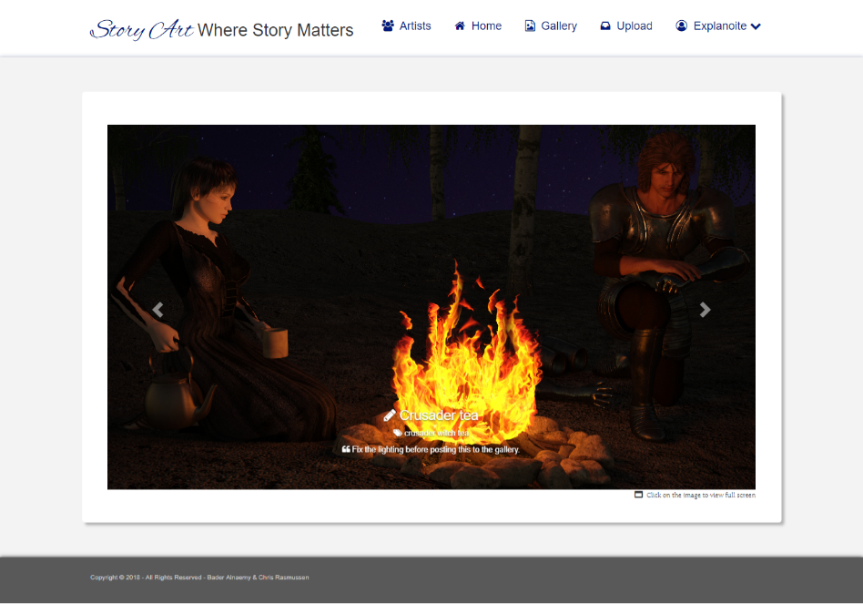
Figure 15 - Image Preview
When an image is opened from a gallery, other images in that gallery can be scrolled using the arrows on either side of the image. To view the image full screen “click” on the image.
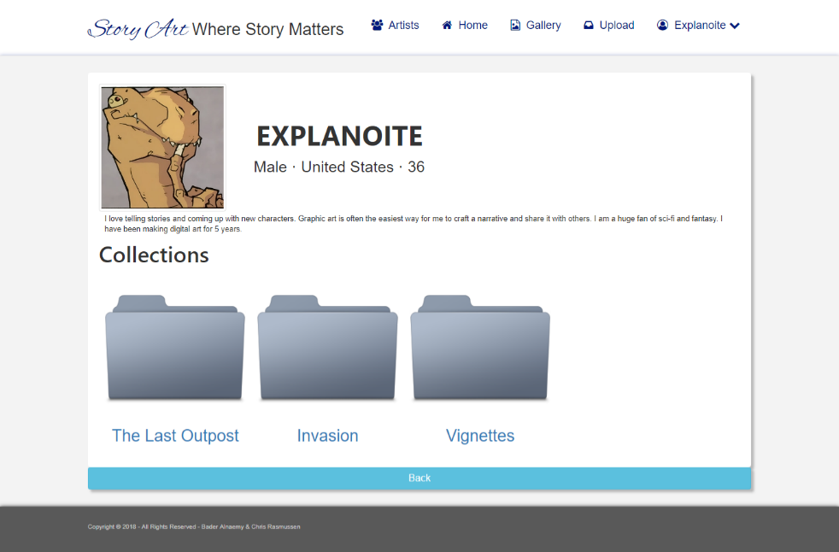
Figure 16 - Artist Profile
Clicking on the “Gallery” option on the top menu shows the logged in user’s gallery.

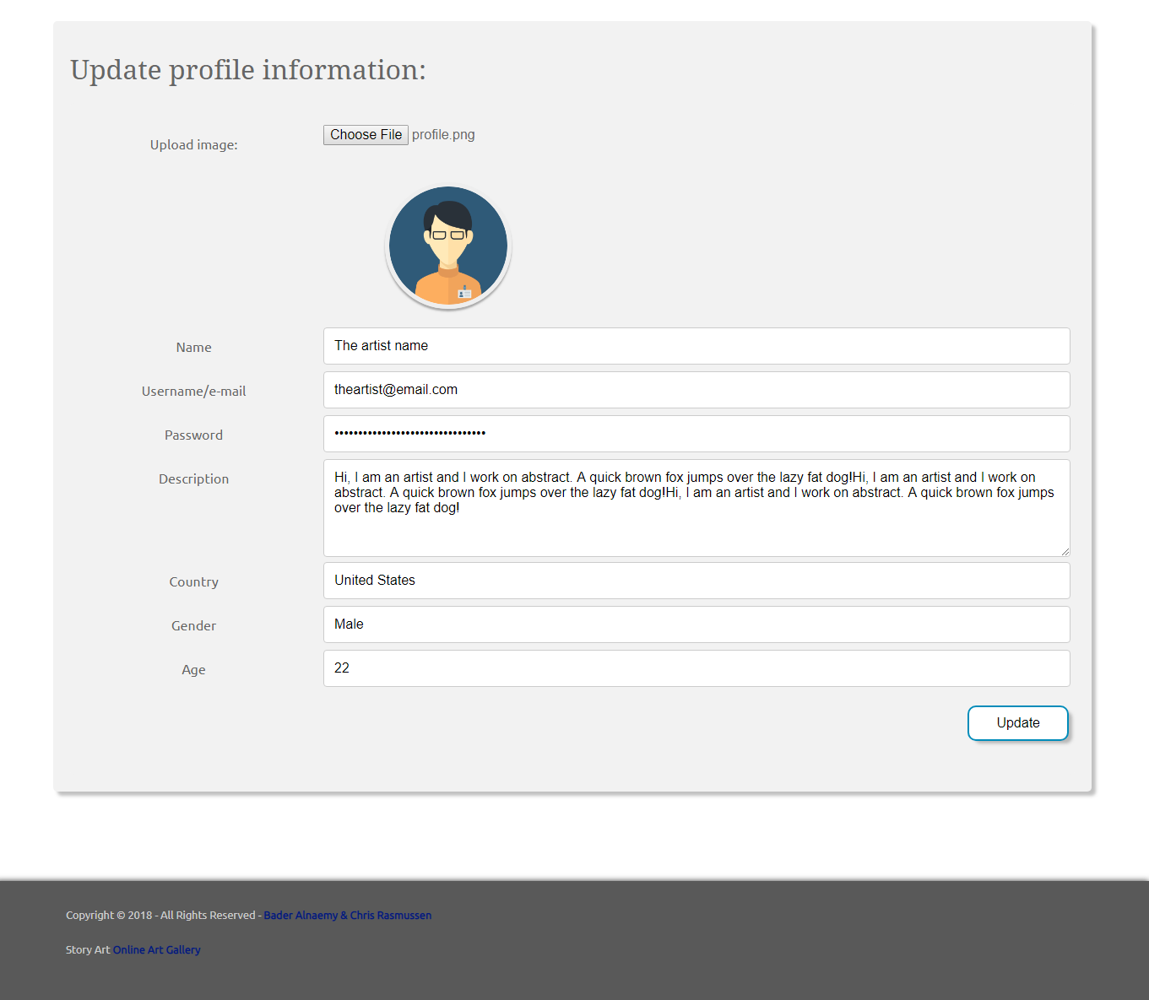

The “User settings page” allows the user to edit the profile information and update the profile avatar.
Note: If a new avatar is not uploaded, the system keeps the old one.

Figure 17 - Update Profile

Source Codes:

Collections Preview
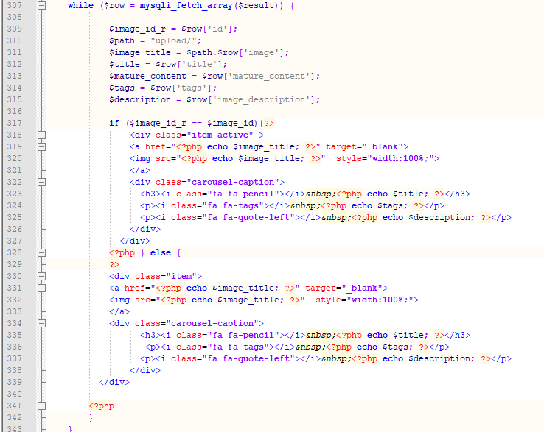
Figure 18 - Collections Preview Source

Image Quick Preview
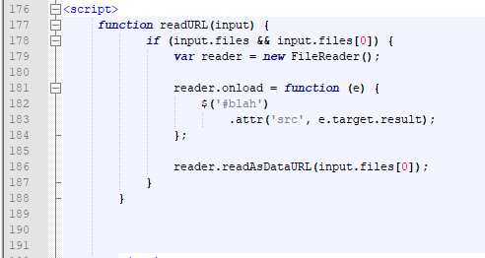
Figure 19 - Image Quick Preview Source

Update user profile
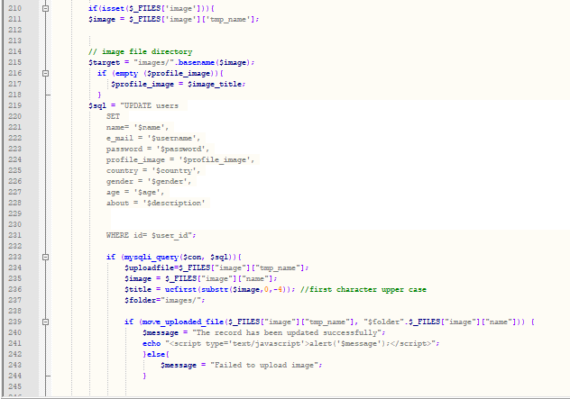
Figure 20 - User Profile Update Source

Art Storage Upload (PHP)
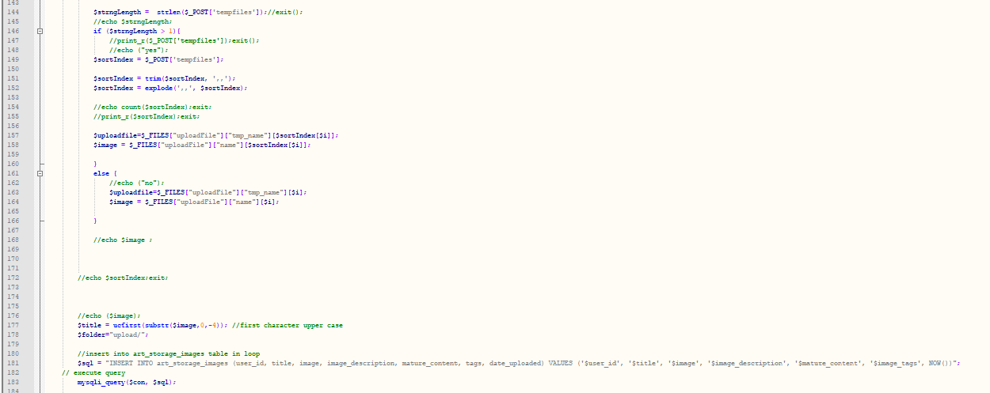
Figure 21 - Art Storage Upload (PHP Source)

Art Storage Upload (JS)
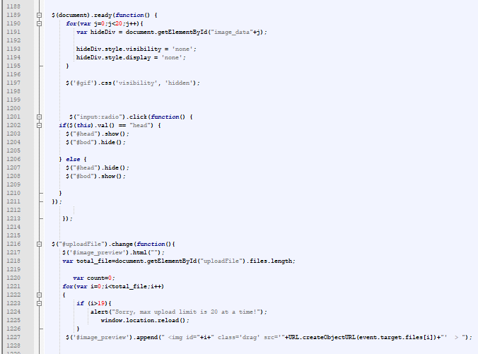
Figure 22 - Art Storage Upload (JS Source)

Project Sketches



Flow Chart
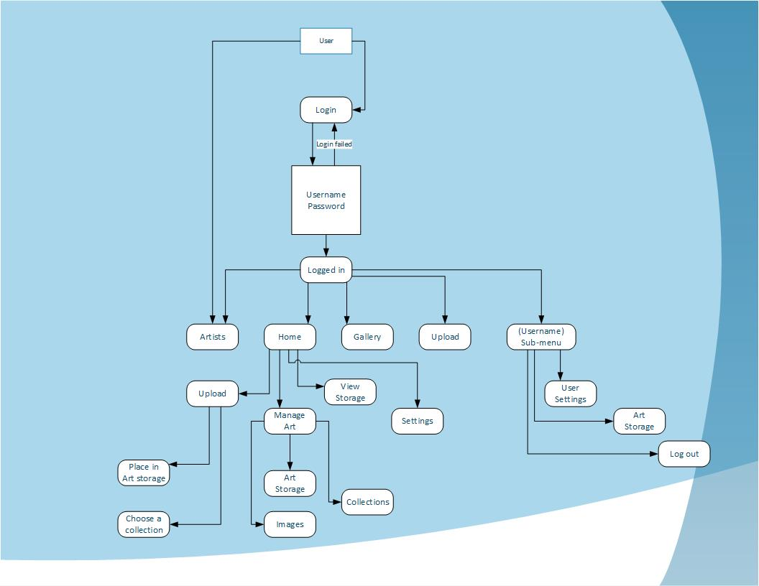
Figure 23 - Flow Chart (Story Art)

Wire Frames

Login
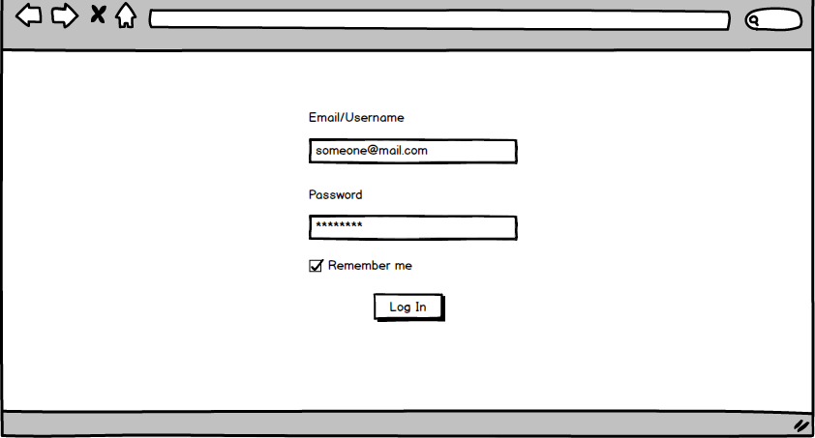
Figure 24 - Login (Wireframe)

Main page
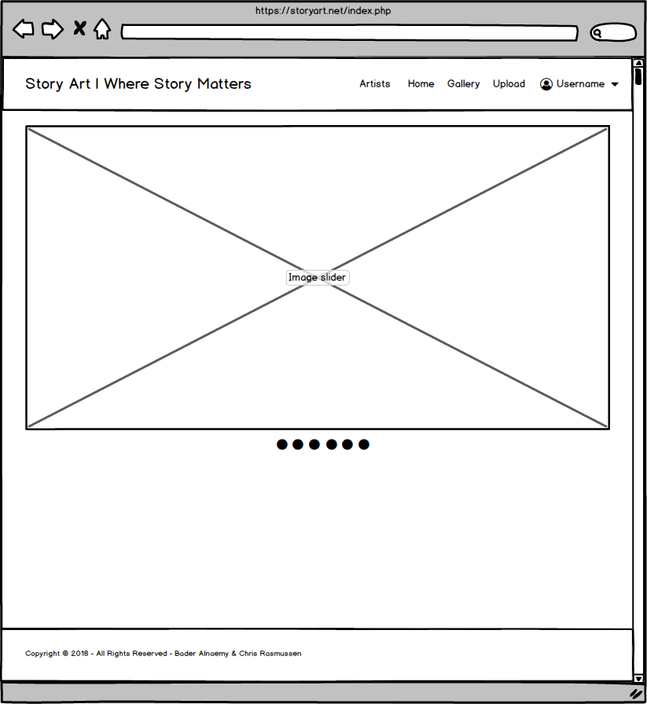
Figure 25 - Main Page (Wireframe)

ERD (Entity Relationship Diagram)

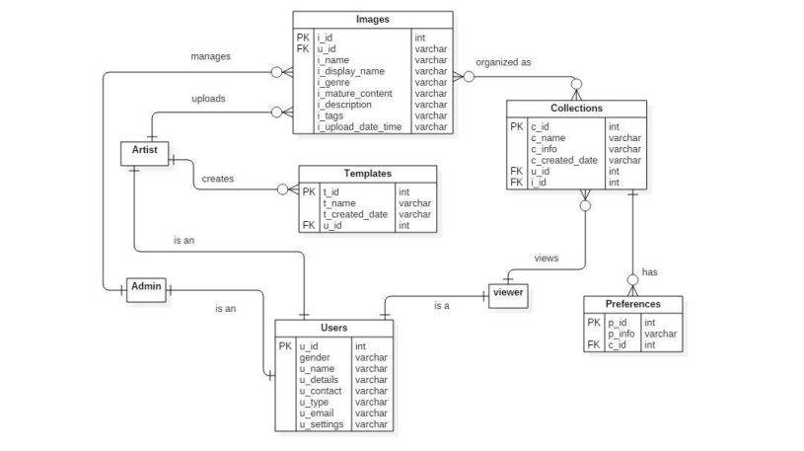
Figure 26 - Entity Relationship Diagram (Story Art)

References
Bouwkamp, K. (2016, May 24). What is JavaScript and Where Can I Learn It? Retrieved from Coding Dojo: https://www.codingdojo.com/blog/what-is-javascript/
Bradley, S. (2006, March 14). The Benefits Of Cascading Style Sheets. Retrieved from Vanseo Design: https://vanseodesign.com/css/benefits-of-cascading-style-sheets/
Dymock, S. (2018, 08 25). How can HTML5 & CSS benefit your business? Retrieved from Byte9: https://www.thebyte9.com/news/how-can-html5-css-benefit-your-business
Kira. (2017, March 24). What Is Bootstrap and How Does It Help Me? Retrieved from Simbla: https://www.simbla.com/post/what-is-bootstrap
Moore, J. (2018, Feb 18). What Is MySQL and Why It Is the World’s Most Popular Open Source Database. Retrieved from MySQL Tutorial: http://www.mysqltutorial.org/what-is-mysql/
Narayan, S. (2011, Feb 22). What is jQuery and How to Start using jQuery? Retrieved from Code Project: https://www.codeproject.com/Articles/157446/What-is-jQuery-and-How-to-Start-using-jQuery
Sonali. (2007, APR 10). PHP Programming. Retrieved from EUKHOST: https://www.eukhost.com/blog/webhosting/advantages-of-php-programming/

