Monday Night Specifics

Tailgating Games- Outside Venue @ Tropics Terrace 6-10pm
Backup Space is the Pavilion

Break everyone up into Teams - 11-12 teams of 8 each
Wear a Field Pass for entry
Wear your favorite Team Jersey, T-shirt, etc.
Have fight songs playing in the background along with Tailgating songs
Are we giving away anything?

Icebreaker – 2 Truths & 1 Lie
Tailgating Games Include:
(3) LED Giant Beer Pong
(4) LED Mini Golf
(3) LED Corn Hole
(2) Giant Jenga
(2) LED Disc Golf
- Need to add music (Streamed) is there a restriction? How much for Speakers?
- Are we adding too much to one night with 2 Truths and 1 Lie?
  - Could we build this via Video and they play via there phone (quizlet)

- What will be utilized to Track results? (Online?)
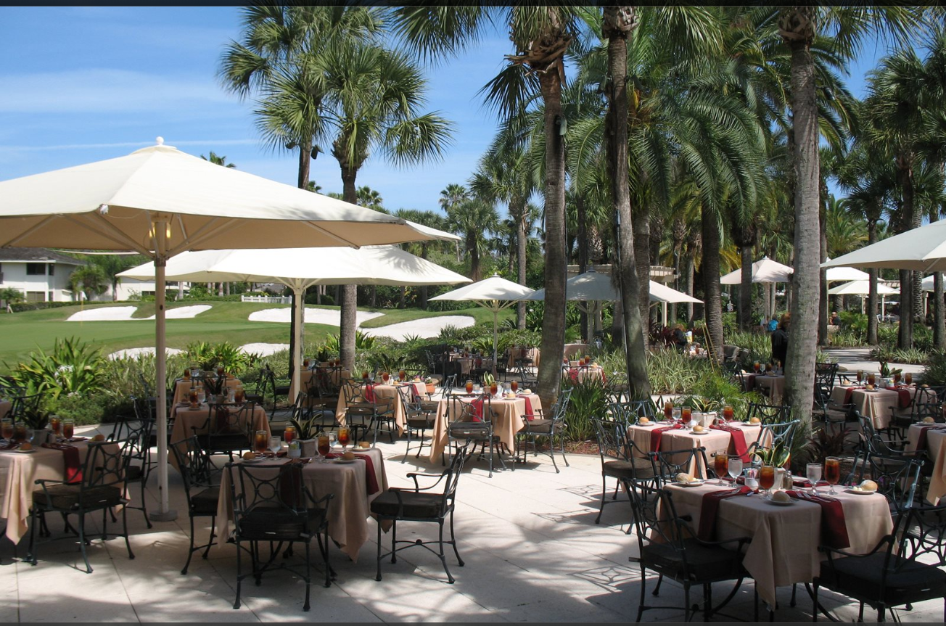
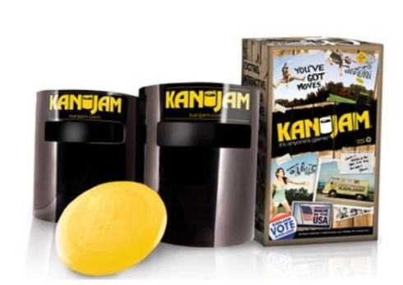
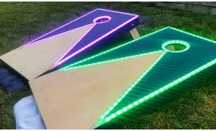
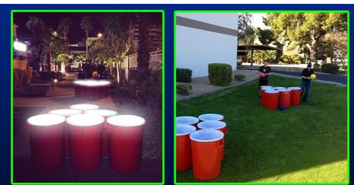
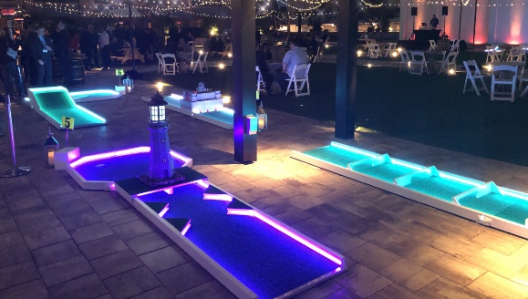

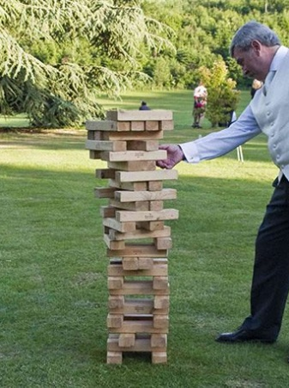

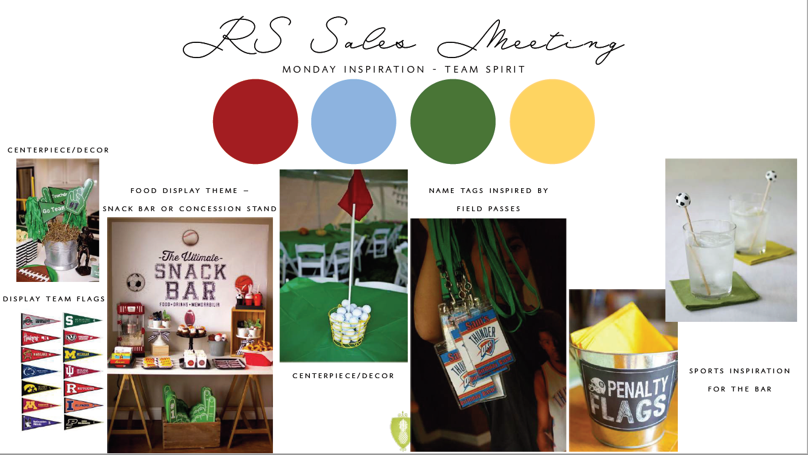

Tuesday Night – Inside Venue @ Lagoon Pavilion
Kentucky Derby Theme with 6- 8 races (2 hours)
Break into Teams and have a TEAM Pot for which you have to place your bets from.
Top team will receive a prize
Hotel will provide Facilitators
Bar and MC and Money booth
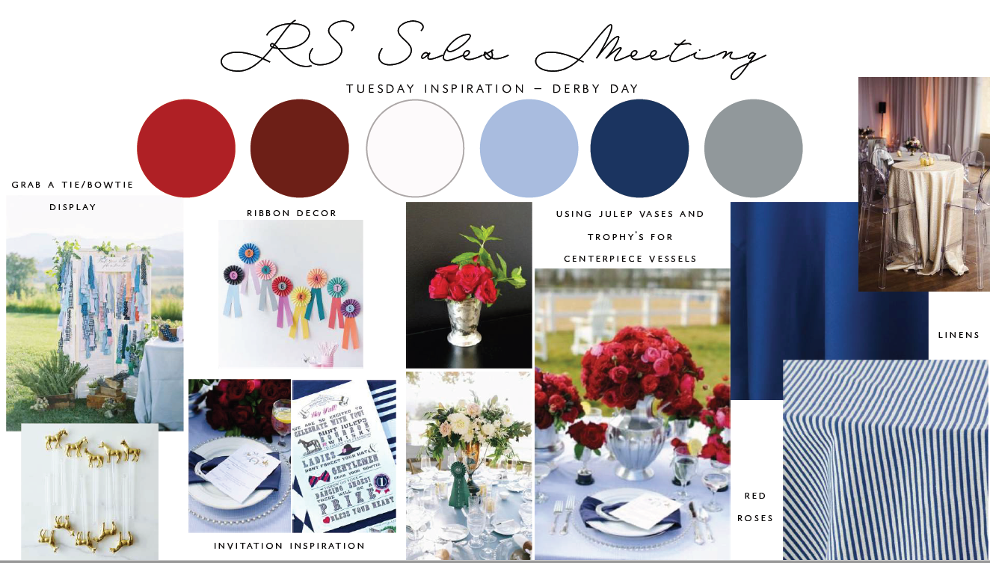

Award Night – Inside @ Lagoon Pavilion
Cocktail Hour – Comfort seating area
Dinner served in an additional area
Pre-Award Entertainment – Jimmy Fallon Skit(s)
Many themes we could run with here – Continue with the Green Grass theme.
Create a Backdrop with Lights and Theme on Raised Stage
- do theater seating in that part of the pavilion

