Kundalini Yoga
Adult Winter Session 2019

Exchange: $120. email to Register gracefulevolutionyoga@gmail.com
DATES: January 21, 28, February 4, 11, 18, 25, March 4, 11, 18, 25
Location: McBEth house Centre. 31 McBeth St, Winnipeg, MB
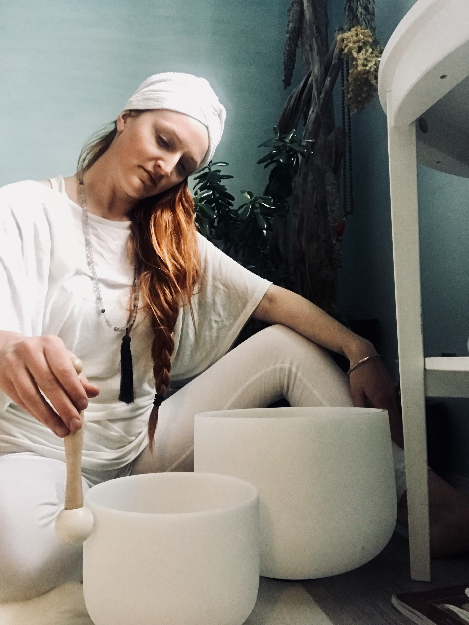

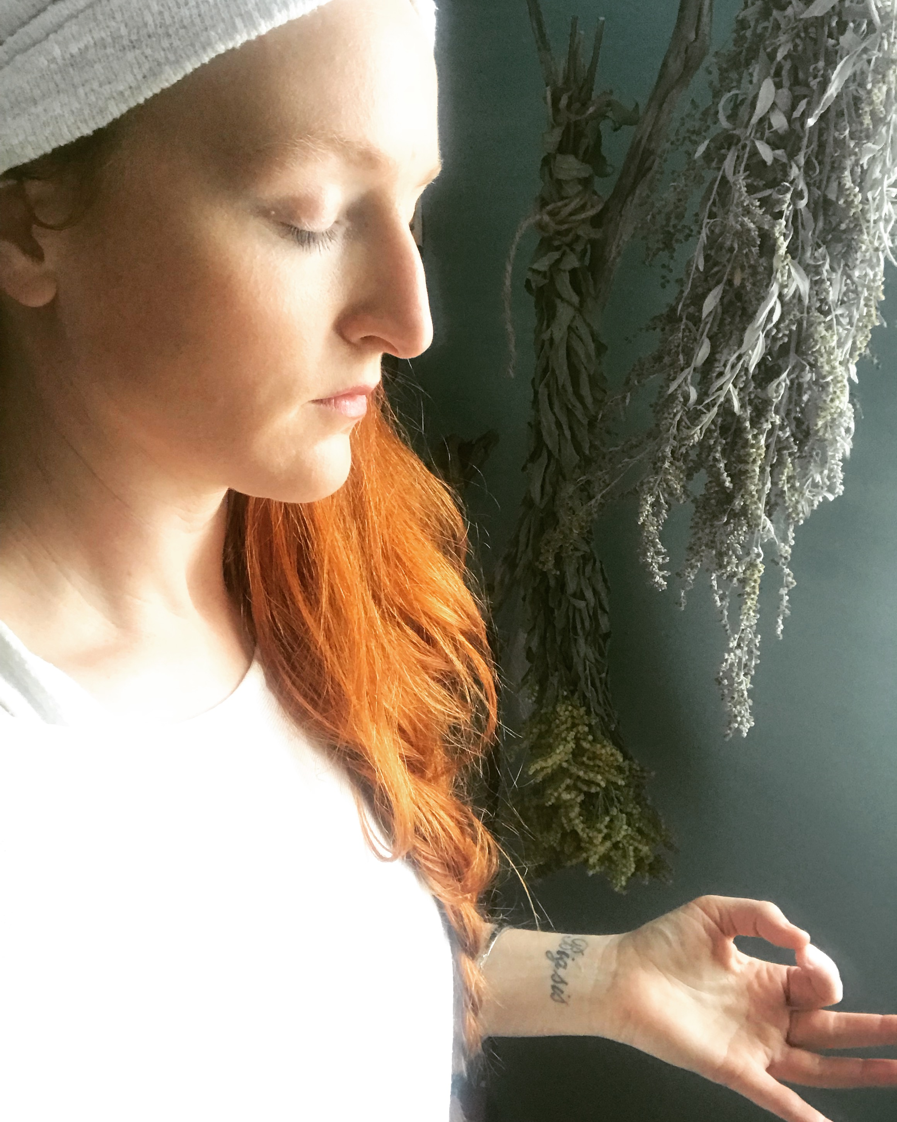
join me for a 10 week Journey through the chakras


