Awakening Intentions  ~Retreat~ | 
 | 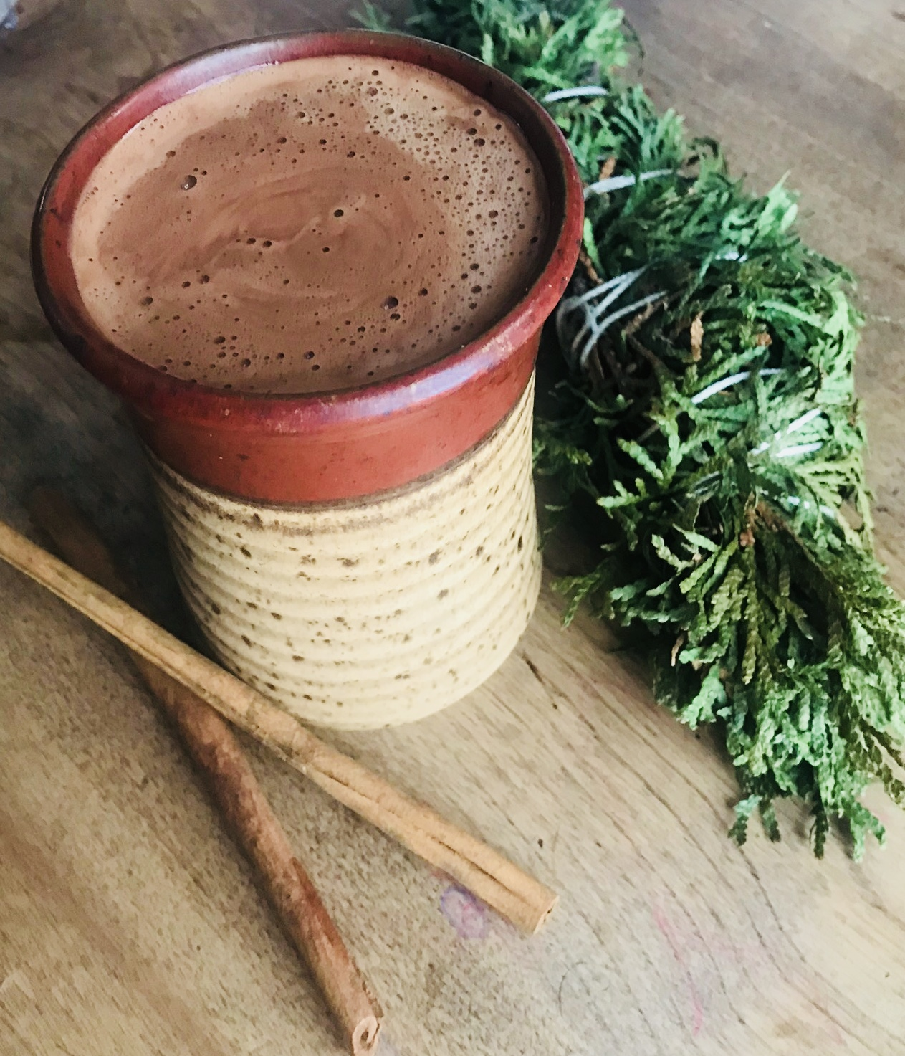

  - Serene ECO-Lodge, Onanole, MB
  - January 11, 12, 13, 2019
Here’s to a New Year of New Intentions!. Experience 3 days of freshly prepared Ayruvedic inspired meals & beverages, 2 morning Kundalini Yoga Classes to rejuvenate & balance the body, 2 Yin Yoga Classes in the evening. Unwind with a combination of Hot Stone Massage & Ayruvedic Facial for deep relaxation & radiance, PLUS Reiki treatments for whole energy alignment. REGISTER gzoppa@hotmail.com, gracefulevolutionyoga@gmail.com, or PM us on Facebook
EARLY BIRD Price $399 (register before Dec 25, 2018) $439 (Dec 26-Jan 7th) **SPACE LIMITED**
* SOUND * SACRED BODY TREATMENTS * FACIALS

A Deeply Nourishing Experience
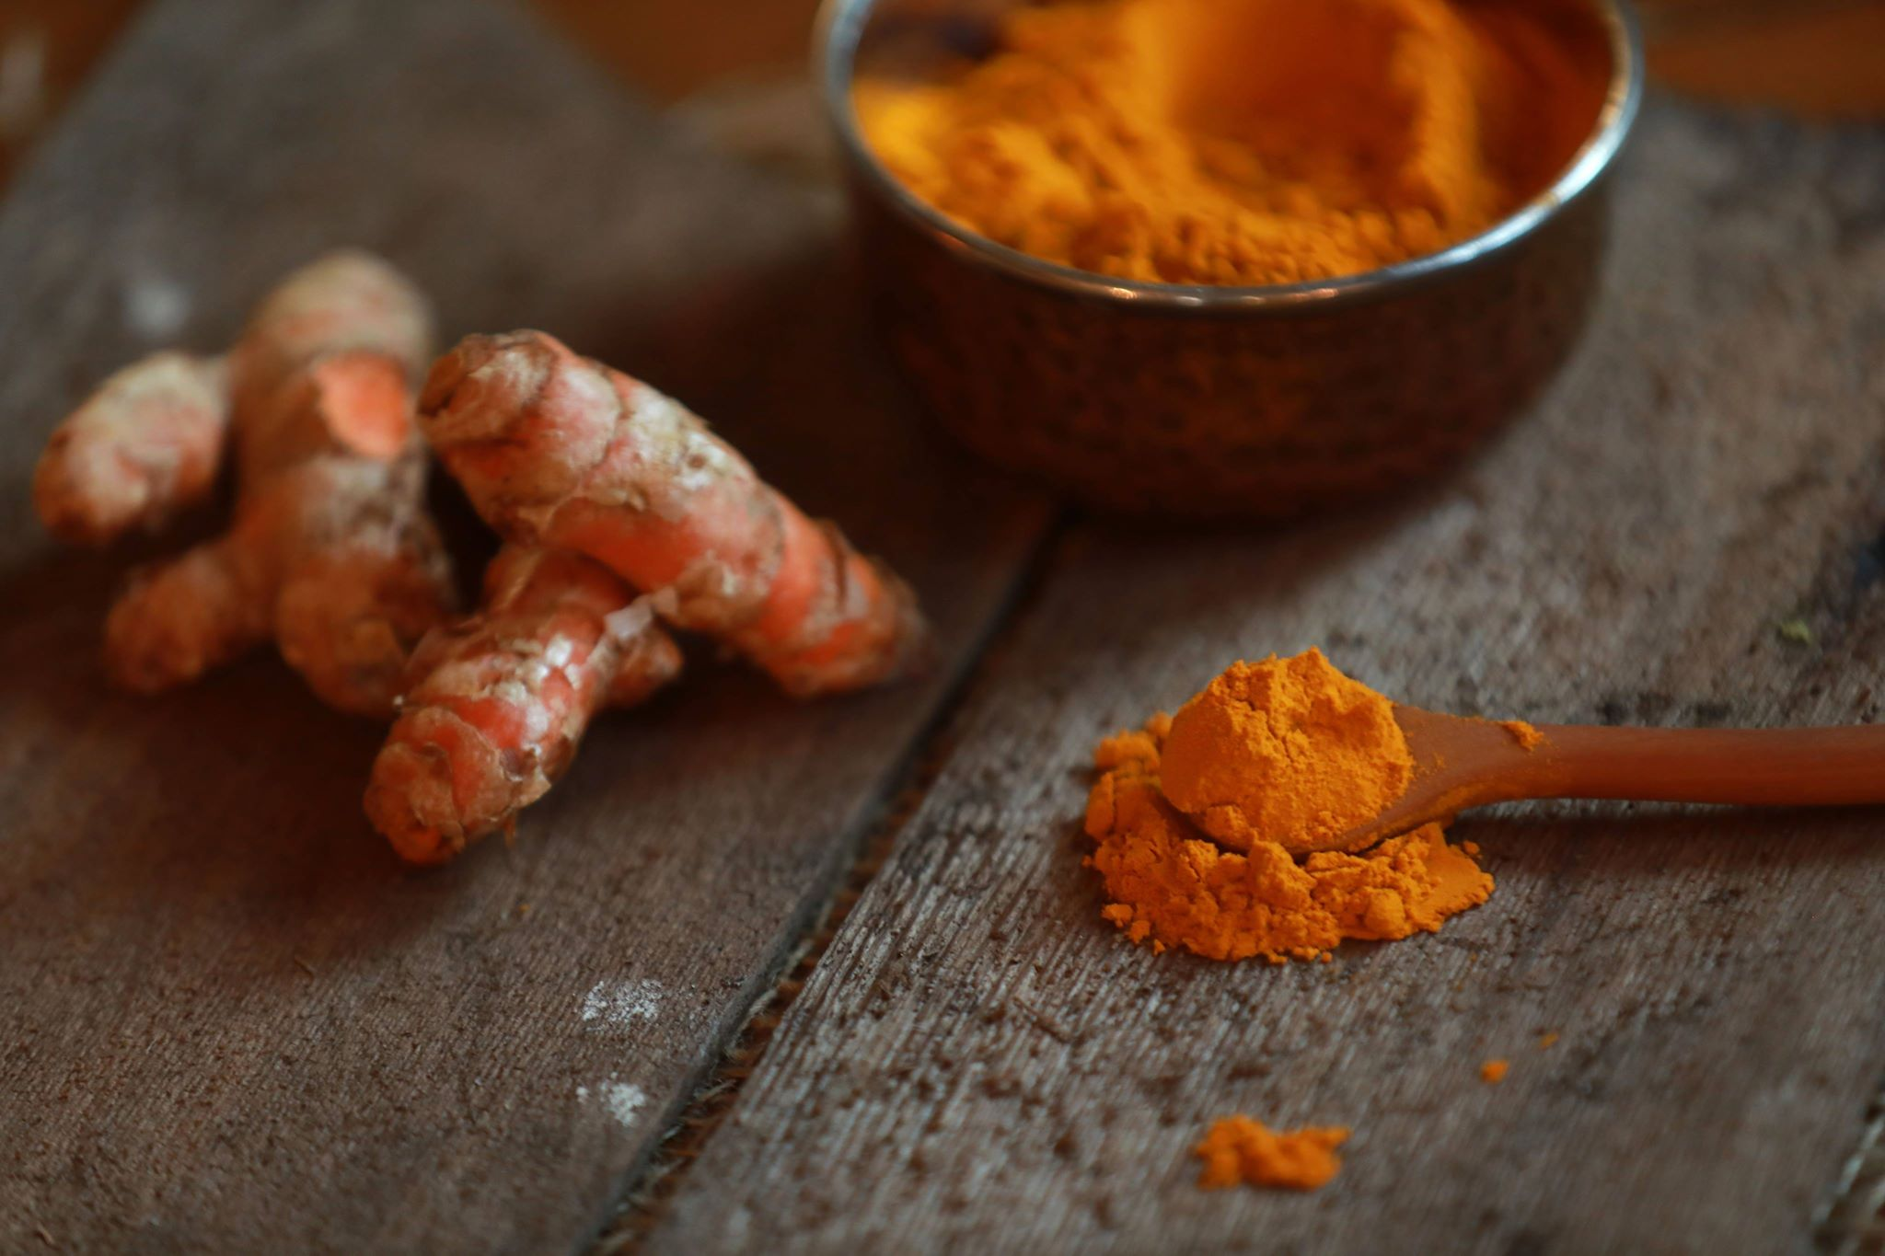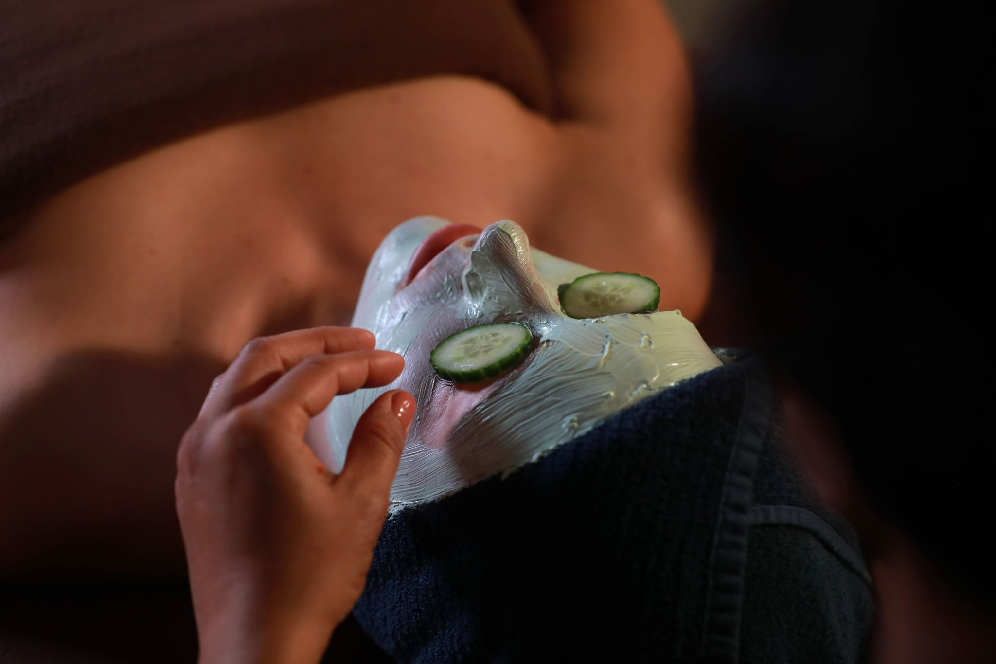

REIKI, HOT STONE MASSAGE, AYRUVEDIC FACIAL
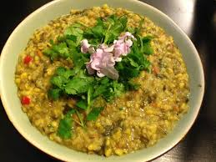

NOURISHING PLANT BASED MEALS

Balance the Doshas, strengthen your Agni, and nourish the body, with organic, fresh ingredients, prepared with love, and blessed with Reiki


KUNDALINI YOGA: Yoga of Awareness, PLUS Evening Yin Yoga
Summon your kundalini energy, revitalize your cells, balance the chakras, recharge and most importantly, relax deeply.
A Divine Collaboration Brought to You By: Spa Botanica, Graceful Evolution & Phoenix Rising
