Kundalini Yoga
Adult Winter Session 2019

Exchange: $100. email to Register gracefulevolutionyoga@gmail.com
DATES: January 22, 29, February 5, 12, 19, 26, March 5, 12, 19, 26
Location: ~HOME STUDIO LOCATION~ EAST SELKIRK, MB
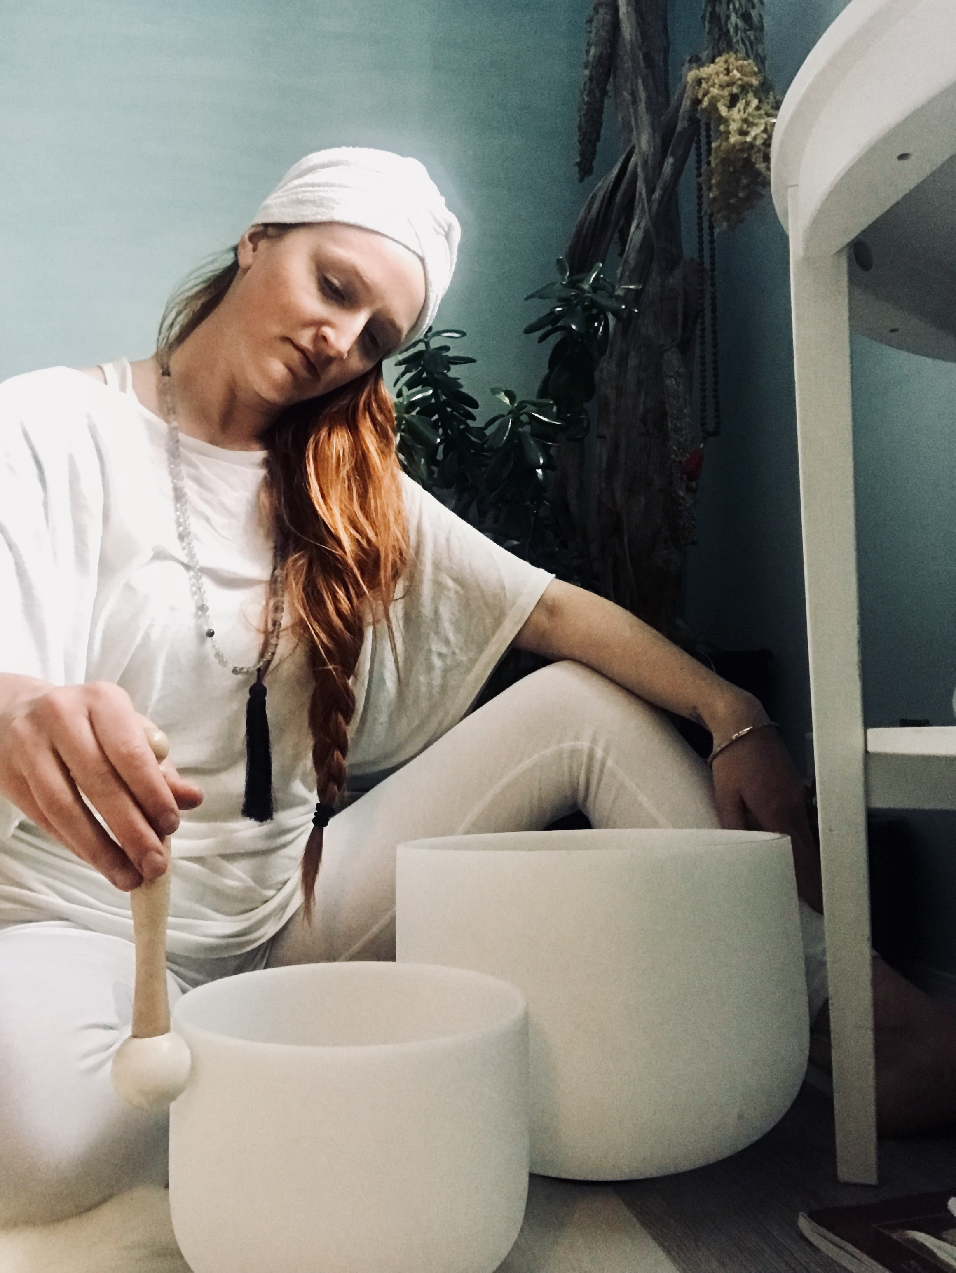

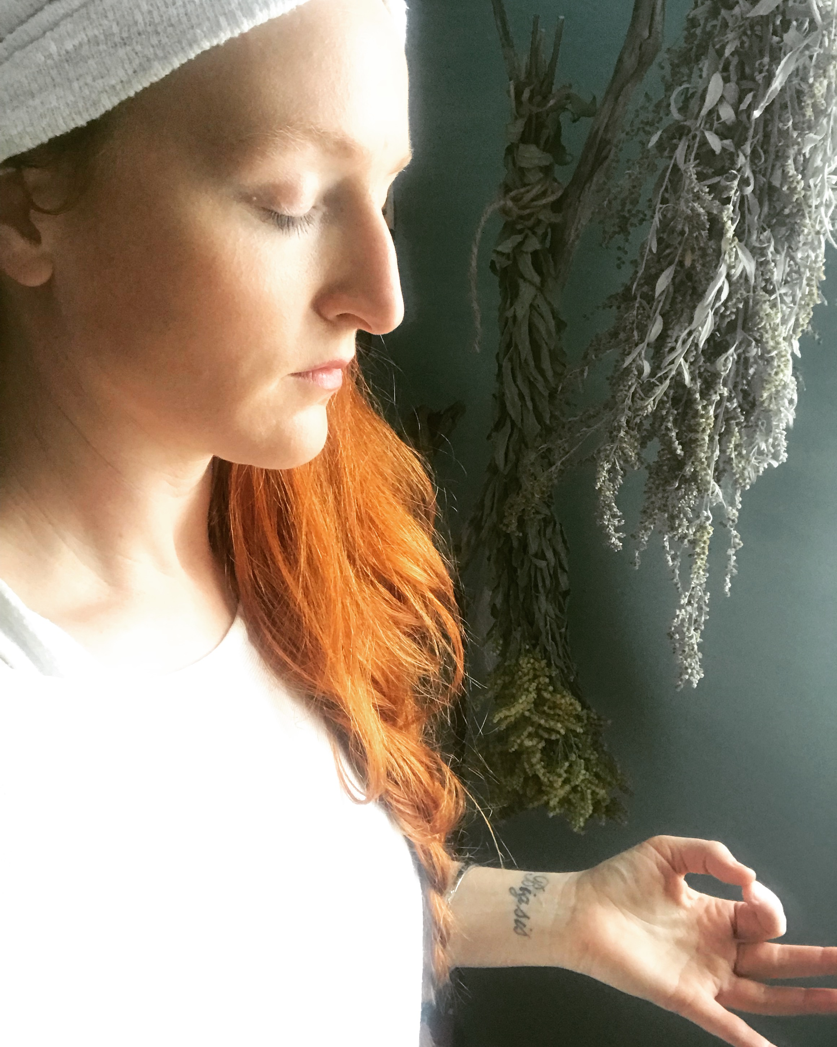
join me for a 10 week Journey through the chakras


