VISUAL GUIDE TO THE TYPE OF STYLE I AM LOOKING FOR:
Example 1:
I like this because the symbol breaks up the word. The word MYND would look interesting in this arrangement (with a less prominent TRIBE added). The symbol does not need to be an asterisk, it could be anything. The simplistic font is bold. Eventually the symbol in the middle may be used to represent the brand.
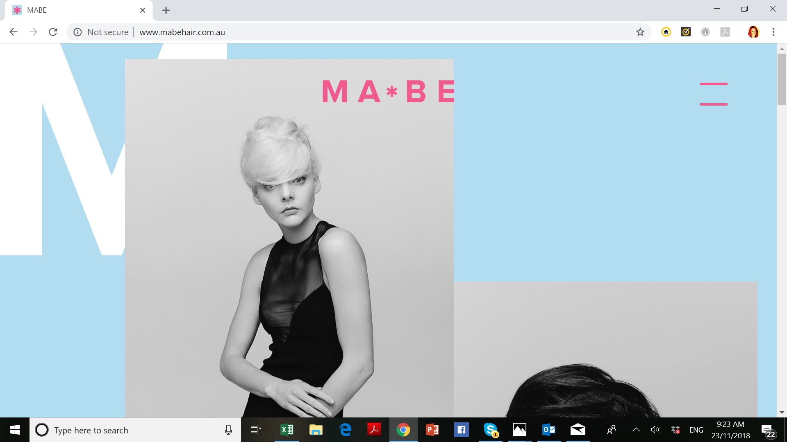

Example 2: Letter stacking of the MYND component of MYND TRIBE could be interesting and striking. The font needs to be simple, modern, clean and bold.

