

Pricing List

Mission Statement:

Wolf Grinders creates innovative, durable cannabis products for the on-the-go cannabis consumer.

Our Products:

All Wolf Grinders products were designed with traveling in mind and they provide everything needed for the on-the-go cannabis user. The Combo-Crusher includes a grinder, removable pipe, pick piece, lighter holster, kief catch, and enough space for storage, all in one hand held device.

The scorpion pipe was also designed with a focus on portability. Like the pipes in the big bowl and mini grinders, it’s cnc machined from aluminum. It features a swiveling cover and folding pipe stem making it very small and portable, while also stopping any spillage when traveling. A pick piece is also built-in.

All products sold by Wolf Grinders are CNC machined out of aircraft grade 6061 aluminum in an ISO 9001 certified factory. our products are also bead blasted and anodized for a smooth vibrant finish. We also offer custom laser engraving.

Combo Crusher - $47.50.00 CAD wholesale, $95.00 CAD suggested Retail

CNC machined grinder, covered pipe, lighter holster, kief catch, pick piece and storage. 70mm diameter, 52mm height. High borosilicate glass bowl that’s 22mm diameter and 11mm height. Available in Black and Silver

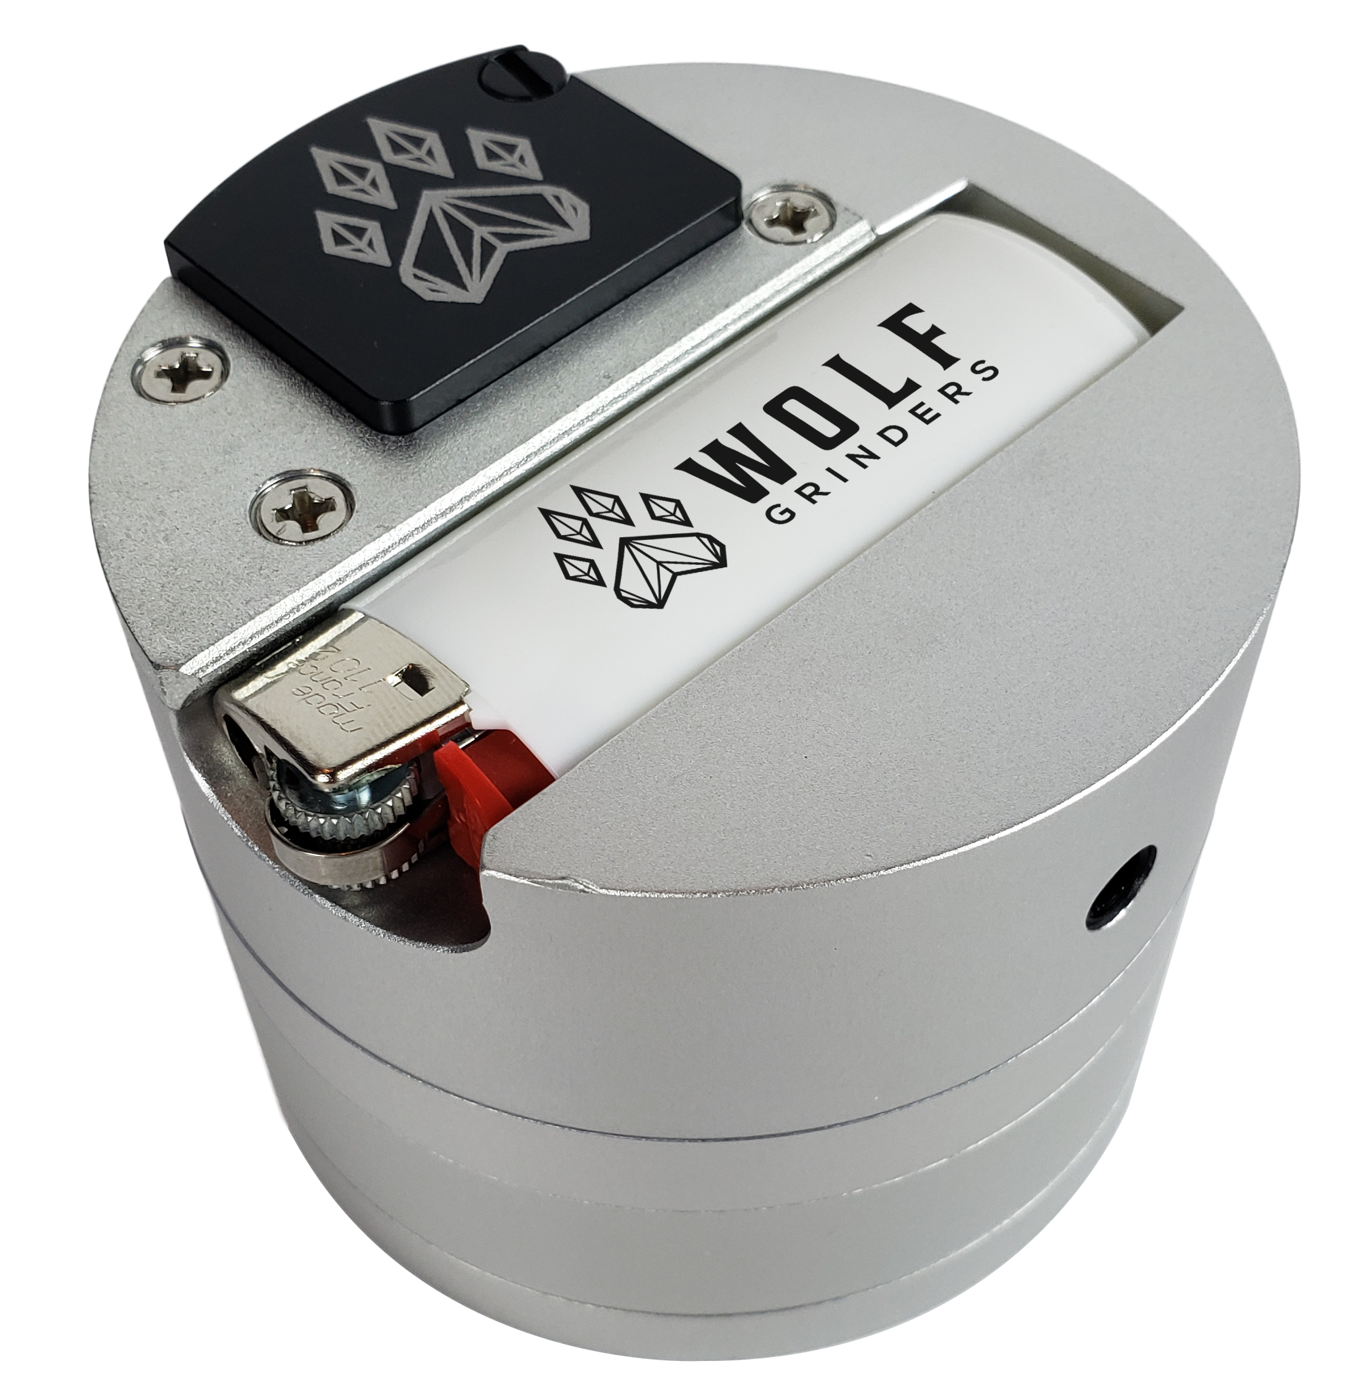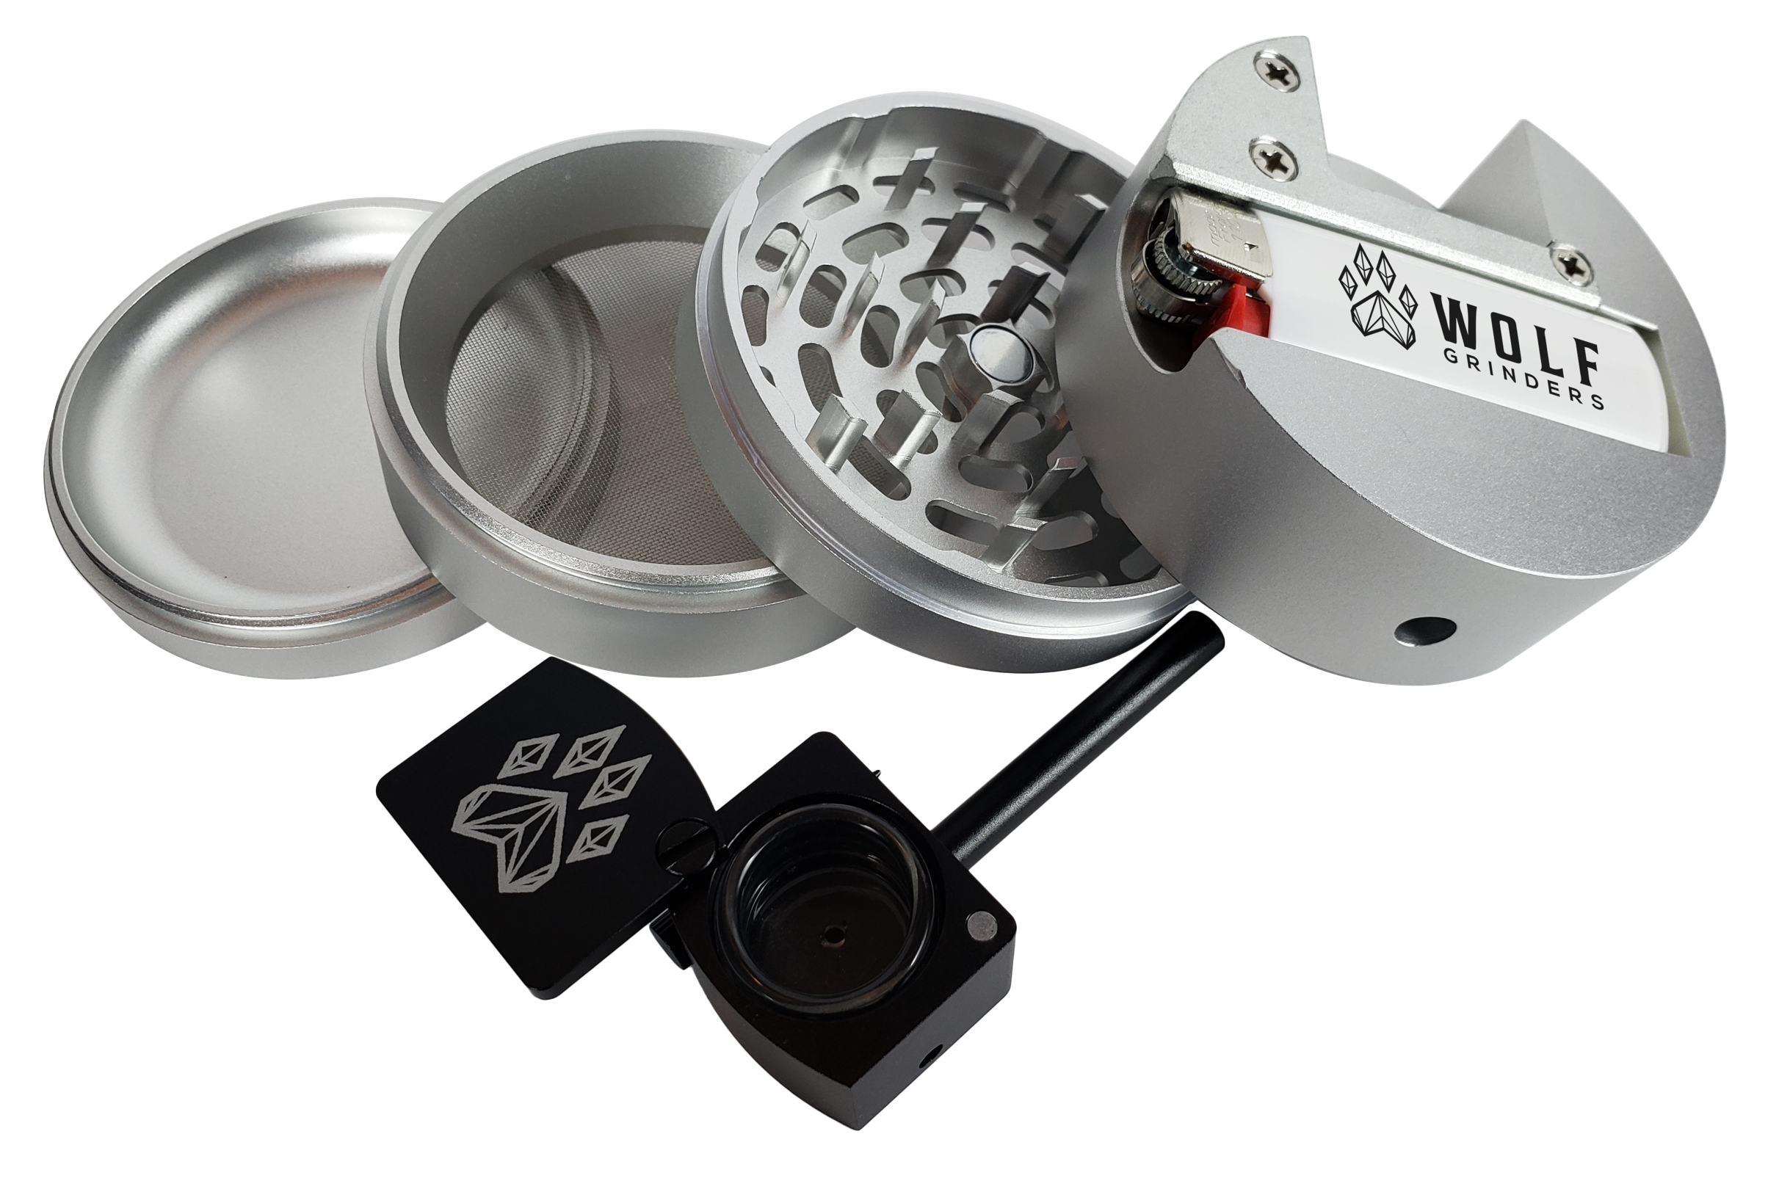

Big Bowl Grinder – $27.50 CAD Wholesale, $55.00 CAD Suggested retail

CNC machined Grinder, pipe, lighter holster, and storage. 69mm diameter, 48mm height. High Borosilicate Glass bowl that is 22mm diameter and 11mm height.
Available in Black, Blue, Red, Green, and Silver.
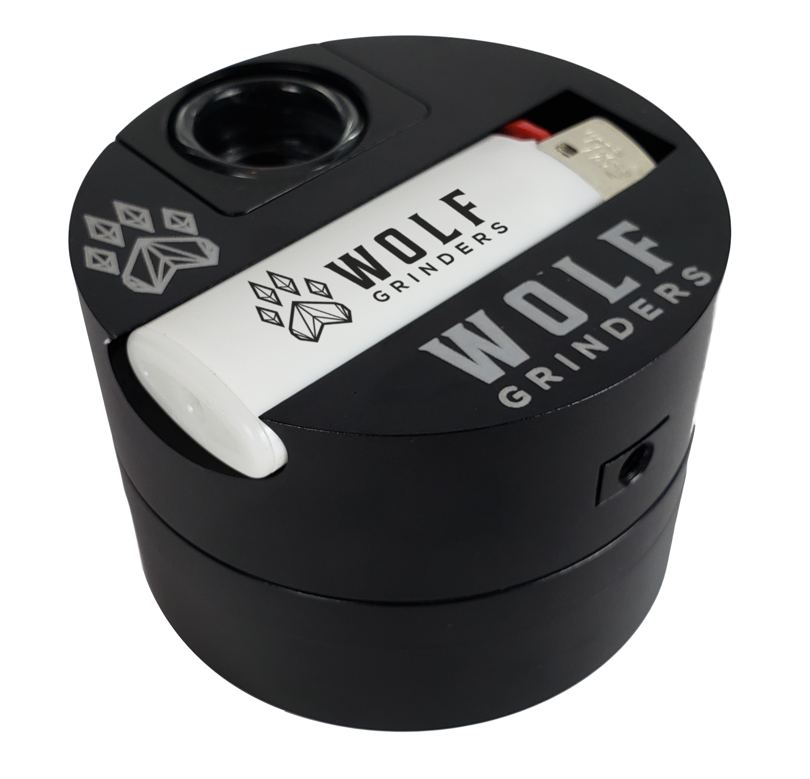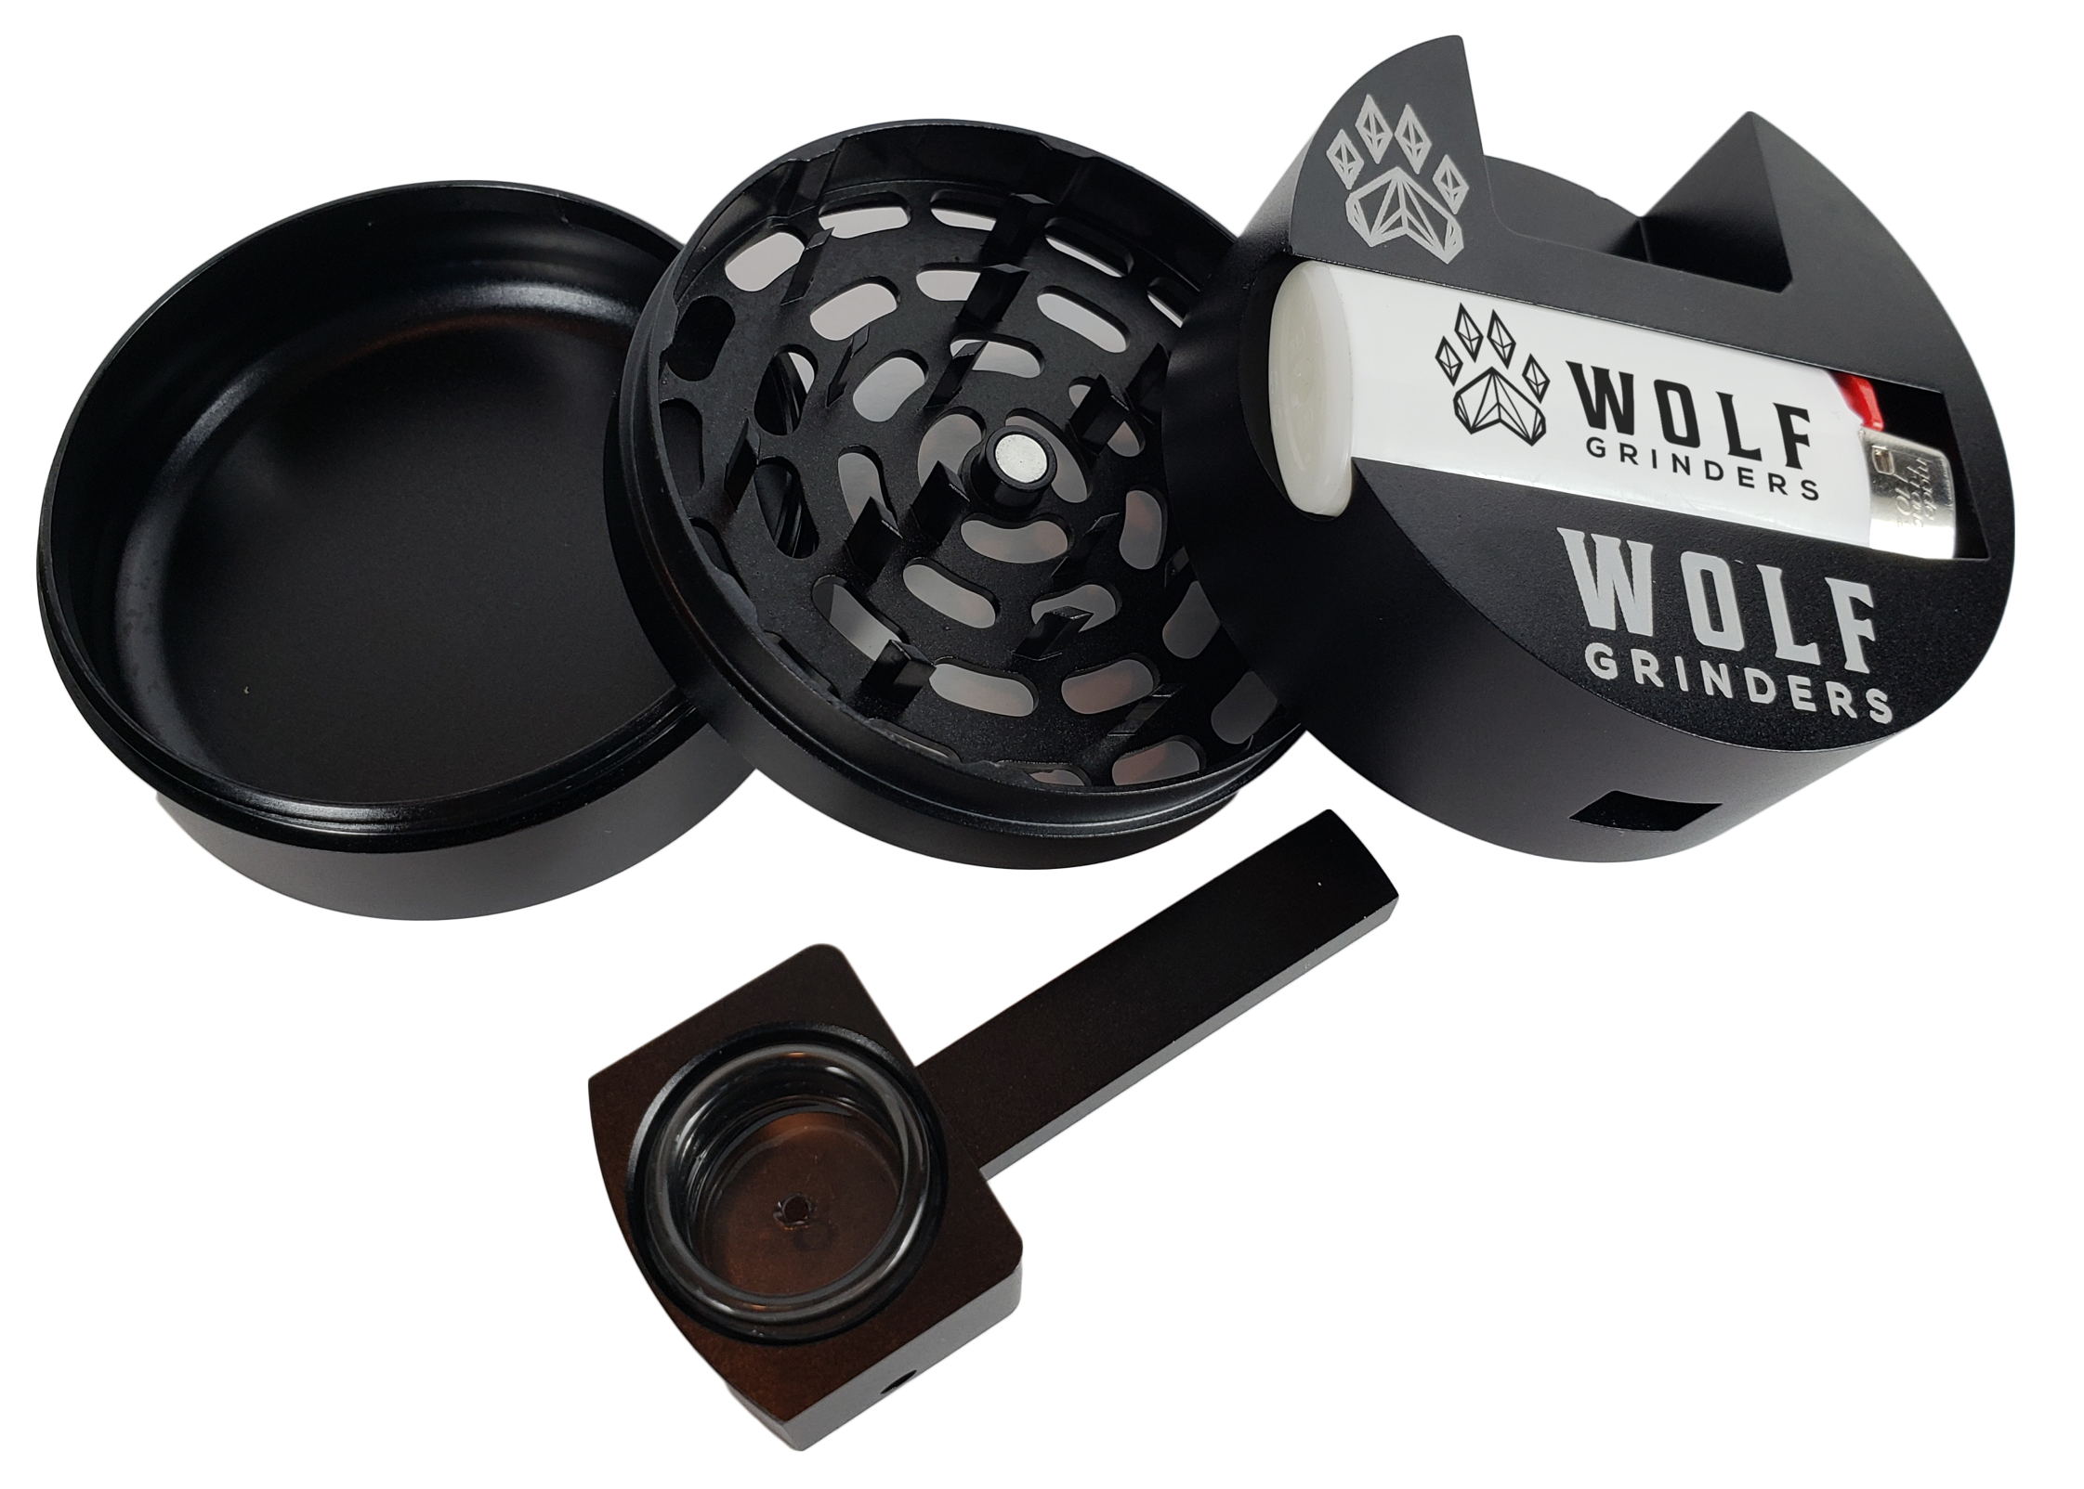

Scorpion Pipes - $25.00 CAD Wholesale, $50.00 CAD suggested retail

CNC machined pipe with folding stem and swiveling cover which are both held in “open” and “Closed” positions by magnets. Borosilicate Glass bowl that is 22mm diameter and 11mm height. Very portable and discreet. Built in Pick Piece.
Available in black and silver.
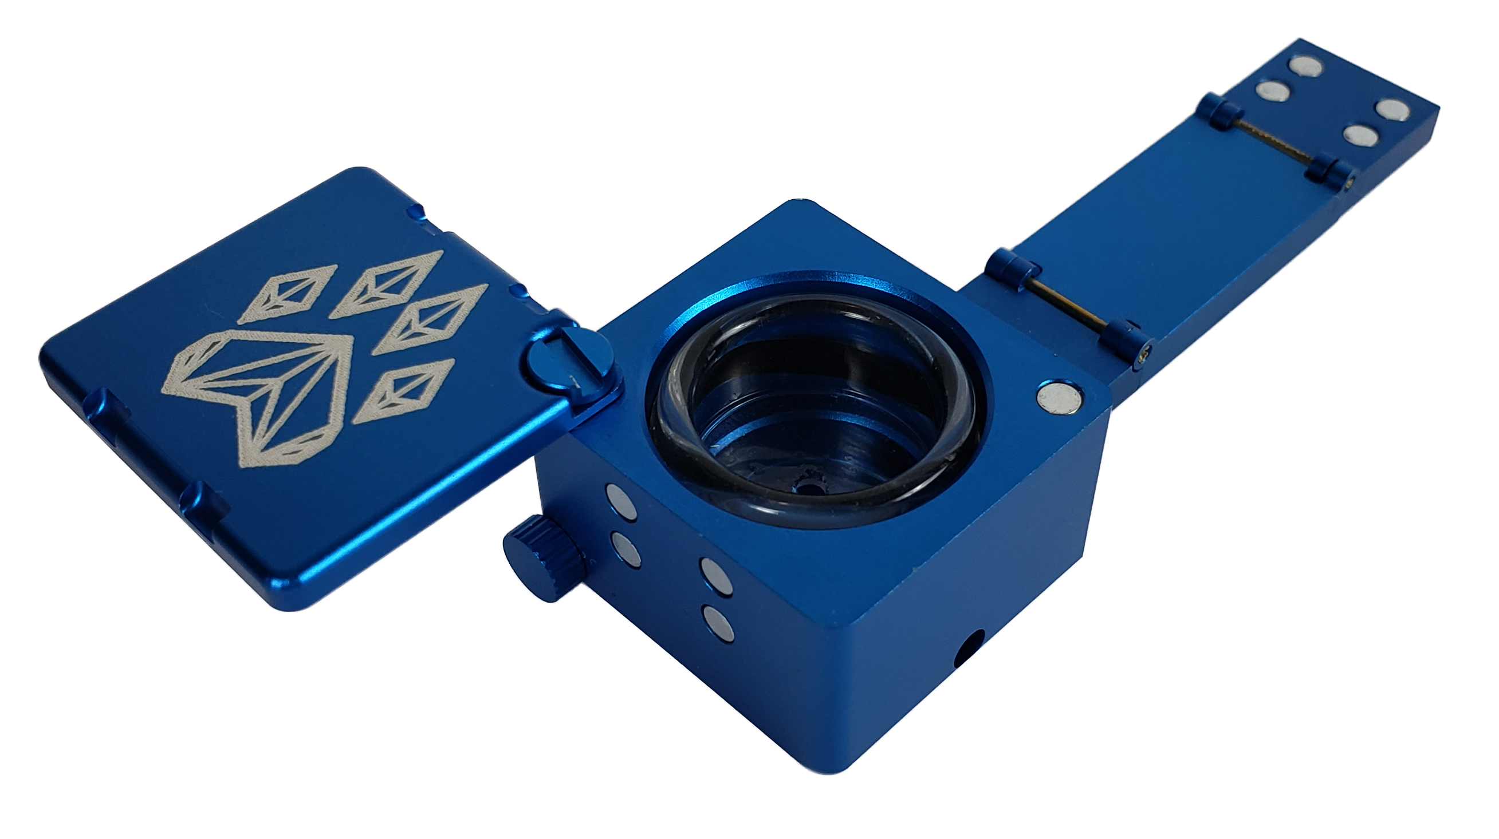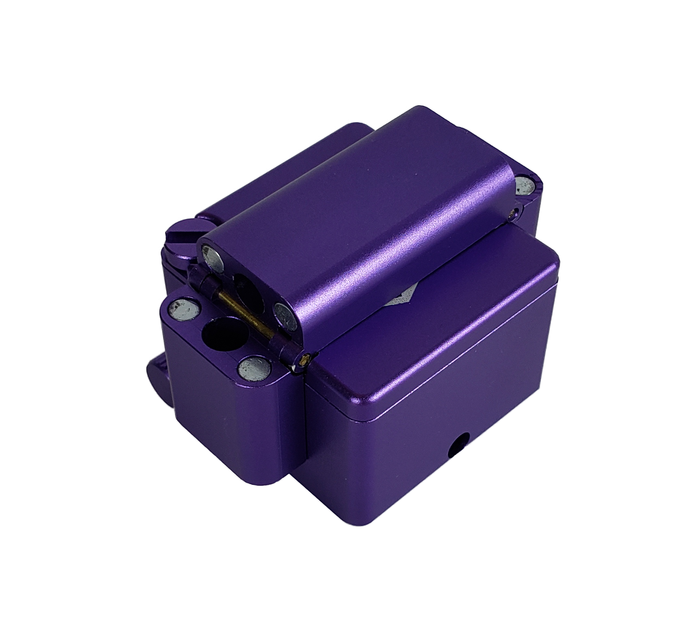

Cannon Pipes - $17.50 CAD wholesale, $35.00 CAD suggested retail

Larger Cnc Machined Pipe with huge quartz glass bowl. The bowl is 28mm in diameter and 11mm in height and has two intake holes to increase airflow. Great for sharing.
Available in Black, Silver, Red, blue, and green.
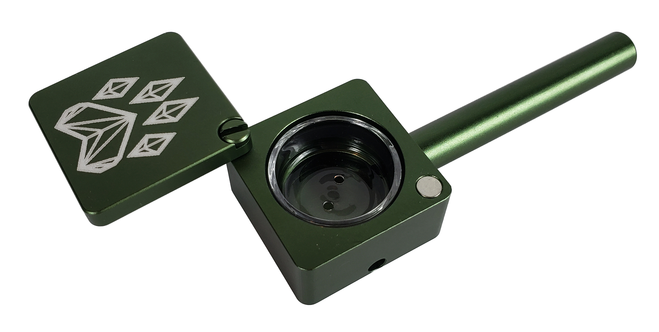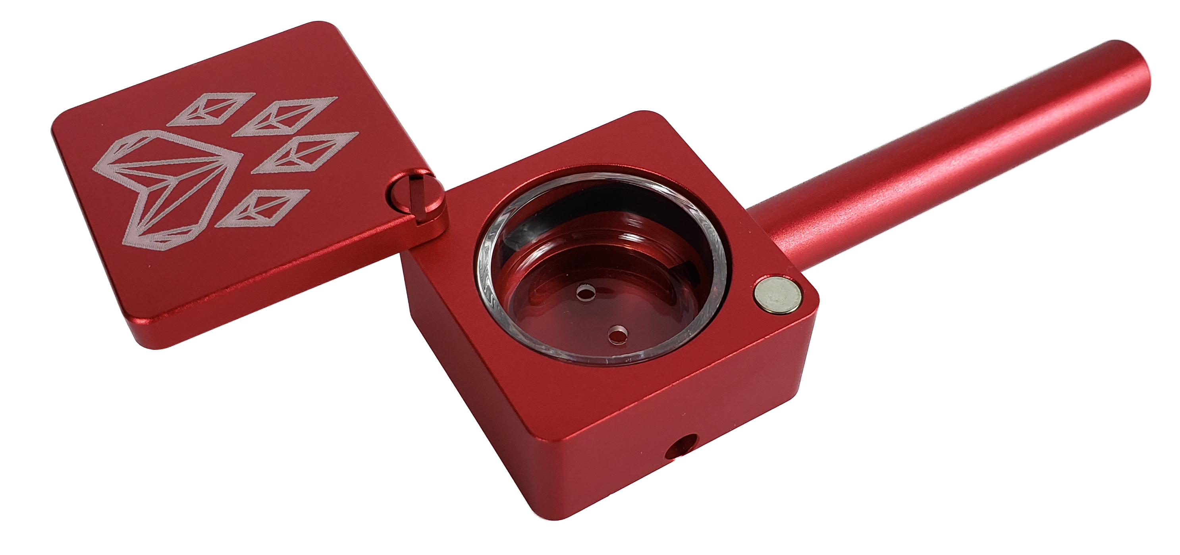

Carrying Case (canna-vault included) - $12.00 CAD Wholesale, $24.00 CAD suggested retail

This durable hard plastic carrying case perfectly fits a big bowl grinder and cannapack vault. The third space can be used to store things like papers, extra lighters, or vape pens. Comes with a small padlock as well to keep children or roommates out. Great for trips. Available in Blue, Purple, and Black
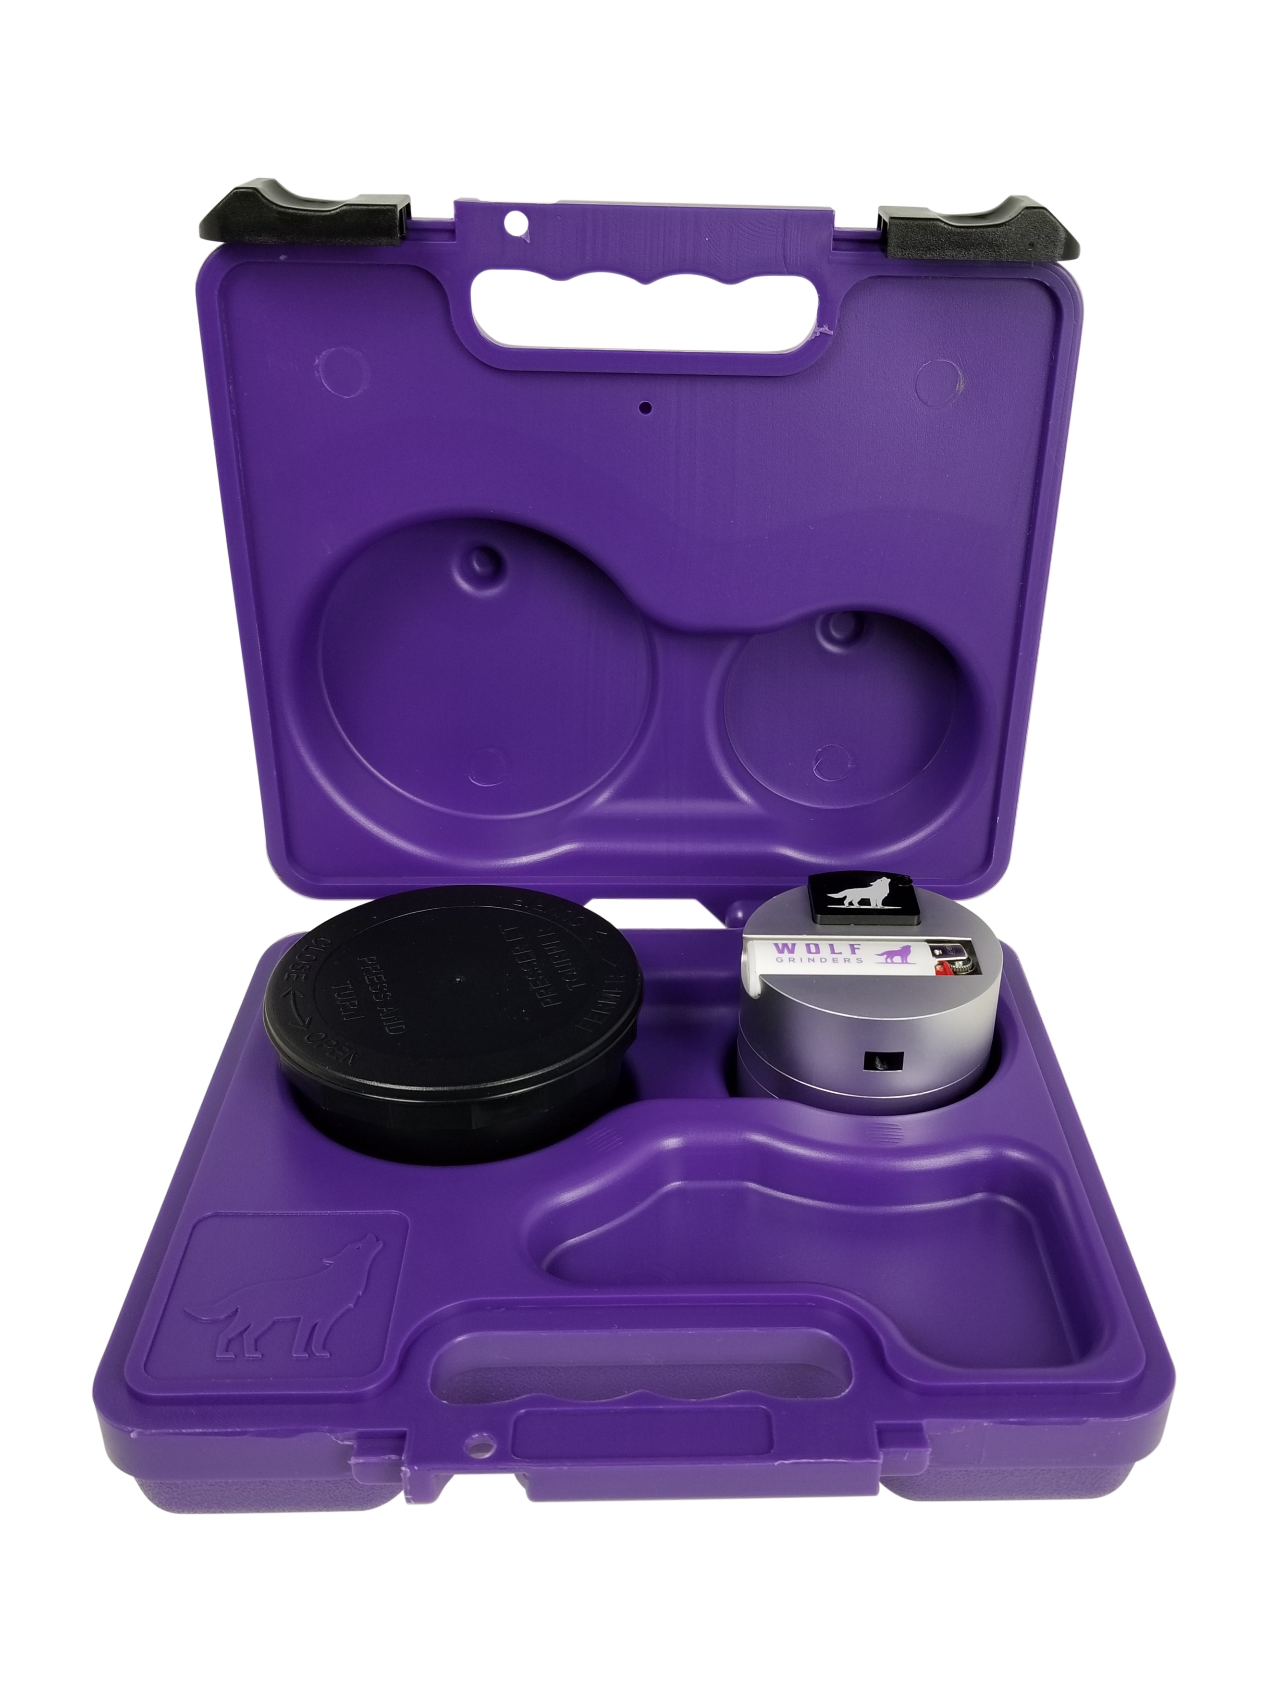
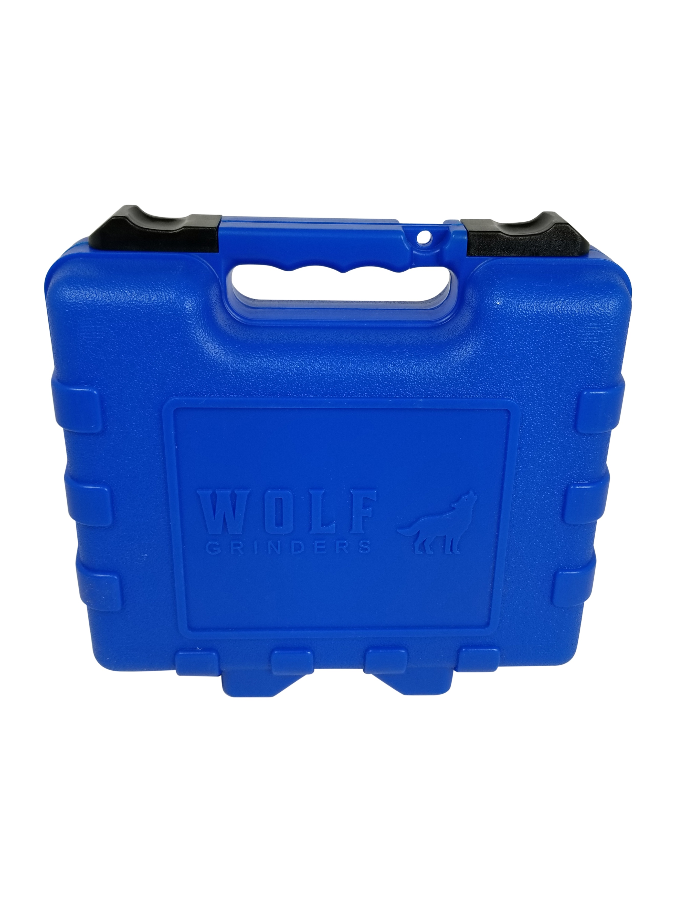

Canna-pack vault –$2.90 CAD Wholesale, Suggested retail $5.80 CAD

The Cannapack Vault is made of fully recyclable polypropylene. It holds ~10g of dried bud, is smell-proof & child resistant as prescribed by the Canadian Food & Drug Regulations.
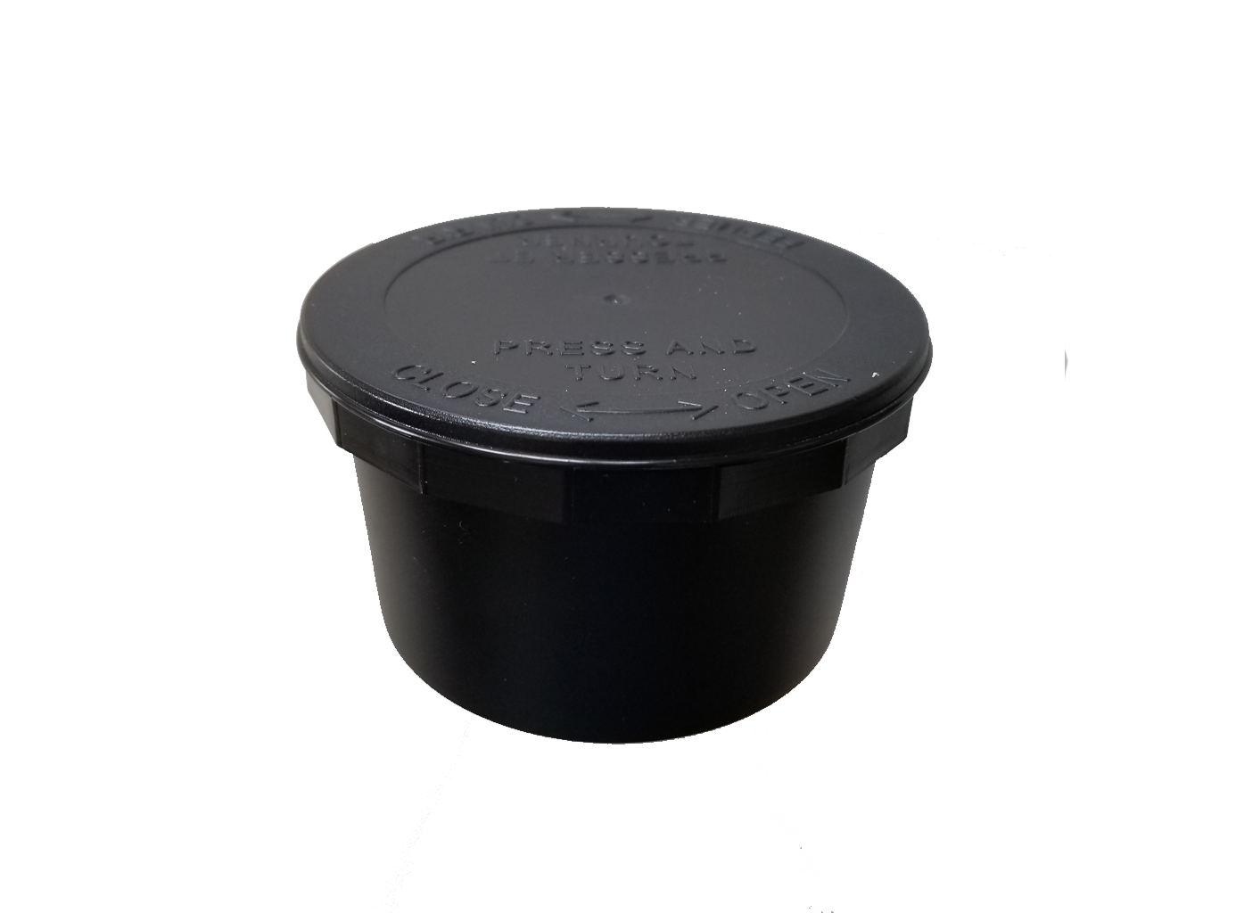

Rolling Trays – $0.50 CAD Wholesale, $5.50 CAD Suggested retail

Tin, 17cm by 14cm. available in black and white

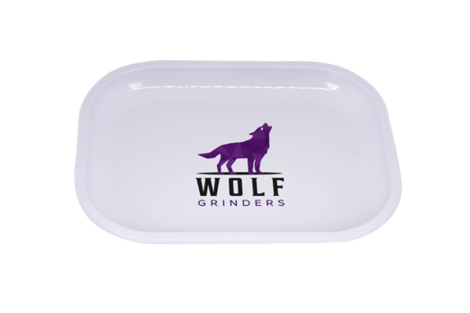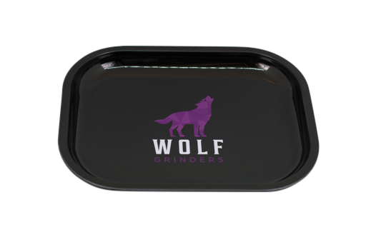

Extra Bowls/Bands, 3-pack - $2.90 CAD Wholesale, $5.80 CAD Suggested Retail

22mm high borosilicate bowls for the scorpion, big bowl, and mini. Both come with silicone bands fitted. Same pricing for Larger Cannon Bowl.

