Figure 1 | Figure 2 | Figure 3
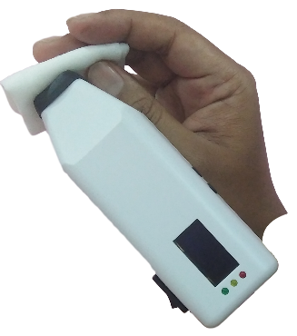 | 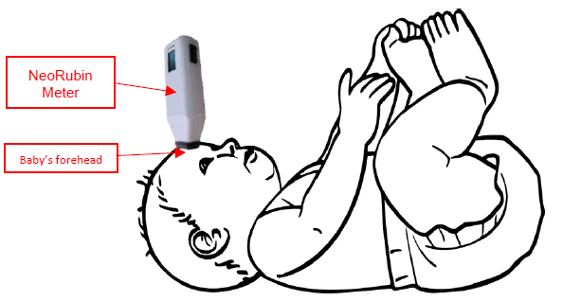 | 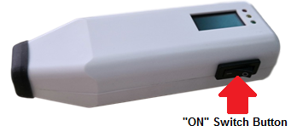
Figure 4 | Figure 5 | Figure 6
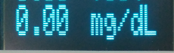 | 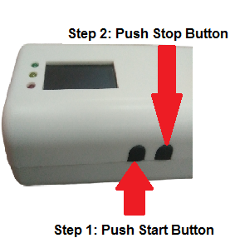 | 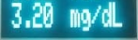

1. For hygiene purposes, kindly clean the rubber cap using alcohol swap before touch any baby skin as shown in Figure 1.
2. Place the jaundice meter on the baby forehead (please ensure the rubber cap of the meter have fully contact with baby skin) as shown in Figure 2.
3. “ON” the switch button as shown in Figure 3.
4. Wait until LCD screen display “0.00 mg/dL” as shown in Figure 4.
5. Push “start” button to start the measurement as shown in Figure 5 (refer step 1).
6. Wait for 2-5 seconds, the result (mg/dL) will be displayed at LCD Display.
7. Push “stop” button to freeze the measurement result as shown in Figure 5 (refer step 2).
8. Record the result of mg/dL value shown in Figure 6 for medical interpretation

