Client: Heroiq Health (formerly IQ)

Project: Heroiq Health Brand Identity
Date: 07.31.18

The Opportunity:

Create a brand for Heroiq Health that positions them as the world’s leading membership-based organization focused on empowering its members to improve their health through lifestyle changes and fight America’s Diabetic health crisis. Launching in March 2019, we need to create a compelling brand identity that will live both as a community health program and a retail prepared food offering.

Understanding the Business
With a combination of prepared meals that are scientifically proven to lower blood sugar, blood pressure, cholesterol, and weight, along with coaching programs that teach you to make every day healthy choices, the membership helps people take small steps that add up to big change. Every member gets:

- A personalized meal plan that is clinically proven to lower blood sugar, blood pressure, cholesterol and weight
- A choice of over 30 delicious meals, created by a chef and shipped frozen to your home for $5 a meal
- One-on-one coaching sessions, education and daily tips to help you meet your specific health goals and shift the way users view food, eating, and lifestyle.
- An engaging app filled with tracking tools, education materials and rewards
- A community of people living with Type II Diabetes and prediabetes to support and encourage you

How will it work?

The main offering will be the membership for $240 a year which allows users to access every aspect of Heroiq Health as well as meals for $5. The membership fee allows Heroiq to lower meals to be sold at cost considering the health crisis among lower income families and/or those in food deserts. Outside of the membership, meals can be purchased for $10 both online (DTC) and at retail. Ultimately, the goal is to drive toward membership in addition to purchasing prepared foods. Considering this, the product and brand identity straddles the world of retail +membership/community.

The food is fresh prepared and then flash frozen. The meal plans are meant to feel familiar and comforting in the sense that this is not entirely off track from what our consumer regularly eats. In other words, the food is not considered a “diet” but rather a step in the right direction toward health with balanced nutrition.

Why it will work/Reasons to Believe:
- The only clinically proven meal plan that lowers the 4 biomarkers associated with diabetes and heart disease (blood sugar, blood pressure, cholesterol, and weight).
  - Over 20 years of research and development backed by Campbell’s
- Food that tastes good!
- Behavior change coaching
- Easy to stick with and convenient
- Affordable (being sold pretty much at cost)
- Community support
- Sustainable and practical

What is the purpose and intention of this program?

The organization’s purpose is to be the champion of America’s health. Through this membership platform Heroiq will address the diabetes epidemic and set out to end the crisis.

What does the name Heroiq mean?

The name represents a few aspects of being a hero:
- Being your own hero, to take back control of your health and feel empowered to create change.
- Being a hero to others through a community of support and helping others on their journey. Additionally, for every membership sold, a membership is given to a child with type 2 diabetes. Being part of the program means you are inherently supporting others in their journey. This creates a community of “heroes” which will be highlighted with success stories and encouragement.

The name also holds “IQ” in the spelling which is a nod to the past. Campbell’s developed a clinically proven meal plan to help lower numbers associated with diabetes and heart disease. Campbell's branded their program Intelligent Quisine. This science was later sold and further developed under the IQ, Intelligent Quisine, brand. Now the company is renaming to Heroiq Health and evolving beyond prepared foods into a community of wellness and support for those with diabetes or prediabetes. This story does not need to be pushed but rather told as part of the backstory and holds the existing proof and history of where the concept comes from. To consumers, using “iq” just creates a unique way to spell Heroiq.

Brand Positioning:
A healthy lifestyle brand underpinned by clinical proof and credibility.
While the brand has a clinical aspect, this is not where we want to position. The brand needs to be able to sit with other clinical brands and not feel like an imposter but there is a strong emotional undercurrent when impacting and changing lives which helps to solidify Heroiq as a trusted lifestyle brand. It needs to feel warm and accessible not cold and clinical. In terms of scale position, the brand is attainable and should be considered mass rather than premium as the way in for many members will be food displays at retail.

There is a stigma associated with type II diabetes. The disease is most related to genetics however, once diagnosed many people can feel ashamed and guilty. This means the branding needs to represent something people are proud to be part of with packaging they are comfortable to have on their desk/in the office fridge. People need to feel confident to associate Heroiq as part of their lifestyle.

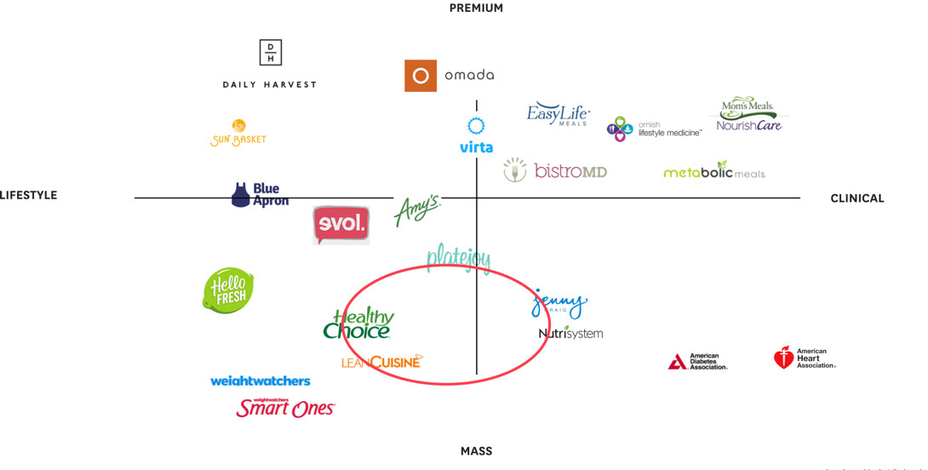

Who are we talking to and what do we know about them?

Prediabetes or those diagnosed and living with type II diabetes

There are approximately 84 million Americans with prediabetes and 30 million living with diabetes. Most people don’t know they are developing diabetes and only find out when they go for a routine check-up, another illness, or symptoms that brings them to the doctor/hospital where blood is drawn.

Because of this, they do not have access or the knowledge of how to eat healthy. They often aren’t aware of the impact of their lifestyle (nutrition, physical activity, sleep, stress) on their health and blood sugar, which explains why a diagnosis as diabetic or prediabetic is unexpected. With little to no prior nutrition education and understanding, this audience struggles to understand what food, portions and habits can help them reach their target weight and glucose levels. They are searching online looking for grocery lists curated by other diabetics and asking for advice in forums on what diet to follow and foods to consume.

This audience needs to understand why being their own health hero is the answer. They need to learn how accessible and possible it is to create change in their health and find control. They often know conceptually what foods are good for them, but have a hard time building healthy eating habits that are easy to follow and affordable. It is likely that they don’t view food as a solution and are looking for medication as an easier solution than lifestyle change.

How should the brand make them feel?

Empowered – I finally have a sense of control and the ability to manage my own health. I feel supported and guided. I am taking my well-being into my own hands. I am my own health hero and I inspire those around me.

Brand Personality?
Proud. Inspiring. Supportive. Optimistic.

She is an American-made, matriarch with the genuine goal of helping others achieve success. She is your favorite coach. She cheers you on as you reach your goals and gives you tough love when you need the motivation and accountability. She has high expectations of those around her but understands each individual’s preferences and capabilities and works with them to become the best they can be. She has made a lasting impact on your life and everyone she interacts with. She is warm and approachable, and holds her community together. She is the woman striking up conversation in line at the grocery store or with the barista at a coffee shop. She has the ability to simplify complex situations and make audacious goals seem possible. She is aware of her impact and takes pride in what she does, big or small. While she is comforting support, when things feel hard, she will hold you accountable and is not afraid to get down to business in service of helping you become your best and healthiest self.

Tone?
Accessible. Empowering. Wholesome. Creditable/Respectable. (in the clinical health world).

Brands we admire?

Weight Watchers: For the community building, support and accountability

Target (Digital): For bringing high quality (design) to the masses, aspirational

Amazon Prime: Implies value, stands for excellence, accessible, easy and flexible

LinkedIn: Community building, people helping each other out, reconnecting, bettering yourself/career

Google: Trusted resource for all things search, practical, accessible, data-driven

How will Heroiq Health evolve?
Heroiq will act as an ecosystem with multiple brand extensions (Heroiq coaching, Heroiq recipes, etc.). The brand should be designed with Heroiq as the master brand that all extensions live under. The different offerings within the membership all ultimately work together in their goal to help members achieve better health but are each unique in their contribution to our members’ success. For example, the coaching will strengthen what is understood through a consistent meal plan (i.e. a balanced meal is x,y,z).

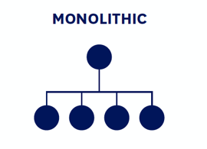Example: 

Creative guidelines/mandatories
- Full name is Heroiq Health and logo must include both but health can be smaller.
- Strike a balance of approachable (mass market) and serious (clinical/scientific). Branding needs to sit comfortably with the clinical brands but standout in retail mass market space. Should not feel cold or sterile. Audience should feel comfortable and proud to eat at work, with family and friends.
- Consider how subbrands would be structured.
- IQ should not be emphasized in the logo (does not necessarily need to be explained and can live as a background story).
- Straddle membership model and retail

Deliverables?
- Initial round of up to three brand concepts.
- Brand concepts should consider logo, brand voice, imagery, typography and colors.

Timing?
- DiGo to Share Design Brief with Abby for Approval - 7/30/18
- IQ to Approve Design Brief - 7/31/18
- DiGo to Kickoff Design Team - 8/1/18
- Design Development - 8/1-8/20
- R1 Internal Review – 8/17/18
- R1 Client Presentation - 8/21/18
- R1 Client Feedback Due - 8/23/18
- R2 Internal Review – 8/30/18
- R2 Client Presentation - 8/31/18
- R2 Client Feedback Due - 9/4/18
- R3 Final Revisions - 9/5-9/10
- Final Approval of Creative - 9/11/18
- DiGo to Handoff Creative Assets - 9/12/18
- Style Guide Development - 9/11-9/17
- DiGo to Share Style Guide for Feedback - 9/18/18
- IQ to Provide Feedback on Style Guide - 9/20/18
- DiGo to Share Final Approved Style Guide - 9/21/18

Appendix: Audience Context

Pre-diagnosed or those diagnosed and living with type II diabetes – emotion around adapting

Often people are aware that diabetes is a possibility given their family history and start to notice symptoms like extreme thirst, frequent urination, blurriness, numbness in toes, extreme fatigue, etc. This typically results in a doctors visit where a diagnosis is given. And sometimes, people are experiencing the symptoms but are unaware that those symptoms are a result of diabetes. Some will go to the doctor and others will hold off and wait. Our target consists of two buckets, those pre-diagnosed with diabetes and those living with diabetes. Within these two buckets there are various thoughts and emotions.

Once diagnosed, the response varies. Some people will take it very seriously and spend a great deal of time focusing on taking back control of their health but often those people run out of steam and feel overwhelmed and frustrated. Other times after diagnosis, there is complete denial and inability to deal with the news which leads to ignoring the problem and continuing down the road with an unmanaged disease.

There are many different ways to respond to the news of being “prediabetic” and learning you have type II diabetes. Ultimately, the news is shocking, scary, and often overwhelming. The disease implies a new required way of living, level of awareness, and attention to detail that has likely never been present in their lives.

